SECURITIES AND EXCHANGE COMMISSION
Washington, D.C. 20549

FORM 6-K

Report of Foreign Private Issuer

Pursuant to Rule 13a-16 or 15d-16 of
the Securities Exchange Act of 1934

For the month of October 2026

Commission File No. 1-31690

TC Energy Corporation
(Translation of Registrant's Name into English)

450 – 1 Street S.W., Calgary, Alberta, T2P 5H1, Canada
(Address of Principal Executive Offices)

Indicate by check mark whether the registrant files or will file annual reports under cover of Form 20-F or Form 40-F:

Form 20-F ☐ Form 40-F ☑

Exhibit 99.1 to this report, furnished on Form 6-K, is furnished, not filed, and will not be incorporated by reference into any registration statement filed by the registrant under the Securities Act of 1933, as amended.

EXHIBIT INDEX

99.1 |  |  | A copy of the registrant’s news release dated October 16, 2026.

SIGNATURES

Pursuant to the requirements of the Securities Exchange Act of 1934, the registrant has duly caused this report to be signed on its behalf by the undersigned, thereunto duly authorized.

Date: October 16, 2026

 |  |  | TC ENERGY CORPORATION
 |  |  | By: |  |  | /s/ Jane M. Brindle
 |  |  |  |  |  | Jane M. Brindle
 |  |  |  |  |  | Vice-President, Law and Corporate Secretary

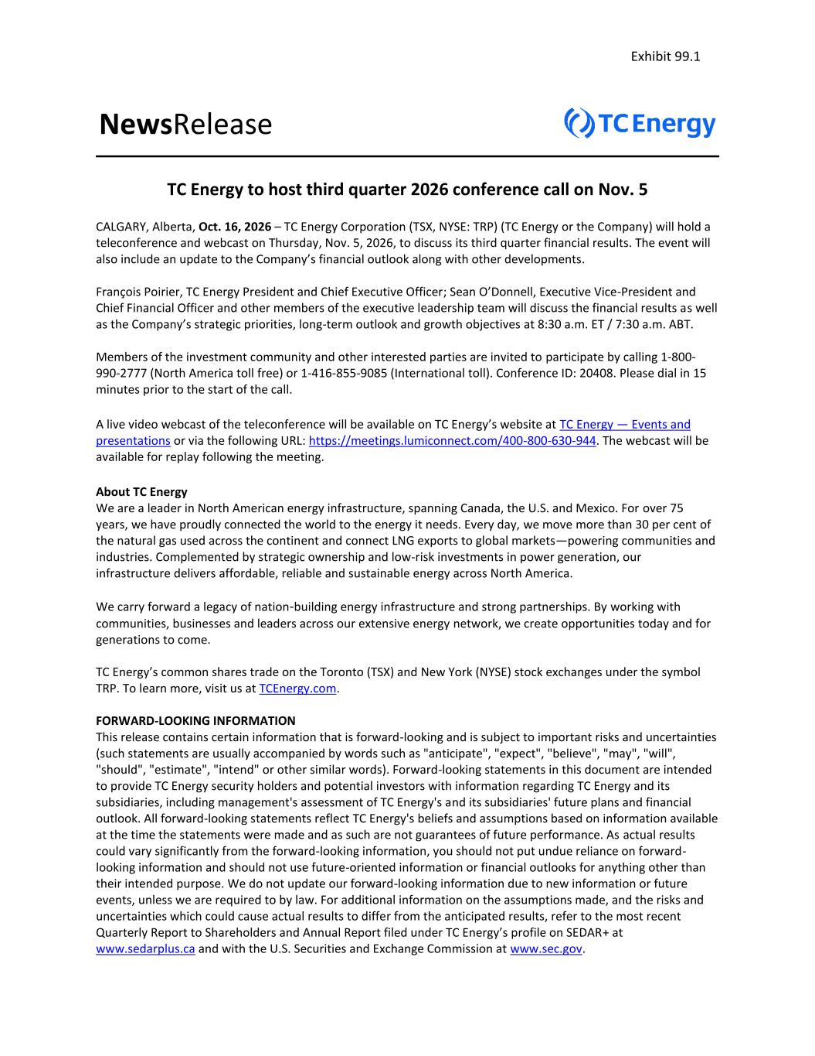

NewsRelease TC Energy to host third quarter 2026 conference call on Nov. 5 CALGARY, Alberta, Oct. 16, 2026 – TC Energy Corporation (TSX, NYSE: TRP) (TC Energy or the Company) will hold a teleconference and webcast on Thursday, Nov. 5, 2026, to discuss its third quarter financial results. The event will also include an update to the Company’s financial outlook along with other developments. François Poirier, TC Energy President and Chief Executive Officer; Sean O’Donnell, Executive Vice-President and Chief Financial Officer and other members of the executive leadership team will discuss the financial results as well as the Company’s strategic priorities, long-term outlook and growth objectives at 8:30 a.m. ET / 7:30 a.m. ABT. Members of the investment community and other interested parties are invited to participate by calling 1-800- 990-2777 (North America toll free) or 1-416-855-9085 (International toll). Conference ID: 20408. Please dial in 15 minutes prior to the start of the call. A live video webcast of the teleconference will be available on TC Energy’s website at TC Energy — Events and presentations or via the following URL: https://meetings.lumiconnect.com/400-800-630-944. The webcast will be available for replay following the meeting. About TC Energy We are a leader in North American energy infrastructure, spanning Canada, the U.S. and Mexico. For over 75 years, we have proudly connected the world to the energy it needs. Every day, we move more than 30 per cent of the natural gas used across the continent and connect LNG exports to global markets—powering communities and industries. Complemented by strategic ownership and low-risk investments in power generation, our infrastructure delivers affordable, reliable and sustainable energy across North America. We carry forward a legacy of nation-building energy infrastructure and strong partnerships. By working with communities, businesses and leaders across our extensive energy network, we create opportunities today and for generations to come. TC Energy’s common shares trade on the Toronto (TSX) and New York (NYSE) stock exchanges under the symbol TRP. To learn more, visit us at TCEnergy.com. FORWARD-LOOKING INFORMATION This release contains certain information that is forward-looking and is subject to important risks and uncertainties (such statements are usually accompanied by words such as "anticipate", "expect", "believe", "may", "will", "should", "estimate", "intend" or other similar words). Forward-looking statements in this document are intended to provide TC Energy security holders and potential investors with information regarding TC Energy and its subsidiaries, including management's assessment of TC Energy's and its subsidiaries' future plans and financial outlook. All forward-looking statements reflect TC Energy's beliefs and assumptions based on information available at the time the statements were made and as such are not guarantees of future performance. As actual results could vary significantly from the forward-looking information, you should not put undue reliance on forward- looking information and should not use future-oriented information or financial outlooks for anything other than their intended purpose. We do not update our forward-looking information due to new information or future events, unless we are required to by law. For additional information on the assumptions made, and the risks and uncertainties which could cause actual results to differ from the anticipated results, refer to the most recent Quarterly Report to Shareholders and Annual Report filed under TC Energy’s profile on SEDAR+ at www.sedarplus.ca and with the U.S. Securities and Exchange Commission at www.sec.gov. Exhibit 99.1


-30- Media Inquiries: Media Relations media@tcenergy.com 403-920-7859 or 800-608-7859 Investor & Analyst Inquiries: Investor Relations investor_relations@tcenergy.com 403-920-7911 or 800-361-6522

