SECURITIES AND EXCHANGE COMMISSION
Washington, D.C. 20549

FORM 6-K

Report of Foreign Private Issuer

Pursuant to Rule 13a-16 or 15d-16 of
the Securities Exchange Act of 1934

For the month of October 2026

Commission File No. 1-31690

TC Energy Corporation
(Translation of Registrant's Name into English)

450 – 1 Street S.W., Calgary, Alberta, T2P 5H1, Canada
(Address of Principal Executive Offices)

Indicate by check mark whether the registrant files or will file annual reports under cover of Form 20-F or Form 40-F:

Form 20-F ☐ Form 40-F ☑

Exhibit 99.1 to this report, furnished on Form 6-K, is furnished, not filed, and will not be incorporated by reference into any registration statement filed by the registrant under the Securities Act of 1933, as amended.

EXHIBIT INDEX

99.1 |  |  | A copy of the registrant’s news release dated October 13, 2026.

SIGNATURES

Pursuant to the requirements of the Securities Exchange Act of 1934, the registrant has duly caused this report to be signed on its behalf by the undersigned, thereunto duly authorized.

Date: October 13, 2026

 |  |  | TC ENERGY CORPORATION
 |  |  | By: |  |  | /s/ Jane M. Brindle
 |  |  |  |  |  | Jane M. Brindle
 |  |  |  |  |  | Vice-President, Law and Corporate Secretary

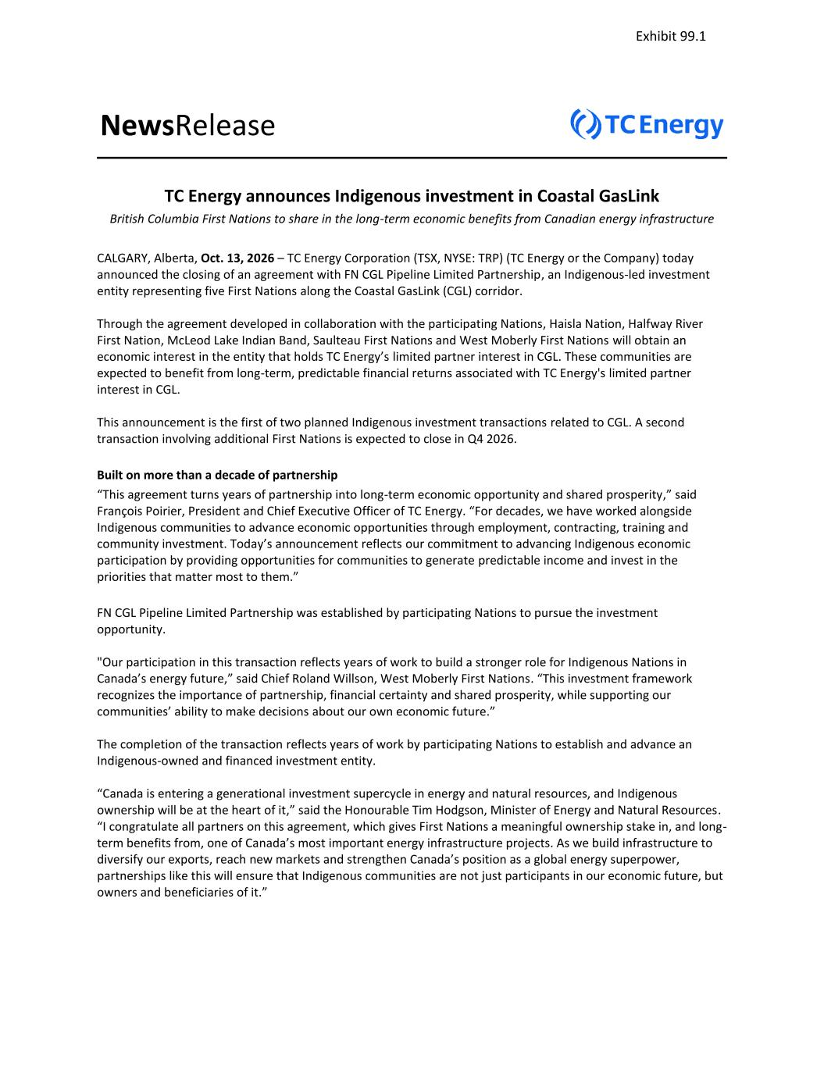

NewsRelease TC Energy announces Indigenous investment in Coastal GasLink British Columbia First Nations to share in the long-term economic benefits from Canadian energy infrastructure CALGARY, Alberta, Oct. 13, 2026 – TC Energy Corporation (TSX, NYSE: TRP) (TC Energy or the Company) today announced the closing of an agreement with FN CGL Pipeline Limited Partnership, an Indigenous-led investment entity representing five First Nations along the Coastal GasLink (CGL) corridor. Through the agreement developed in collaboration with the participating Nations, Haisla Nation, Halfway River First Nation, McLeod Lake Indian Band, Saulteau First Nations and West Moberly First Nations will obtain an economic interest in the entity that holds TC Energy’s limited partner interest in CGL. These communities are expected to benefit from long-term, predictable financial returns associated with TC Energy's limited partner interest in CGL. This announcement is the first of two planned Indigenous investment transactions related to CGL. A second transaction involving additional First Nations is expected to close in Q4 2026. Built on more than a decade of partnership “This agreement turns years of partnership into long-term economic opportunity and shared prosperity,” said François Poirier, President and Chief Executive Officer of TC Energy. “For decades, we have worked alongside Indigenous communities to advance economic opportunities through employment, contracting, training and community investment. Today’s announcement reflects our commitment to advancing Indigenous economic participation by providing opportunities for communities to generate predictable income and invest in the priorities that matter most to them.” FN CGL Pipeline Limited Partnership was established by participating Nations to pursue the investment opportunity. "Our participation in this transaction reflects years of work to build a stronger role for Indigenous Nations in Canada’s energy future,” said Chief Roland Willson, West Moberly First Nations. “This investment framework recognizes the importance of partnership, financial certainty and shared prosperity, while supporting our communities’ ability to make decisions about our own economic future.” The completion of the transaction reflects years of work by participating Nations to establish and advance an Indigenous-owned and financed investment entity. “Canada is entering a generational investment supercycle in energy and natural resources, and Indigenous ownership will be at the heart of it,” said the Honourable Tim Hodgson, Minister of Energy and Natural Resources. “I congratulate all partners on this agreement, which gives First Nations a meaningful ownership stake in, and long- term benefits from, one of Canada’s most important energy infrastructure projects. As we build infrastructure to diversify our exports, reach new markets and strengthen Canada’s position as a global energy superpower, partnerships like this will ensure that Indigenous communities are not just participants in our economic future, but owners and beneficiaries of it.” Exhibit 99.1

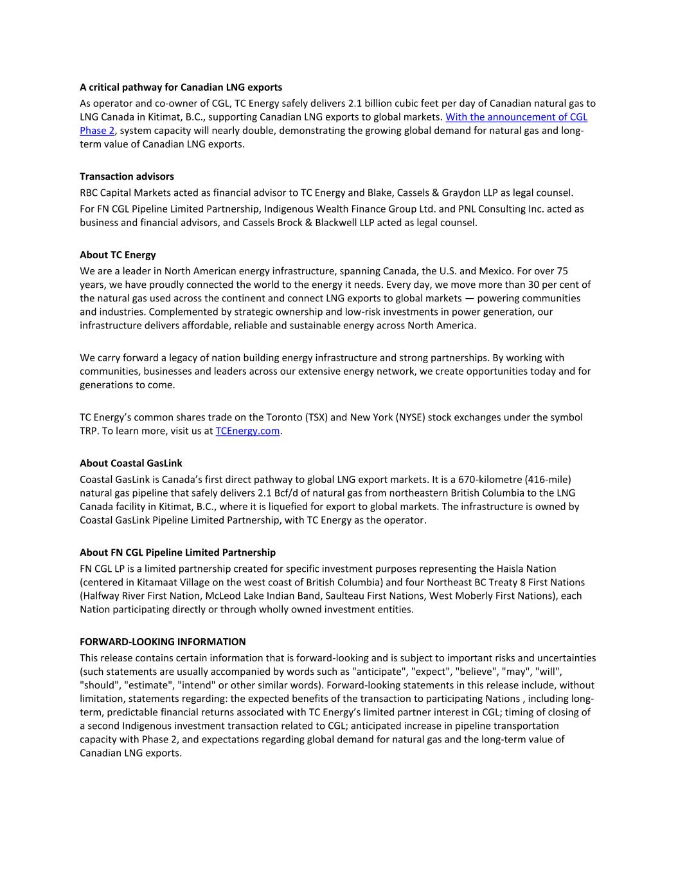
A critical pathway for Canadian LNG exports As operator and co-owner of CGL, TC Energy safely delivers 2.1 billion cubic feet per day of Canadian natural gas to LNG Canada in Kitimat, B.C., supporting Canadian LNG exports to global markets. With the announcement of CGL Phase 2, system capacity will nearly double, demonstrating the growing global demand for natural gas and long- term value of Canadian LNG exports. Transaction advisors RBC Capital Markets acted as financial advisor to TC Energy and Blake, Cassels & Graydon LLP as legal counsel. For FN CGL Pipeline Limited Partnership, Indigenous Wealth Finance Group Ltd. and PNL Consulting Inc. acted as business and financial advisors, and Cassels Brock & Blackwell LLP acted as legal counsel. About TC Energy We are a leader in North American energy infrastructure, spanning Canada, the U.S. and Mexico. For over 75 years, we have proudly connected the world to the energy it needs. Every day, we move more than 30 per cent of the natural gas used across the continent and connect LNG exports to global markets — powering communities and industries. Complemented by strategic ownership and low-risk investments in power generation, our infrastructure delivers affordable, reliable and sustainable energy across North America. We carry forward a legacy of nation building energy infrastructure and strong partnerships. By working with communities, businesses and leaders across our extensive energy network, we create opportunities today and for generations to come. TC Energy’s common shares trade on the Toronto (TSX) and New York (NYSE) stock exchanges under the symbol TRP. To learn more, visit us at TCEnergy.com. About Coastal GasLink Coastal GasLink is Canada’s first direct pathway to global LNG export markets. It is a 670-kilometre (416-mile) natural gas pipeline that safely delivers 2.1 Bcf/d of natural gas from northeastern British Columbia to the LNG Canada facility in Kitimat, B.C., where it is liquefied for export to global markets. The infrastructure is owned by Coastal GasLink Pipeline Limited Partnership, with TC Energy as the operator. About FN CGL Pipeline Limited Partnership FN CGL LP is a limited partnership created for specific investment purposes representing the Haisla Nation (centered in Kitamaat Village on the west coast of British Columbia) and four Northeast BC Treaty 8 First Nations (Halfway River First Nation, McLeod Lake Indian Band, Saulteau First Nations, West Moberly First Nations), each Nation participating directly or through wholly owned investment entities. FORWARD-LOOKING INFORMATION This release contains certain information that is forward-looking and is subject to important risks and uncertainties (such statements are usually accompanied by words such as "anticipate", "expect", "believe", "may", "will", "should", "estimate", "intend" or other similar words). Forward-looking statements in this release include, without limitation, statements regarding: the expected benefits of the transaction to participating Nations , including long- term, predictable financial returns associated with TC Energy’s limited partner interest in CGL; timing of closing of a second Indigenous investment transaction related to CGL; anticipated increase in pipeline transportation capacity with Phase 2, and expectations regarding global demand for natural gas and the long-term value of Canadian LNG exports.

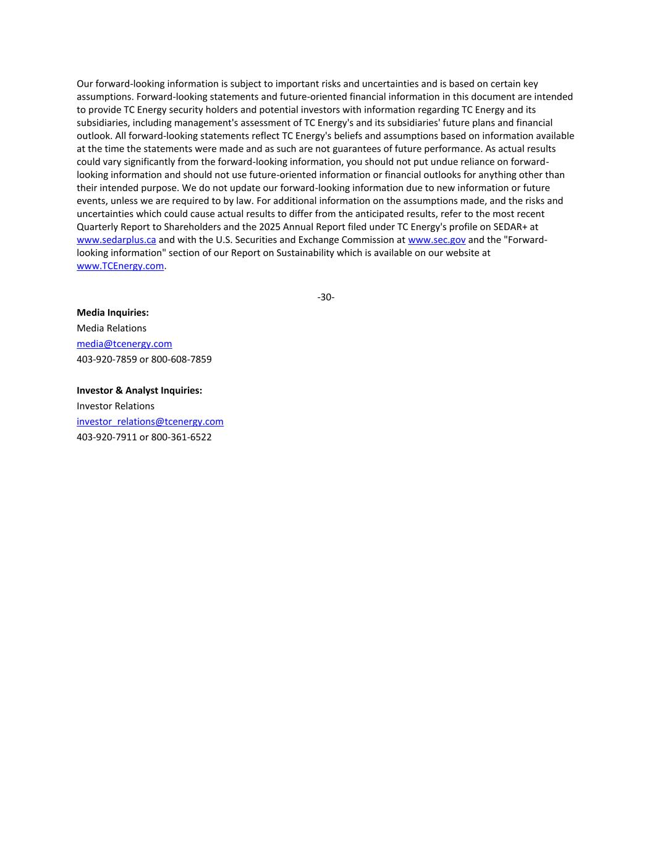
Our forward-looking information is subject to important risks and uncertainties and is based on certain key assumptions. Forward-looking statements and future-oriented financial information in this document are intended to provide TC Energy security holders and potential investors with information regarding TC Energy and its subsidiaries, including management's assessment of TC Energy's and its subsidiaries' future plans and financial outlook. All forward-looking statements reflect TC Energy's beliefs and assumptions based on information available at the time the statements were made and as such are not guarantees of future performance. As actual results could vary significantly from the forward-looking information, you should not put undue reliance on forward- looking information and should not use future-oriented information or financial outlooks for anything other than their intended purpose. We do not update our forward-looking information due to new information or future events, unless we are required to by law. For additional information on the assumptions made, and the risks and uncertainties which could cause actual results to differ from the anticipated results, refer to the most recent Quarterly Report to Shareholders and the 2025 Annual Report filed under TC Energy's profile on SEDAR+ at www.sedarplus.ca and with the U.S. Securities and Exchange Commission at www.sec.gov and the "Forward- looking information" section of our Report on Sustainability which is available on our website at www.TCEnergy.com. -30- Media Inquiries: Media Relations media@tcenergy.com 403-920-7859 or 800-608-7859 Investor & Analyst Inquiries: Investor Relations investor_relations@tcenergy.com 403-920-7911 or 800-361-6522

