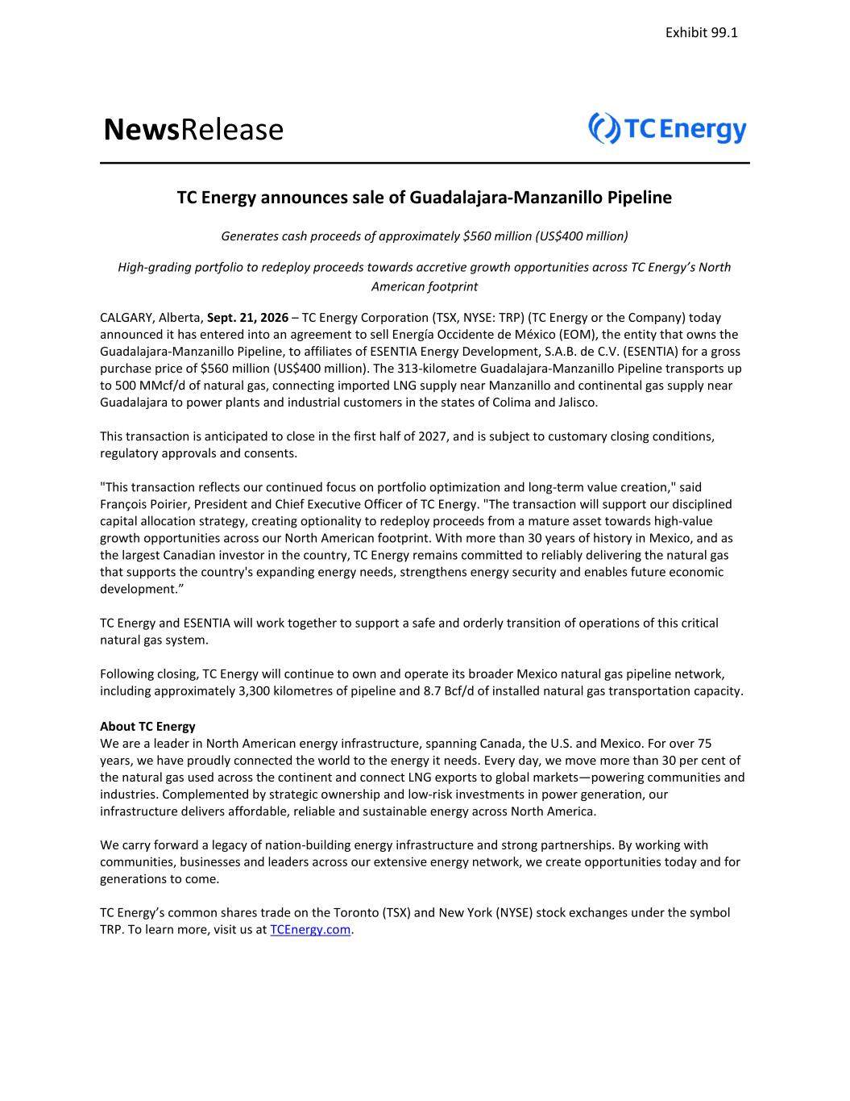
NewsRelease TC Energy announces sale of Guadalajara-Manzanillo Pipeline Generates cash proceeds of approximately $560 million (US$400 million) High-grading portfolio to redeploy proceeds towards accretive growth opportunities across TC Energy’s North American footprint CALGARY, Alberta, Sept. 21, 2026 – TC Energy Corporation (TSX, NYSE: TRP) (TC Energy or the Company) today announced it has entered into an agreement to sell Energía Occidente de México (EOM), the entity that owns the Guadalajara-Manzanillo Pipeline, to affiliates of ESENTIA Energy Development, S.A.B. de C.V. (ESENTIA) for a gross purchase price of $560 million (US$400 million). The 313-kilometre Guadalajara-Manzanillo Pipeline transports up to 500 MMcf/d of natural gas, connecting imported LNG supply near Manzanillo and continental gas supply near Guadalajara to power plants and industrial customers in the states of Colima and Jalisco. This transaction is anticipated to close in the first half of 2027, and is subject to customary closing conditions, regulatory approvals and consents. "This transaction reflects our continued focus on portfolio optimization and long-term value creation," said François Poirier, President and Chief Executive Officer of TC Energy. "The transaction will support our disciplined capital allocation strategy, creating optionality to redeploy proceeds from a mature asset towards high-value growth opportunities across our North American footprint. With more than 30 years of history in Mexico, and as the largest Canadian investor in the country, TC Energy remains committed to reliably delivering the natural gas that supports the country's expanding energy needs, strengthens energy security and enables future economic development.” TC Energy and ESENTIA will work together to support a safe and orderly transition of operations of this critical natural gas system. Following closing, TC Energy will continue to own and operate its broader Mexico natural gas pipeline network, including approximately 3,300 kilometres of pipeline and 8.7 Bcf/d of installed natural gas transportation capacity. About TC Energy We are a leader in North American energy infrastructure, spanning Canada, the U.S. and Mexico. For over 75 years, we have proudly connected the world to the energy it needs. Every day, we move more than 30 per cent of the natural gas used across the continent and connect LNG exports to global markets—powering communities and industries. Complemented by strategic ownership and low-risk investments in power generation, our infrastructure delivers affordable, reliable and sustainable energy across North America. We carry forward a legacy of nation-building energy infrastructure and strong partnerships. By working with communities, businesses and leaders across our extensive energy network, we create opportunities today and for generations to come. TC Energy’s common shares trade on the Toronto (TSX) and New York (NYSE) stock exchanges under the symbol TRP. To learn more, visit us at TCEnergy.com. Exhibit 99.1

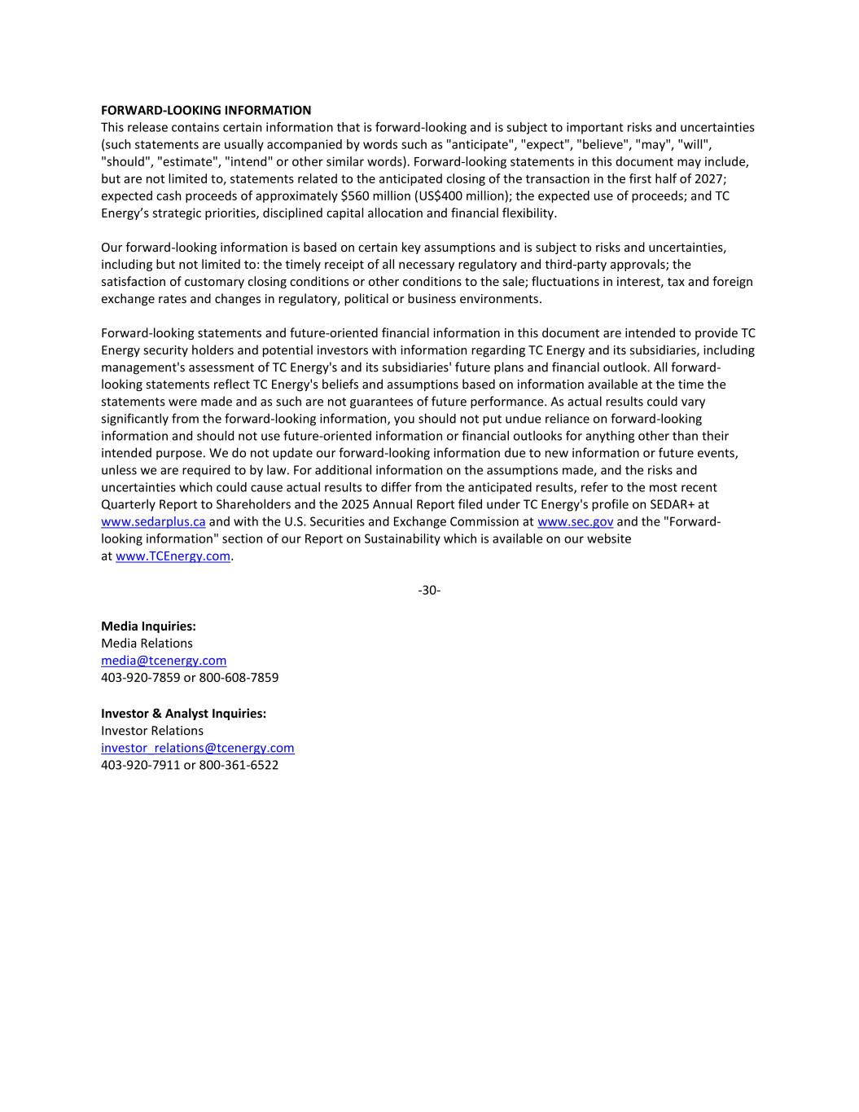
FORWARD-LOOKING INFORMATION This release contains certain information that is forward-looking and is subject to important risks and uncertainties (such statements are usually accompanied by words such as "anticipate", "expect", "believe", "may", "will", "should", "estimate", "intend" or other similar words). Forward-looking statements in this document may include, but are not limited to, statements related to the anticipated closing of the transaction in the first half of 2027; expected cash proceeds of approximately $560 million (US$400 million); the expected use of proceeds; and TC Energy’s strategic priorities, disciplined capital allocation and financial flexibility. Our forward-looking information is based on certain key assumptions and is subject to risks and uncertainties, including but not limited to: the timely receipt of all necessary regulatory and third-party approvals; the satisfaction of customary closing conditions or other conditions to the sale; fluctuations in interest, tax and foreign exchange rates and changes in regulatory, political or business environments. Forward-looking statements and future-oriented financial information in this document are intended to provide TC Energy security holders and potential investors with information regarding TC Energy and its subsidiaries, including management's assessment of TC Energy's and its subsidiaries' future plans and financial outlook. All forward- looking statements reflect TC Energy's beliefs and assumptions based on information available at the time the statements were made and as such are not guarantees of future performance. As actual results could vary significantly from the forward-looking information, you should not put undue reliance on forward-looking information and should not use future-oriented information or financial outlooks for anything other than their intended purpose. We do not update our forward-looking information due to new information or future events, unless we are required to by law. For additional information on the assumptions made, and the risks and uncertainties which could cause actual results to differ from the anticipated results, refer to the most recent Quarterly Report to Shareholders and the 2025 Annual Report filed under TC Energy's profile on SEDAR+ at www.sedarplus.ca and with the U.S. Securities and Exchange Commission at www.sec.gov and the "Forward- looking information" section of our Report on Sustainability which is available on our website at www.TCEnergy.com. -30- Media Inquiries: Media Relations media@tcenergy.com 403-920-7859 or 800-608-7859 Investor & Analyst Inquiries: Investor Relations investor_relations@tcenergy.com 403-920-7911 or 800-361-6522

SECURITIES AND EXCHANGE COMMISSION
Washington, D.C. 20549

FORM 6-K

Report of Foreign Private Issuer

Pursuant to Rule 13a-16 or 15d-16 of
the Securities Exchange Act of 1934

For the month of September 2026

Commission File No. 1-31690

TC Energy Corporation
(Translation of Registrant's Name into English)

450 – 1 Street S.W., Calgary, Alberta, T2P 5H1, Canada
(Address of Principal Executive Offices)

Indicate by check mark whether the registrant files or will file annual reports under cover of Form 20-F or Form 40-F:

Form 20-F ☐ Form 40-F ☑

Exhibit 99.1 to this report, furnished on Form 6-K, is furnished, not filed, and will not be incorporated by reference into any registration statement filed by the registrant under the Securities Act of 1933, as amended.

EXHIBIT INDEX

99.1 |  |  | A copy of the registrant’s news release dated September 21, 2026.

SIGNATURES

Pursuant to the requirements of the Securities Exchange Act of 1934, the registrant has duly caused this report to be signed on its behalf by the undersigned, thereunto duly authorized.

Date: September 21, 2026

 |  |  | TC ENERGY CORPORATION
 |  |  | By: |  |  | /s/ Jane M. Brindle
 |  |  |  |  |  | Jane M. Brindle
 |  |  |  |  |  | Vice-President, Law and Corporate Secretary

