SECURITIES AND EXCHANGE COMMISSION
Washington, D.C. 20549

FORM 6-K

Report of Foreign Private Issuer

Pursuant to Rule 13a-16 or 15d-16 of
the Securities Exchange Act of 1934

For the month of October 2026

TC Energy Corporation
(Commission File No. 1-31690)

TransCanada PipeLines Limited
(Commission File No. 1-8887)

(Translation of Registrants’ Names into English)

450 - 1 Street S.W., Calgary, Alberta, T2P 5H1, Canada
(Address of Principal Executive Offices)

Indicate by check mark whether the registrant files or will file annual reports under cover of Form 20-F or Form 40-F:

Form 20-F ☐ Form 40-F ☑

Exhibit 99.1 to this report, furnished on Form 6-K, is furnished, not filed, and will not be incorporated by reference into any registration statement filed by the registrant under the Securities Act of 1933, as amended.

Explanatory Note

TransCanada PipeLines Limited (“TransCanada PipeLines”) is a wholly owned subsidiary of TC Energy Corporation (“TC Energy”). TransCanada PipeLines is relying on the continuous disclosure documents filed by TC Energy pursuant to an exemption from the requirements of National Instrument 51-102 - Continuous Disclosure Obligations and as provided in the decision of the Alberta Securities Commission and Ontario Securities Commission in Re TransCanada Corporation, 2019 ABASC 1, issued on January 3, 2019. Consistent with the exemptive relief, information contained in this Form 6-K is that provided by TC Energy.

EXHIBIT INDEX

99.1 |  |  | A copy of the registrants' Code of Business Ethics Policy, as amended.

SIGNATURES

Pursuant to the requirements of the Securities Exchange Act of 1934, each Registrant has duly caused this report to be signed on its behalf by the undersigned, thereunto duly authorized.

Date: October 5, 2026

 |  |  | TC ENERGY CORPORATION
 |  |  | TRANSCANADA PIPELINES LIMITED
 |  |  | By: |  |  | /s/ Jane M. Brindle
 |  |  |  |  |  | Jane M. Brindle
 |  |  |  |  |  | Vice-President, Law and Corporate Secretary



MAKING THE RIGHT CHOICES – DOING THE RIGHT THING TC Energy’s Code of Business Ethics (COBE) Policy Home Living our values Ethical business conduct Communication Assets and information Have a question? We’re here to help Table of contents EXHIBIT 99.1


MESSAGE FROM FRANÇOIS POIRIER At TC Energy, we know what we do, and more importantly, how we do it, matters. The actions and decisions you make every day impact the Company and the communities we serve. That’s why we must ensure our actions are aligned with our values. It is important that stakeholders, rightsholders and the public are confident they can count on us to act with integrity in every situation. Our core values — safety in every step, personal accountability, one team and active learning — form the foundation of how we do business. Our Code of Business Ethics (COBE) helps us put our values into action by providing clear guidance on what ethical conduct looks like. As a member of the TC Energy team, you are expected to read, understand and comply with the principles and requirements set out in COBE and are required to complete annual COBE training and certification. We encourage you to refer to COBE regularly to help guide your decisions at work. COBE provides a framework for you to ask questions and highlights the resources in place to report concerns. Our purpose is clear — we are proud to connect the world to the energy it needs. François Poirier President & CEO TC Energy – Code of Business Ethics Policy 2 Home Living our values Ethical business conduct Communication Assets and information Have a question? We’re here to help Table of contents

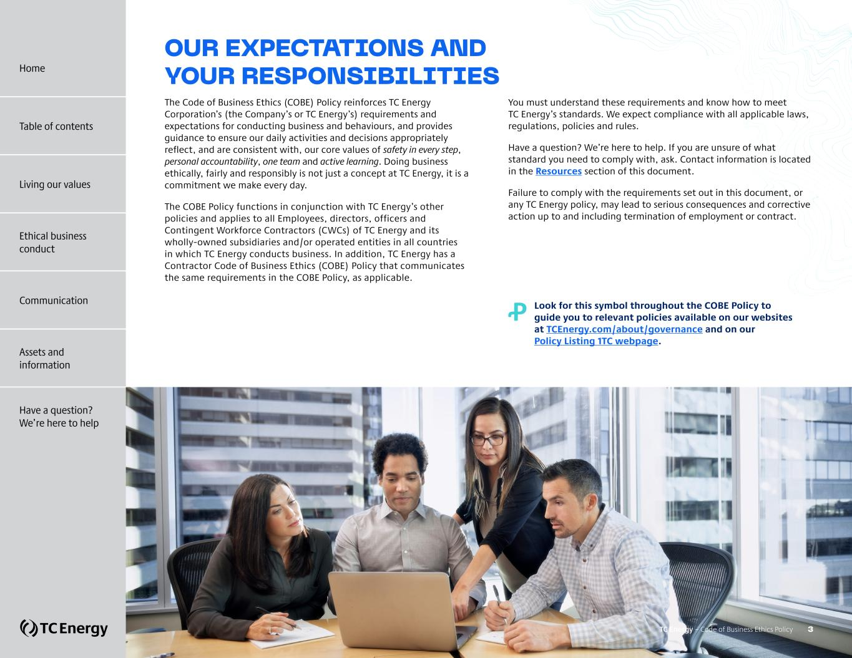
OUR EXPECTATIONS AND YOUR RESPONSIBILITIES The Code of Business Ethics (COBE) Policy reinforces TC Energy Corporation’s (the Company’s or TC Energy’s) requirements and expectations for conducting business and behaviours, and provides guidance to ensure our daily activities and decisions appropriately reflect, and are consistent with, our core values of safety in every step, personal accountability, one team and active learning. Doing business ethically, fairly and responsibly is not just a concept at TC Energy, it is a commitment we make every day. The COBE Policy functions in conjunction with TC Energy’s other policies and applies to all Employees, directors, officers and Contingent Workforce Contractors (CWCs) of TC Energy and its wholly-owned subsidiaries and/or operated entities in all countries in which TC Energy conducts business. In addition, TC Energy has a Contractor Code of Business Ethics (COBE) Policy that communicates the same requirements in the COBE Policy, as applicable. You must understand these requirements and know how to meet TC Energy’s standards. We expect compliance with all applicable laws, regulations, policies and rules. Have a question? We’re here to help. If you are unsure of what standard you need to comply with, ask. Contact information is located in the Resources section of this document. Failure to comply with the requirements set out in this document, or any TC Energy policy, may lead to serious consequences and corrective action up to and including termination of employment or contract. Ꝓ ?Look for this symbol throughout the COBE Policy to guide you to relevant policies available on our websites at TCEnergy.com/about/governance and on our Policy Listing 1TC webpage. TC Energy – Code of Business Ethics Policy 3 Home Table of contents Living our values Ethical business conduct Communication Assets and information Have a question? We’re here to help

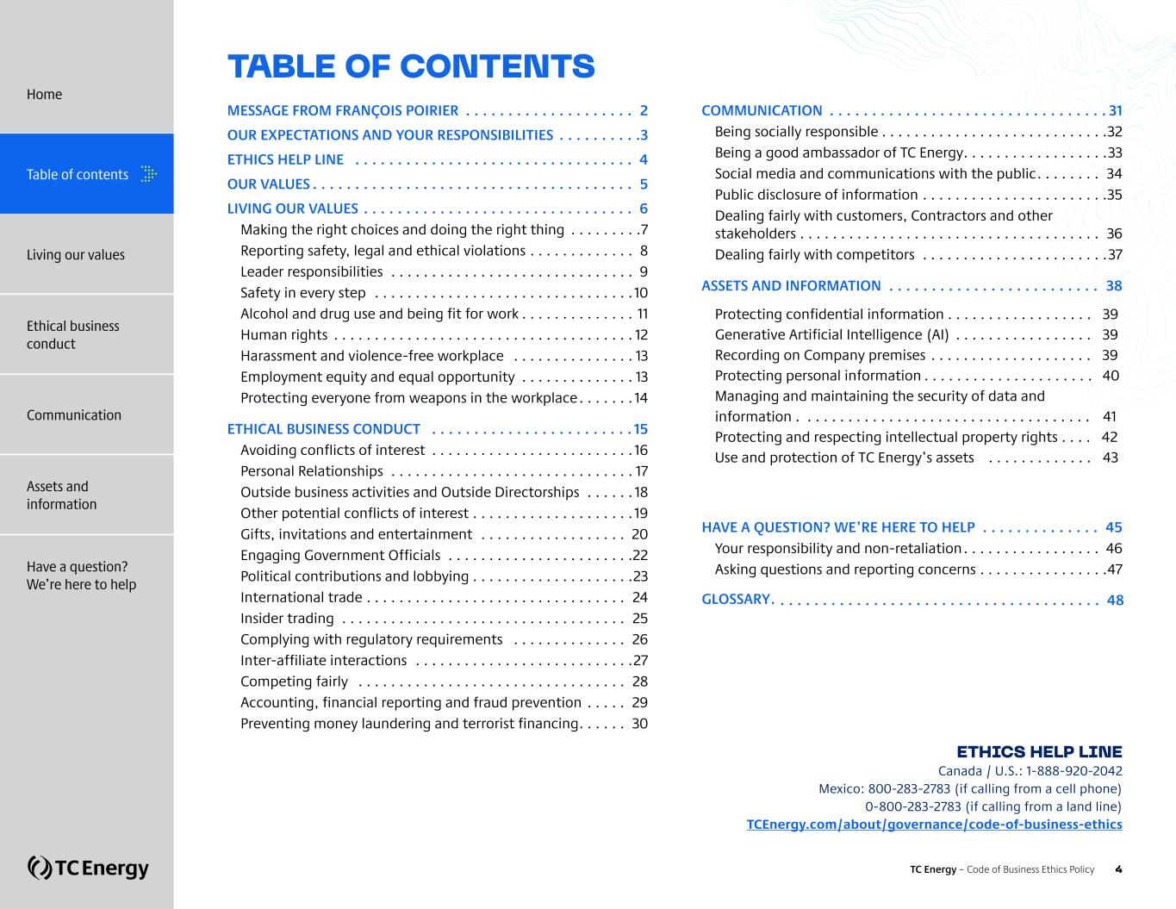
TABLE OF CONTENTS MESSAGE FROM FRANÇOIS POIRIER . . . . . . . . . . . . . . . . . . . . . 2 OUR EXPECTATIONS AND YOUR RESPONSIBILITIES . . . . . . . . . . 3 ETHICS HELP LINE . . . . . . . . . . . . . . . . . . . . . . . . . . . . . . . . . . 4 OUR VALUES. . . . . . . . . . . . . . . . . . . . . . . . . . . . . . . . . . . . . . . 5 LIVING OUR VALUES . . . . . . . . . . . . . . . . . . . . . . . . . . . . . . . . . 6 Making the right choices and doing the right thing . . . . . . . . . 7 Reporting safety, legal and ethical violations. . . . . . . . . . . . . . 8 Leader responsibilities . . . . . . . . . . . . . . . . . . . . . . . . . . . . . . . 9 Safety in every step . . . . . . . . . . . . . . . . . . . . . . . . . . . . . . . . 10 Alcohol and drug use and being fit for work. . . . . . . . . . . . . . . 11 Human rights . . . . . . . . . . . . . . . . . . . . . . . . . . . . . . . . . . . . . 12 Harassment and violence-free workplace . . . . . . . . . . . . . . . 13 Employment equity and equal opportunity . . . . . . . . . . . . . . 13 Protecting everyone from weapons in the workplace. . . . . . . 14 ETHICAL BUSINESS CONDUCT . . . . . . . . . . . . . . . . . . . . . . . . 15 Avoiding conflicts of interest . . . . . . . . . . . . . . . . . . . . . . . . . 16 Personal Relationships . . . . . . . . . . . . . . . . . . . . . . . . . . . . . . 17 Outside business activities and Outside Directorships . . . . . . 18 Other potential conflicts of interest . . . . . . . . . . . . . . . . . . . . 19 Gifts, invitations and entertainment . . . . . . . . . . . . . . . . . . . 20 Engaging Government Officials . . . . . . . . . . . . . . . . . . . . . . . 22 Political contributions and lobbying . . . . . . . . . . . . . . . . . . . . 23 International trade . . . . . . . . . . . . . . . . . . . . . . . . . . . . . . . . . 24 Insider trading . . . . . . . . . . . . . . . . . . . . . . . . . . . . . . . . . . . . 25 Complying with regulatory requirements . . . . . . . . . . . . . . . 26 Inter-affiliate interactions . . . . . . . . . . . . . . . . . . . . . . . . . . . 27 Competing fairly . . . . . . . . . . . . . . . . . . . . . . . . . . . . . . . . . . 28 Accounting, financial reporting and fraud prevention . . . . . . 29 Preventing money laundering and terrorist financing. . . . . . . 30 COMMUNICATION . . . . . . . . . . . . . . . . . . . . . . . . . . . . . . . . . 31 Being socially responsible. . . . . . . . . . . . . . . . . . . . . . . . . . . . 32 Being a good ambassador of TC Energy. . . . . . . . . . . . . . . . . . 33 Social media and communications with the public. . . . . . . . . 34 Public disclosure of information . . . . . . . . . . . . . . . . . . . . . . . 35 Dealing fairly with customers, Contractors and other stakeholders . . . . . . . . . . . . . . . . . . . . . . . . . . . . . . . . . . . . . . 36 Dealing fairly with competitors . . . . . . . . . . . . . . . . . . . . . . . 37 ASSETS AND INFORMATION . . . . . . . . . . . . . . . . . . . . . . . . . . 38 Protecting confidential information . . . . . . . . . . . . . . . . . . 39 Generative Artificial Intelligence (AI) . . . . . . . . . . . . . . . . . 39 Recording on Company premises . . . . . . . . . . . . . . . . . . . . 39 Protecting personal information . . . . . . . . . . . . . . . . . . . . . 40 Managing and maintaining the security of data and information . . . . . . . . . . . . . . . . . . . . . . . . . . . . . . . . . . . . 41 Protecting and respecting intellectual property rights . . . . 42 Use and protection of TC Energy’s assets . . . . . . . . . . . . . 43 HAVE A QUESTION? WE’RE HERE TO HELP . . . . . . . . . . . . . . . 45 Your responsibility and non-retaliation. . . . . . . . . . . . . . . . . . 46 Asking questions and reporting concerns . . . . . . . . . . . . . . . . 47 GLOSSARY . . . . . . . . . . . . . . . . . . . . . . . . . . . . . . . . . . . . . . . 48 ETHICS HELP LINE Canada / U.S.: 1-888-920-2042 Mexico: 800-283-2783 (if calling from a cell phone) 0-800-283-2783 (if calling from a land line) TCEnergy.com/about/governance/code-of-business-ethics Home Table of contents Living our values Ethical business conduct Communication Assets and information Have a question? We’re here to help TC Energy – Code of Business Ethics Policy 4

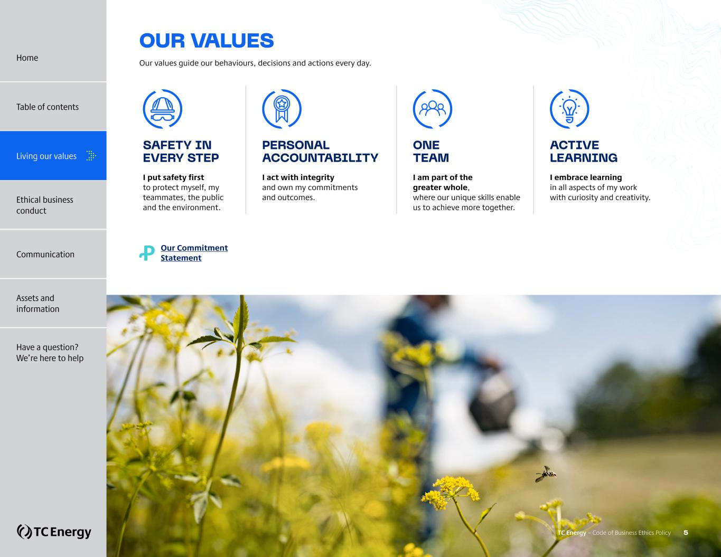
OUR VALUES Our values guide our behaviours, decisions and actions every day. SAFETY IN EVERY STEP I put safety first to protect myself, my teammates, the public and the environment. PERSONAL ACCOUNTABILITY I act with integrity and own my commitments and outcomes. ONE TEAM I am part of the greater whole, where our unique skills enable us to achieve more together. ACTIVE LEARNING I embrace learning in all aspects of my work with curiosity and creativity. Ꝓ Our Commitment Statement TC Energy – Code of Business Ethics Policy 5 Home Table of contents Living our values Ethical business conduct Communication Assets and information Have a question? We’re here to help


LIVING OUR VALUES + Making the right choices and doing the right thing + Reporting safety, legal and ethical violations + Leader responsibilities + Safety in every step + Alcohol and drug use and being fit for work + Human rights + Harassment and violence-free workplace + Employment equity and equal opportunity + Protecting everyone from weapons in the workplace TC Energy – Code of Business Ethics Policy 6 Home Table of contents Ethical business conduct Communication Assets and information Have a question? We’re here to help Living our values

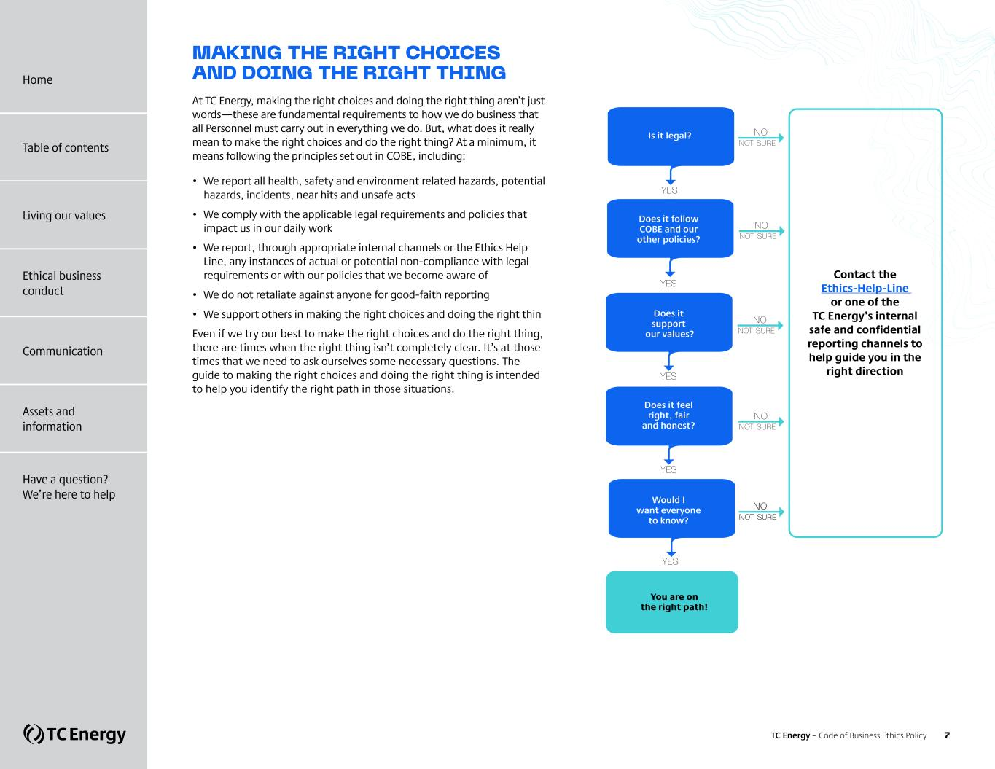
You are on the right path! YES YES Is it legal? Is it legal? YES YES YES Does it follow COBE and our other policies? Does it support our values? Does it feel right, fair and honest? Would I want everyone to know? NO NOT SURE NO NOT SURE NO NOT SURE NO NOT SURE NO NOT SURE MAKING THE RIGHT CHOICES AND DOING THE RIGHT THING At TC Energy, making the right choices and doing the right thing aren’t just words—these are fundamental requirements to how we do business that all Personnel must carry out in everything we do. But, what does it really mean to make the right choices and do the right thing? At a minimum, it means following the principles set out in COBE, including: • We report all health, safety and environment related hazards, potential hazards, incidents, near hits and unsafe acts • We comply with the applicable legal requirements and policies that impact us in our daily work • We report, through appropriate internal channels or the Ethics Help Line, any instances of actual or potential non-compliance with legal requirements or with our policies that we become aware of • We do not retaliate against anyone for good-faith reporting • We support others in making the right choices and doing the right thing Even if we try our best to make the right choices and do the right thing, there are times when the right thing isn’t completely clear. It’s at those times that we need to ask ourselves some necessary questions. The guide to making the right choices and doing the right thing is intended to help you identify the right path in those situations. Contact the Ethics-Help-Line or one of the TC Energy’s internal safe and confidential reporting channels to help guide you in the right direction TC Energy – Code of Business Ethics Policy 7 Home Living our values Ethical business conduct Communication Assets and information Have a question? We’re here to help Table of contents

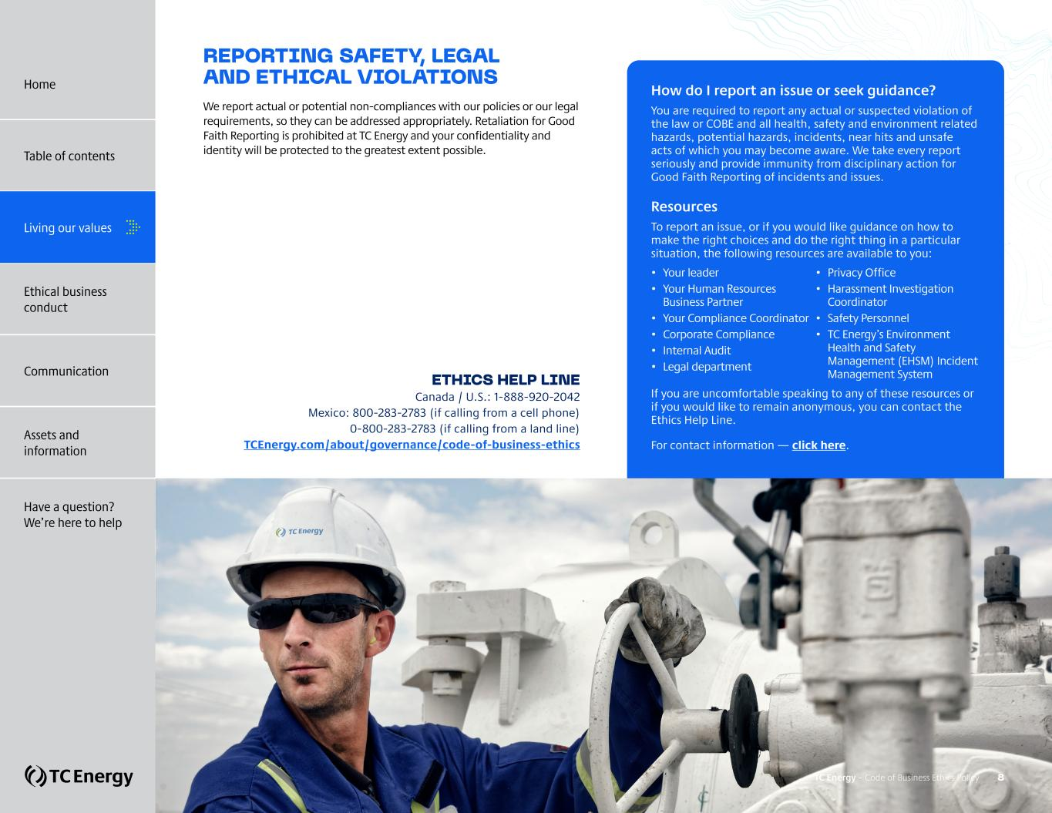
REPORTING SAFETY, LEGAL AND ETHICAL VIOLATIONS We report actual or potential non-compliances with our policies or our legal requirements, so they can be addressed appropriately. Retaliation for Good Faith Reporting is prohibited at TC Energy and your confidentiality and identity will be protected to the greatest extent possible. ETHICS HELP LINE Canada / U.S.: 1-888-920-2042 Mexico: 800-283-2783 (if calling from a cell phone) 0-800-283-2783 (if calling from a land line) TCEnergy.com/about/governance/code-of-business-ethics How do I report an issue or seek guidance? You are required to report any actual or suspected violation of the law or COBE and all health, safety and environment related hazards, potential hazards, incidents, near hits and unsafe acts of which you may become aware. We take every report seriously and provide immunity from disciplinary action for Good Faith Reporting of incidents and issues. Resources To report an issue, or if you would like guidance on how to make the right choices and do the right thing in a particular situation, the following resources are available to you: • Your leader • Your Human Resources Business Partner • Your Compliance Coordinator • Corporate Compliance • Internal Audit • Legal department • Privacy Office • Harassment Investigation Coordinator • Safety Personnel • TC Energy’s Environment Health and Safety Management (EHSM) Incident Management System If you are uncomfortable speaking to any of these resources or if you would like to remain anonymous, you can contact the Ethics Help Line. For contact information — click here. TC Energy – Code of Business Ethics Policy 8 Home Table of contents Living our values Ethical business conduct Communication Assets and information Have a question? We’re here to help

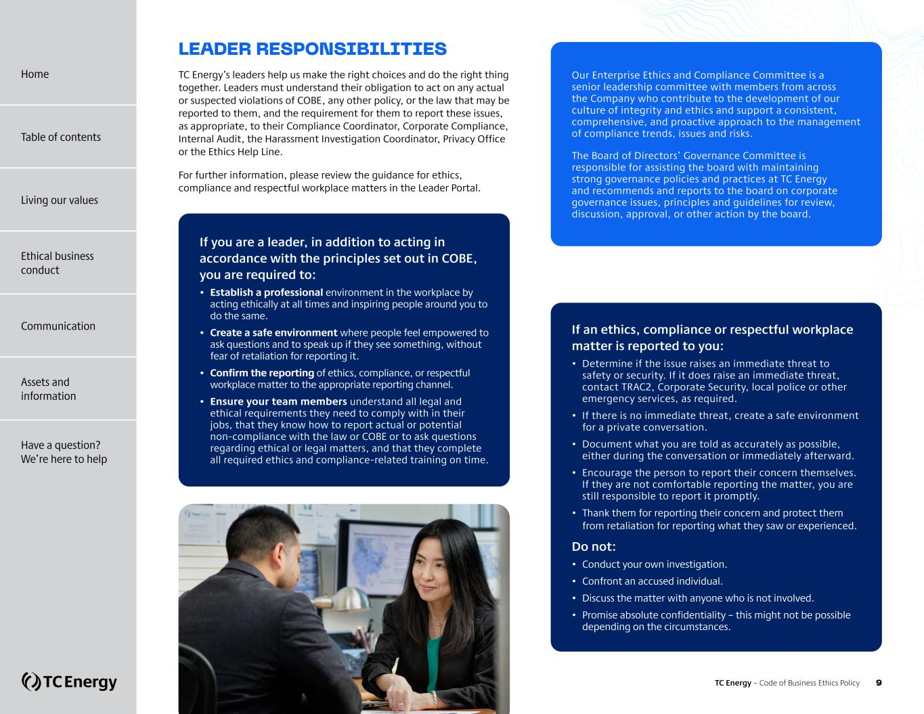
LEADER RESPONSIBILITIES TC Energy’s leaders help us make the right choices and do the right thing together. Leaders must understand their obligation to act on any actual or suspected violations of COBE, any other policy, or the law that may be reported to them, and the requirement for them to report these issues, as appropriate, to their Compliance Coordinator, Corporate Compliance, Internal Audit, the Harassment Investigation Coordinator, Privacy Office or the Ethics Help Line. For further information, please review the guidance for ethics, compliance and respectful workplace matters in the Leader Portal. Our Enterprise Ethics and Compliance Committee is a senior leadership committee with members from across the Company who contribute to the development of our culture of integrity and ethics and support a consistent, comprehensive, and proactive approach to the management of compliance trends, issues and risks. The Board of Directors’ Governance Committee is responsible for assisting the board with maintaining strong governance policies and practices at TC Energy and recommends and reports to the board on corporate governance issues, principles and guidelines for review, discussion, approval, or other action by the board. If you are a leader, in addition to acting in accordance with the principles set out in COBE, you are required to: • Establish a professional environment in the workplace by acting ethically at all times and inspiring people around you to do the same. • Create a safe environment where people feel empowered to ask questions and to speak up if they see something, without fear of retaliation for reporting it. • Confirm the reporting of ethics, compliance, or respectful workplace matter to the appropriate reporting channel. • Ensure your team members understand all legal and ethical requirements they need to comply with in their jobs, that they know how to report actual or potential non-compliance with the law or COBE or to ask questions regarding ethical or legal matters, and that they complete all required ethics and compliance-related training on time. If an ethics, compliance or respectful workplace matter is reported to you: • Determine if the issue raises an immediate threat to safety or security. If it does raise an immediate threat, contact TRAC2, Corporate Security, local police or other emergency services, as required. • If there is no immediate threat, create a safe environment for a private conversation. • Document what you are told as accurately as possible, either during the conversation or immediately afterward. • Encourage the person to report their concern themselves. If they are not comfortable reporting the matter, you are still responsible to report it promptly. • Thank them for reporting their concern and protect them from retaliation for reporting what they saw or experienced. Do not: • Conduct your own investigation. • Confront an accused individual. • Discuss the matter with anyone who is not involved. • Promise absolute confidentiality – this might not be possible depending on the circumstances. TC Energy – Code of Business Ethics Policy 9 Home Living our values Ethical business conduct Communication Assets and information Have a question? We’re here to help Table of contents

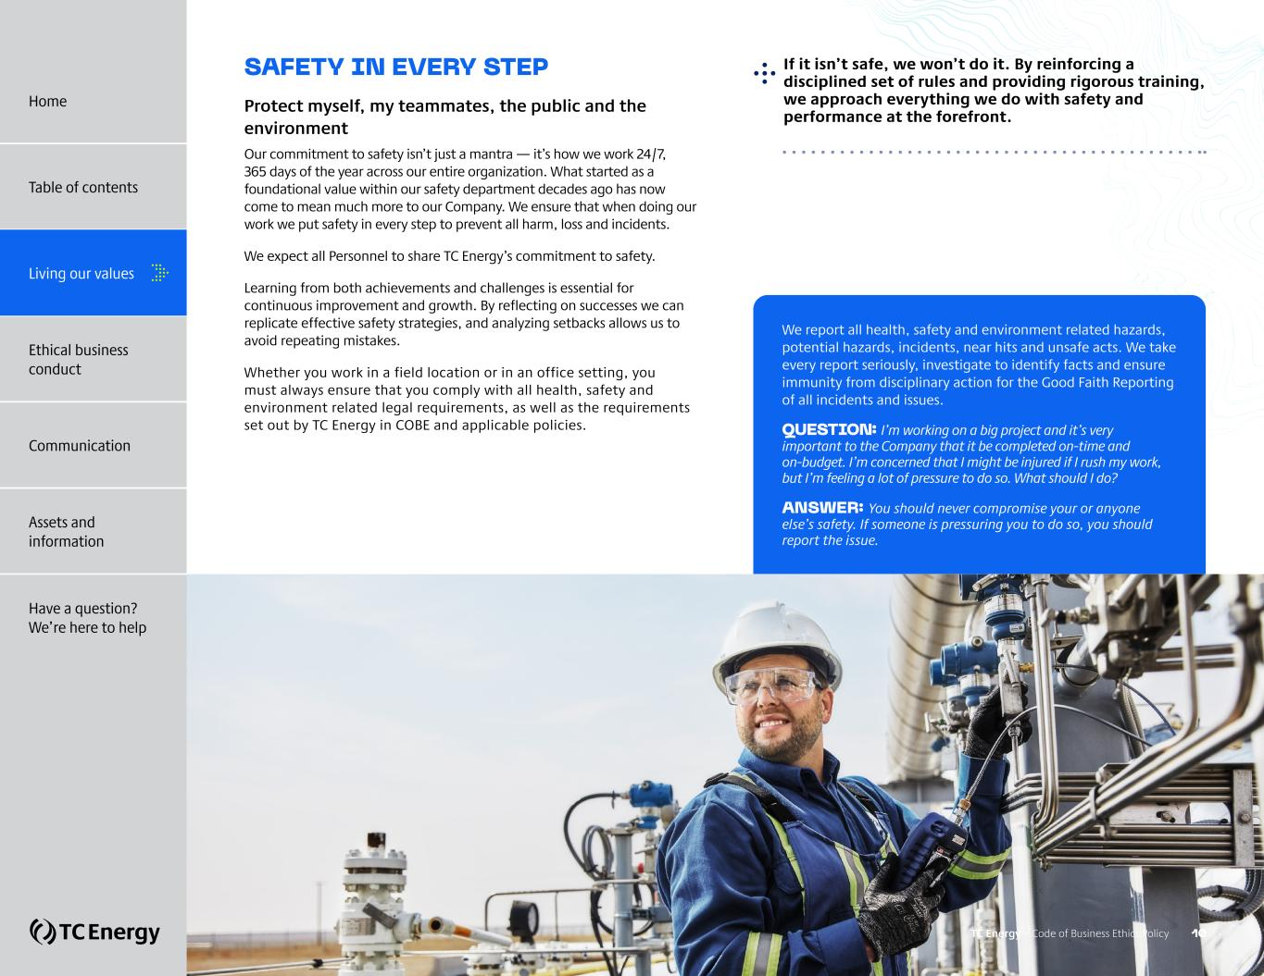
SAFETY IN EVERY STEP Protect myself, my teammates, the public and the environment Our commitment to safety isn’t just a mantra — it’s how we work 24/7, 365 days of the year across our entire organization. What started as a foundational value within our safety department decades ago has now come to mean much more to our Company. We ensure that when doing our work we put safety in every step to prevent all harm, loss and incidents. We expect all Personnel to share TC Energy’s commitment to safety. Learning from both achievements and challenges is essential for continuous improvement and growth. By reflecting on successes we can replicate effective safety strategies, and analyzing setbacks allows us to avoid repeating mistakes. Whether you work in a field location or in an office setting, you must always ensure that you comply with all health, safety and environment related legal requirements, as well as the requirements set out by TC Energy in COBE and applicable policies. ?If it isn’t safe, we won’t do it. By reinforcing a disciplined set of rules and providing rigorous training, we approach everything we do with safety and performance at the forefront. We report all health, safety and environment related hazards, potential hazards, incidents, near hits and unsafe acts. We take every report seriously, investigate to identify facts and ensure immunity from disciplinary action for the Good Faith Reporting of all incidents and issues. QUESTION: I’m working on a big project and it’s very important to the Company that it be completed on-time and on-budget. I’m concerned that I might be injured if I rush my work, but I’m feeling a lot of pressure to do so. What should I do? ANSWER: You should never compromise your or anyone else’s safety. If someone is pressuring you to do so, you should report the issue. TC Energy – Code of Business Ethics Policy 10 Home Table of contents Living our values Ethical business conduct Communication Assets and information Have a question? We’re here to help

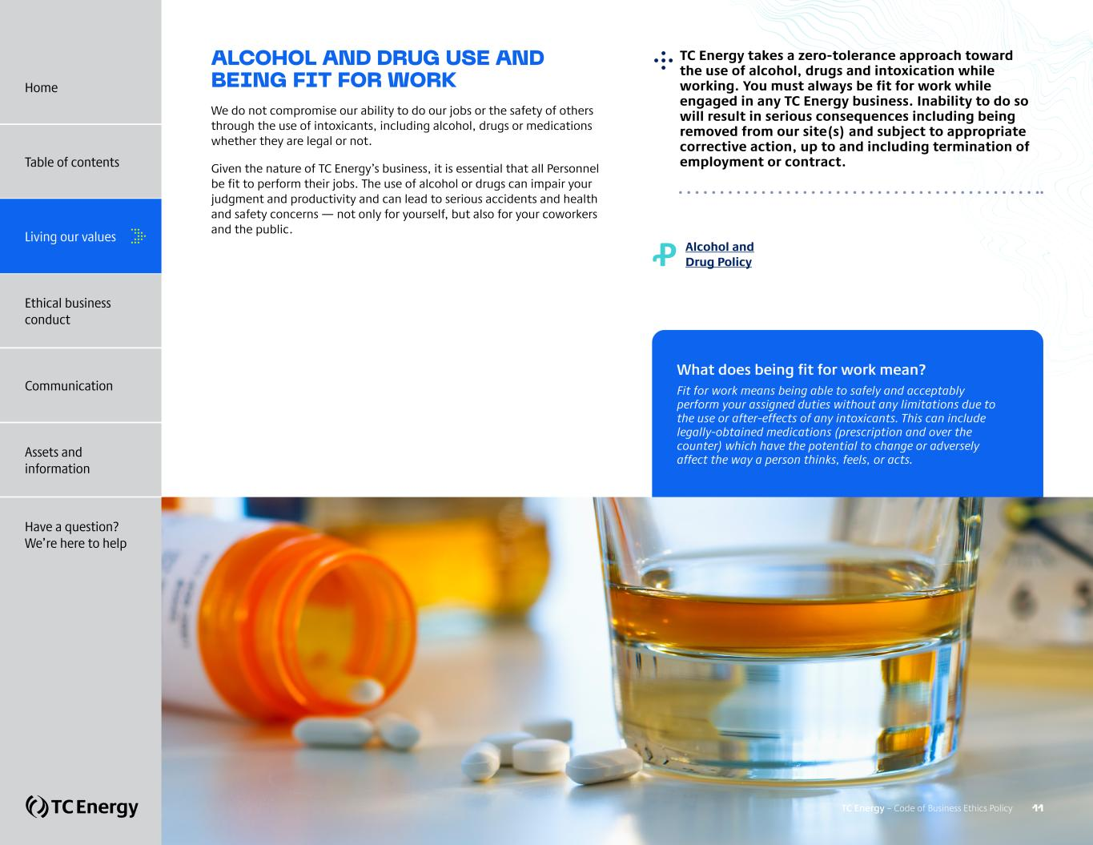
ALCOHOL AND DRUG USE AND BEING FIT FOR WORK We do not compromise our ability to do our jobs or the safety of others through the use of intoxicants, including alcohol, drugs or medications whether they are legal or not. Given the nature of TC Energy’s business, it is essential that all Personnel be fit to perform their jobs. The use of alcohol or drugs can impair your judgment and productivity and can lead to serious accidents and health and safety concerns — not only for yourself, but also for your coworkers and the public. ?TC Energy takes a zero-tolerance approach toward the use of alcohol, drugs and intoxication while working. You must always be fit for work while engaged in any TC Energy business. Inability to do so will result in serious consequences including being removed from our site(s) and subject to appropriate corrective action, up to and including termination of employment or contract. Ꝓ Alcohol and Drug Policy What does being fit for work mean? Fit for work means being able to safely and acceptably perform your assigned duties without any limitations due to the use or after-effects of any intoxicants. This can include legally-obtained medications (prescription and over the counter) which have the potential to change or adversely affect the way a person thinks, feels, or acts. TC Energy – Code of Business Ethics Policy 11 Home Table of contents Living our values Ethical business conduct Communication Assets and information Have a question? We’re here to help

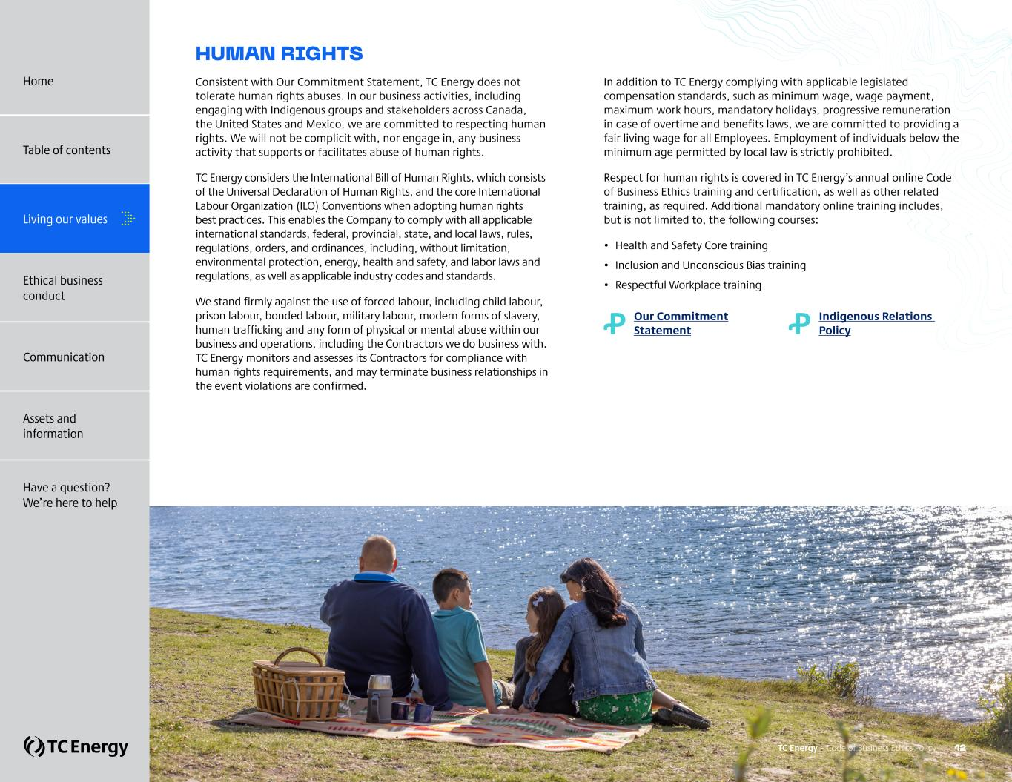
HUMAN RIGHTS Consistent with Our Commitment Statement, TC Energy does not tolerate human rights abuses. In our business activities, including engaging with Indigenous groups and stakeholders across Canada, the United States and Mexico, we are committed to respecting human rights. We will not be complicit with, nor engage in, any business activity that supports or facilitates abuse of human rights. TC Energy considers the International Bill of Human Rights, which consists of the Universal Declaration of Human Rights, and the core International Labour Organization (ILO) Conventions when adopting human rights best practices. This enables the Company to comply with all applicable international standards, federal, provincial, state, and local laws, rules, regulations, orders, and ordinances, including, without limitation, environmental protection, energy, health and safety, and labor laws and regulations, as well as applicable industry codes and standards. We stand firmly against the use of forced labour, including child labour, prison labour, bonded labour, military labour, modern forms of slavery, human trafficking and any form of physical or mental abuse within our business and operations, including the Contractors we do business with. TC Energy monitors and assesses its Contractors for compliance with human rights requirements, and may terminate business relationships in the event violations are confirmed. In addition to TC Energy complying with applicable legislated compensation standards, such as minimum wage, wage payment, maximum work hours, mandatory holidays, progressive remuneration in case of overtime and benefits laws, we are committed to providing a fair living wage for all Employees. Employment of individuals below the minimum age permitted by local law is strictly prohibited. Respect for human rights is covered in TC Energy’s annual online Code of Business Ethics training and certification, as well as other related training, as required. Additional mandatory online training includes, but is not limited to, the following courses: • Health and Safety Core training • Inclusion and Unconscious Bias training • Respectful Workplace training Ꝓ Our Commitment Statement Ꝓ Indigenous Relations Policy TC Energy – Code of Business Ethics Policy 12 Home Table of contents Living our values Ethical business conduct Communication Assets and information Have a question? We’re here to help

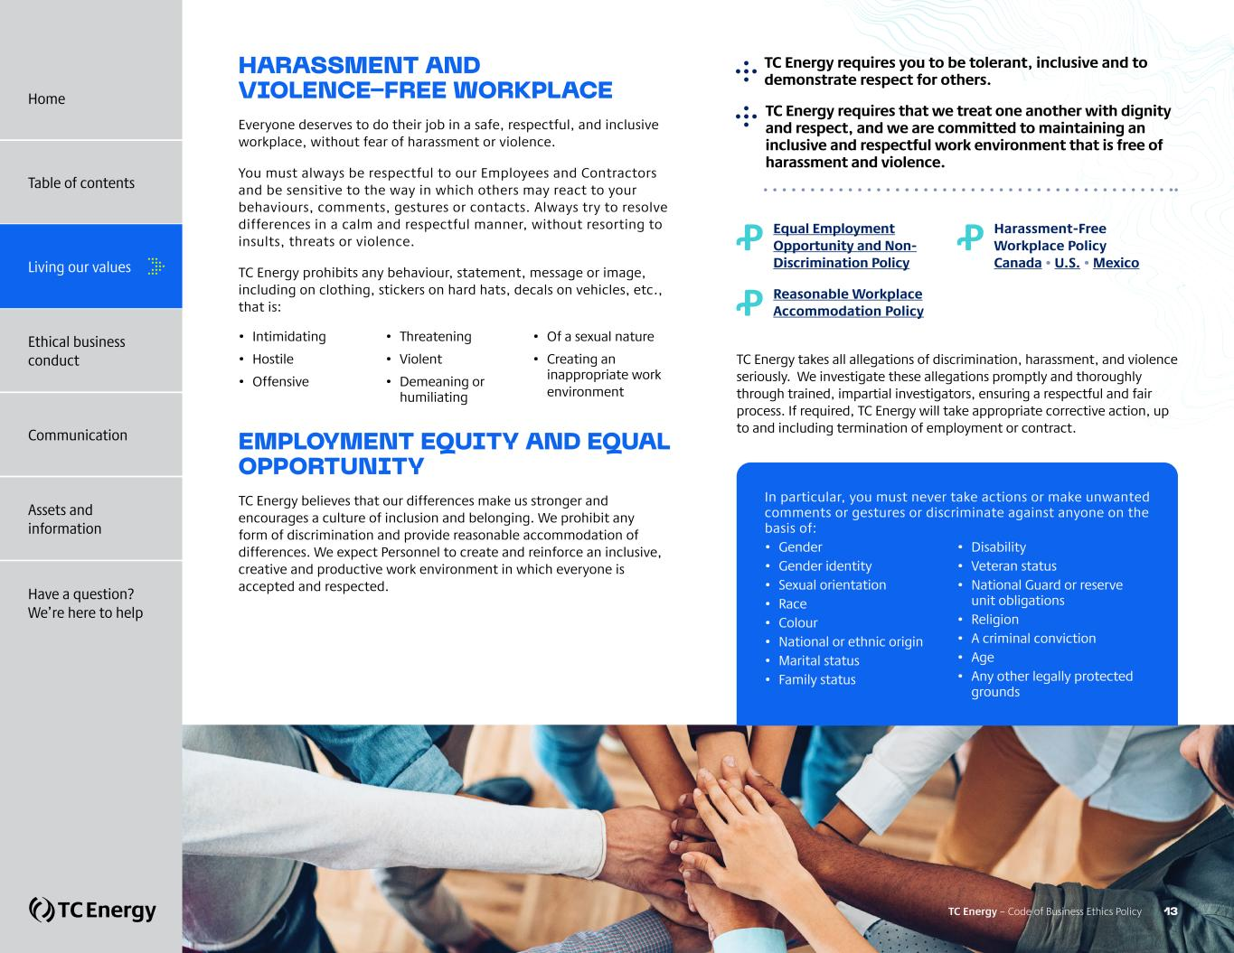
Ꝓ ?Equal Employment Opportunity and Non- Discrimination Policy Ꝓ ?Reasonable Workplace Accommodation Policy Ꝓ ?Harassment-Free Workplace Policy Canada • U.S. • Mexico TC Energy takes all allegations of discrimination, harassment, and violence seriously. We investigate these allegations promptly and thoroughly through trained, impartial investigators, ensuring a respectful and fair process. If required, TC Energy will take appropriate corrective action, up to and including termination of employment or contract. ?TC Energy requires you to be tolerant, inclusive and to demonstrate respect for others. ?TC Energy requires that we treat one another with dignity and respect, and we are committed to maintaining an inclusive and respectful work environment that is free of harassment and violence. HARASSMENT AND VIOLENCE-FREE WORKPLACE Everyone deserves to do their job in a safe, respectful, and inclusive workplace, without fear of harassment or violence. You must always be respectful to our Employees and Contractors and be sensitive to the way in which others may react to your behaviours, comments, gestures or contacts. Always try to resolve differences in a calm and respectful manner, without resorting to insults, threats or violence. TC Energy prohibits any behaviour, statement, message or image, including on clothing, stickers on hard hats, decals on vehicles, etc., that is: • Intimidating • Hostile • Offensive • Threatening • Violent • Demeaning or humiliating • Of a sexual nature • Creating an inappropriate work environment EMPLOYMENT EQUITY AND EQUAL OPPORTUNITY TC Energy believes that our differences make us stronger and encourages a culture of inclusion and belonging. We prohibit any form of discrimination and provide reasonable accommodation of differences. We expect Personnel to create and reinforce an inclusive, creative and productive work environment in which everyone is accepted and respected. In particular, you must never take actions or make unwanted comments or gestures or discriminate against anyone on the basis of: • Gender • Gender identity • Sexual orientation • Race • Colour • National or ethnic origin • Marital status • Family status • Disability • Veteran status • National Guard or reserve unit obligations • Religion • A criminal conviction • Age • Any other legally protected grounds TC Energy – Code of Business Ethics Policy 13 Home Table of contents Living our values Ethical business conduct Communication Assets and information Have a question? We’re here to help

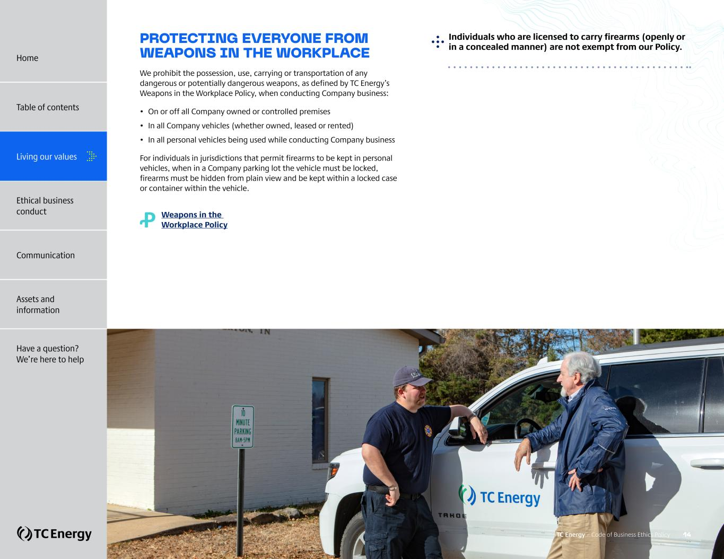
PROTECTING EVERYONE FROM WEAPONS IN THE WORKPLACE We prohibit the possession, use, carrying or transportation of any dangerous or potentially dangerous weapons, as defined by TC Energy’s Weapons in the Workplace Policy, when conducting Company business: • On or off all Company owned or controlled premises • In all Company vehicles (whether owned, leased or rented) • In all personal vehicles being used while conducting Company business For individuals in jurisdictions that permit firearms to be kept in personal vehicles, when in a Company parking lot the vehicle must be locked, firearms must be hidden from plain view and be kept within a locked case or container within the vehicle. Ꝓ Weapons in the Workplace Policy ?Individuals who are licensed to carry firearms (openly or in a concealed manner) are not exempt from our Policy. TC Energy – Code of Business Ethics Policy 14 Home Table of contents Living our values Ethical business conduct Communication Assets and information Have a question? We’re here to help


ETHICAL BUSINESS CONDUCT + Avoiding conflicts of interest + Personal Relationships + Outside business activities and Outside Directorships + Other potential conflicts of interest + Gifts, invitations and entertainment + Engaging Government Officials + Political contributions and lobbying + International trade + Insider trading + Complying with regulatory requirements + Inter-affiliate interactions + Competing fairly + Accounting, financial reporting and fraud prevention + Preventing money laundering and terrorist financing TC Energy – Code of Business Ethics Policy 15 Home Table of contents Living our values Communication Assets and information Have a question? We’re here to help Ethical business conduct

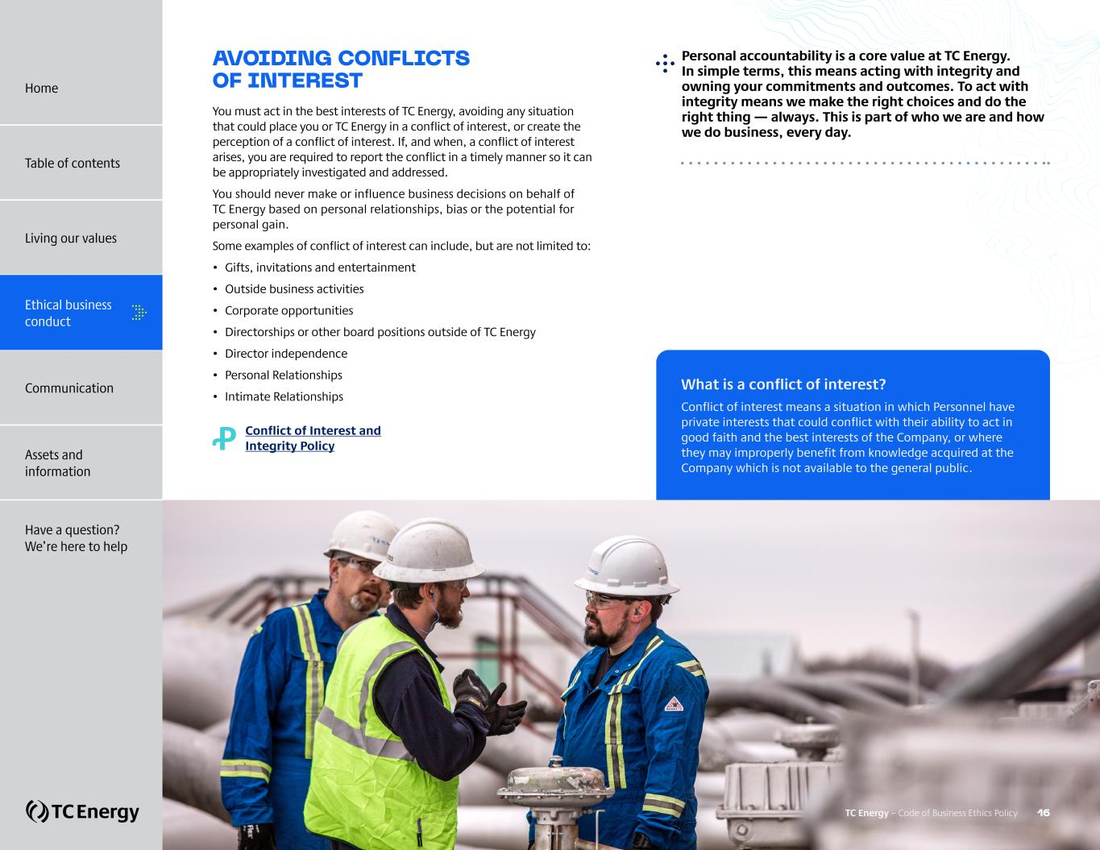
AVOIDING CONFLICTS OF INTEREST You must act in the best interests of TC Energy, avoiding any situation that could place you or TC Energy in a conflict of interest, or create the perception of a conflict of interest. If, and when, a conflict of interest arises, you are required to report the conflict in a timely manner so it can be appropriately investigated and addressed. You should never make or influence business decisions on behalf of TC Energy based on personal relationships, bias or the potential for personal gain. Some examples of conflict of interest can include, but are not limited to: • Gifts, invitations and entertainment • Outside business activities • Corporate opportunities • Directorships or other board positions outside of TC Energy • Director independence • Personal Relationships • Intimate Relationships Ꝓ Conflict of Interest and Integrity Policy ?Personal accountability is a core value at TC Energy. In simple terms, this means acting with integrity and owning your commitments and outcomes. To act with integrity means we make the right choices and do the right thing — always. This is part of who we are and how we do business, every day. What is a conflict of interest? Conflict of interest means a situation in which Personnel have private interests that could conflict with their ability to act in good faith and the best interests of the Company, or where they may improperly benefit from knowledge acquired at the Company which is not available to the general public. TC Energy – Code of Business Ethics Policy 16 Home Table of contents Living our values Ethical business conduct Communication Assets and information Have a question? We’re here to help


PERSONAL RELATIONSHIPS Personnel who have a Personal Relationship within the Company must not be in a direct or indirect (through others) reporting relationship with each other. In particular, the Company prohibits all Intimate Relationships between individuals in a direct or indirect reporting relationship. If Personnel are not certain whether a Personal Relationship within the Company is permissible, they should immediately discuss their situation with their TC Energy leader HR Business Partners, or HR Governance. Failure to disclose a relationship that could place individuals in a conflict of interest or create the perception of a conflict of interest could be a breach of Company policy. QUESTION: I want to hire someone who I know has a family member already working for TC Energy. Is that allowed? ANSWER: Yes, it is acceptable to hire someone (Employee or CWC) who has family members already working for TC Energy provided that doing so does not result in the person directly or indirectly (through other leader(s)) reporting to their family member. The onus is on all Personnel to notify HR Governance when they become aware of a Personal Relationship where there is a direct or indirect reporting relationship within the Company. TC Energy – Code of Business Ethics Policy 17 Home Table of contents Living our values Ethical business conduct Communication Assets and information Have a question? We’re here to help

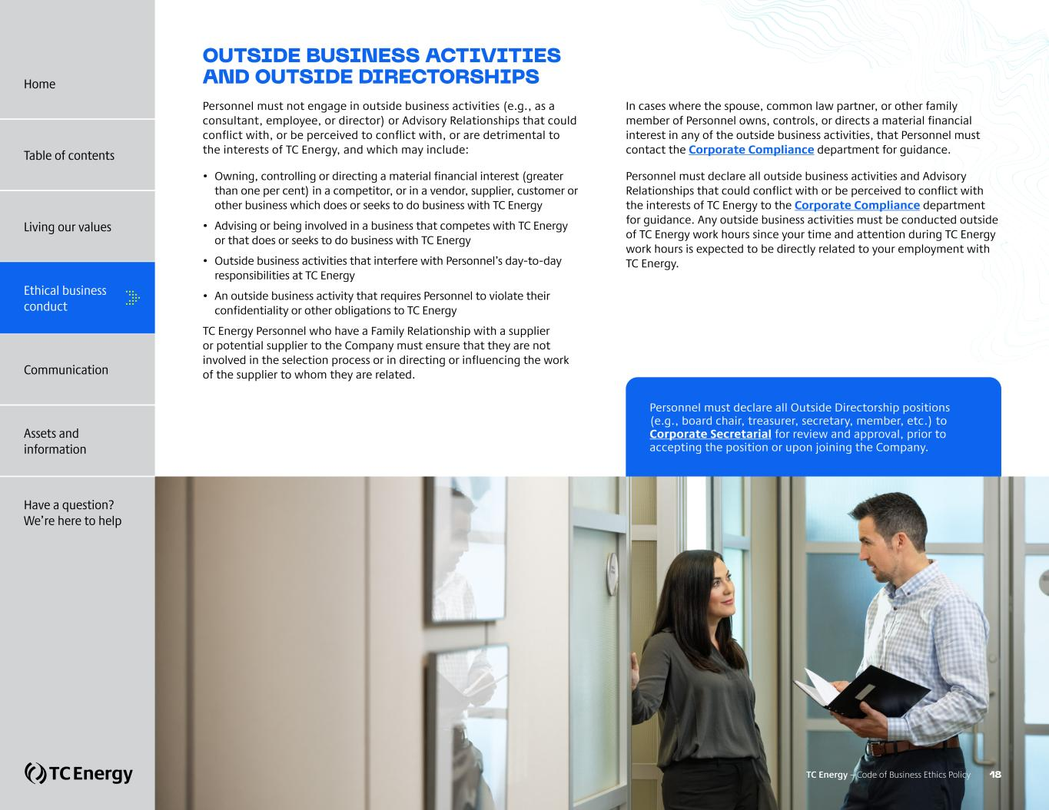
OUTSIDE BUSINESS ACTIVITIES AND OUTSIDE DIRECTORSHIPS Personnel must not engage in outside business activities (e.g., as a consultant, employee, or director) or Advisory Relationships that could conflict with, or be perceived to conflict with, or are detrimental to the interests of TC Energy, and which may include: • Owning, controlling or directing a material financial interest (greater than one per cent) in a competitor, or in a vendor, supplier, customer or other business which does or seeks to do business with TC Energy • Advising or being involved in a business that competes with TC Energy or that does or seeks to do business with TC Energy • Outside business activities that interfere with Personnel’s day-to-day responsibilities at TC Energy • An outside business activity that requires Personnel to violate their confidentiality or other obligations to TC Energy TC Energy Personnel who have a Family Relationship with a supplier or potential supplier to the Company must ensure that they are not involved in the selection process or in directing or influencing the work of the supplier to whom they are related. In cases where the spouse, common law partner, or other family member of Personnel owns, controls, or directs a material financial interest in any of the outside business activities, that Personnel must contact the Corporate Compliance department for guidance. Personnel must declare all outside business activities and Advisory Relationships that could conflict with or be perceived to conflict with the interests of TC Energy to the Corporate Compliance department for guidance. Any outside business activities must be conducted outside of TC Energy work hours since your time and attention during TC Energy work hours is expected to be directly related to your employment with TC Energy. Personnel must declare all Outside Directorship positions (e.g., board chair, treasurer, secretary, member, etc.) to Corporate Secretarial for review and approval, prior to accepting the position or upon joining the Company. TC Energy – Code of Business Ethics Policy 18 Home Table of contents Living our values Ethical business conduct Communication Assets and information Have a question? We’re here to help

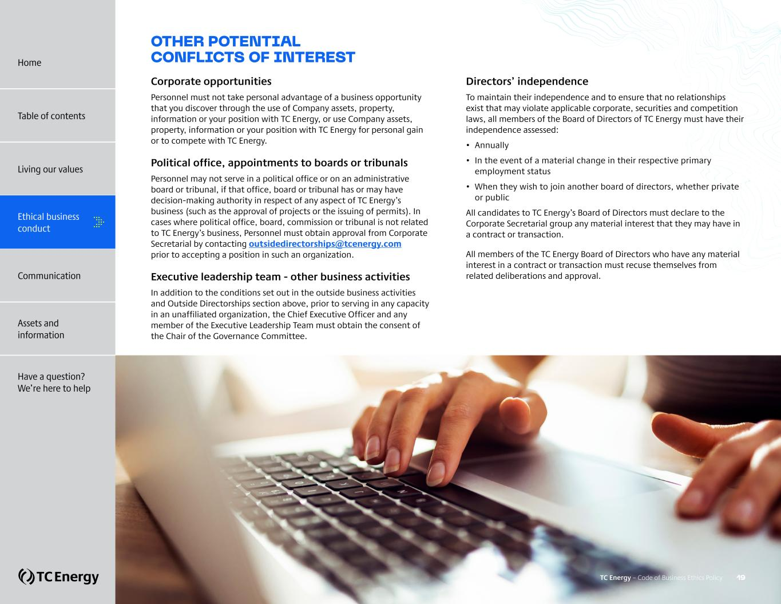
OTHER POTENTIAL CONFLICTS OF INTEREST Corporate opportunities Personnel must not take personal advantage of a business opportunity that you discover through the use of Company assets, property, information or your position with TC Energy, or use Company assets, property, information or your position with TC Energy for personal gain or to compete with TC Energy. Political office, appointments to boards or tribunals Personnel may not serve in a political office or on an administrative board or tribunal, if that office, board or tribunal has or may have decision-making authority in respect of any aspect of TC Energy’s business (such as the approval of projects or the issuing of permits). In cases where political office, board, commission or tribunal is not related to TC Energy’s business, Personnel must obtain approval from Corporate Secretarial by contacting outsidedirectorships@tcenergy.com prior to accepting a position in such an organization. Executive leadership team - other business activities In addition to the conditions set out in the outside business activities and Outside Directorships section above, prior to serving in any capacity in an unaffiliated organization, the Chief Executive Officer and any member of the Executive Leadership Team must obtain the consent of the Chair of the Governance Committee. Directors’ independence To maintain their independence and to ensure that no relationships exist that may violate applicable corporate, securities and competition laws, all members of the Board of Directors of TC Energy must have their independence assessed: • Annually • In the event of a material change in their respective primary employment status • When they wish to join another board of directors, whether private or public All candidates to TC Energy’s Board of Directors must declare to the Corporate Secretarial group any material interest that they may have in a contract or transaction. All members of the TC Energy Board of Directors who have any material interest in a contract or transaction must recuse themselves from related deliberations and approval. TC Energy – Code of Business Ethics Policy 19 Home Table of contents Living our values Ethical business conduct Communication Assets and information Have a question? We’re here to help

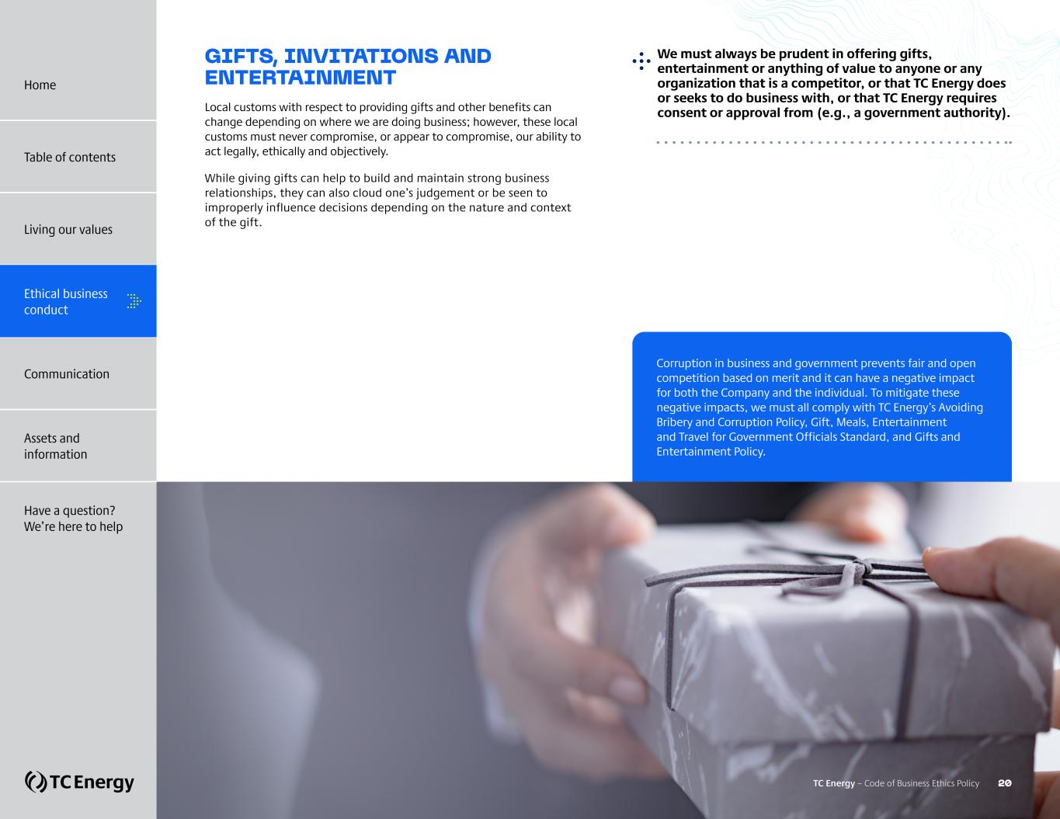
GIFTS, INVITATIONS AND ENTERTAINMENT Local customs with respect to providing gifts and other benefits can change depending on where we are doing business; however, these local customs must never compromise, or appear to compromise, our ability to act legally, ethically and objectively. While giving gifts can help to build and maintain strong business relationships, they can also cloud one’s judgement or be seen to improperly influence decisions depending on the nature and context of the gift. ?We must always be prudent in offering gifts, entertainment or anything of value to anyone or any organization that is a competitor, or that TC Energy does or seeks to do business with, or that TC Energy requires consent or approval from (e.g., a government authority). Corruption in business and government prevents fair and open competition based on merit and it can have a negative impact for both the Company and the individual. To mitigate these negative impacts, we must all comply with TC Energy’s Avoiding Bribery and Corruption Policy, Gift, Meals, Entertainment and Travel for Government Officials Standard, and Gifts and Entertainment Policy. TC Energy – Code of Business Ethics Policy 20 Home Table of contents Living our values Ethical business conduct Communication Assets and information Have a question? We’re here to help

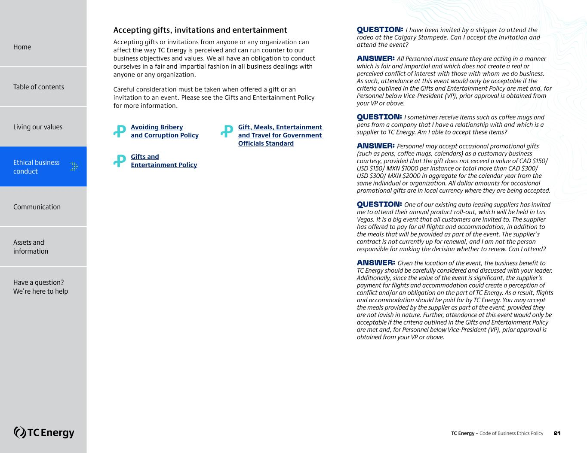
Accepting gifts, invitations and entertainment Accepting gifts or invitations from anyone or any organization can affect the way TC Energy is perceived and can run counter to our business objectives and values. We all have an obligation to conduct ourselves in a fair and impartial fashion in all business dealings with anyone or any organization. Careful consideration must be taken when offered a gift or an invitation to an event. Please see the Gifts and Entertainment Policy for more information. Ꝓ Avoiding Bribery and Corruption Policy Ꝓ Gifts and Entertainment Policy Ꝓ ?Gift, Meals, Entertainment and Travel for Government Officials Standard QUESTION: I have been invited by a shipper to attend the rodeo at the Calgary Stampede. Can I accept the invitation and attend the event? ANSWER: All Personnel must ensure they are acting in a manner which is fair and impartial and which does not create a real or perceived conflict of interest with those with whom we do business. As such, attendance at this event would only be acceptable if the criteria outlined in the Gifts and Entertainment Policy are met and, for Personnel below Vice-President (VP), prior approval is obtained from your VP or above. QUESTION: I sometimes receive items such as coffee mugs and pens from a company that I have a relationship with and which is a supplier to TC Energy. Am I able to accept these items? ANSWER: Personnel may accept occasional promotional gifts (such as pens, coffee mugs, calendars) as a customary business courtesy, provided that the gift does not exceed a value of CAD $150/ USD $150/ MXN $1000 per instance or total more than CAD $300/ USD $300/ MXN $2000 in aggregate for the calendar year from the same individual or organization. All dollar amounts for occasional promotional gifts are in local currency where they are being accepted. QUESTION: One of our existing auto leasing suppliers has invited me to attend their annual product roll-out, which will be held in Las Vegas. It is a big event that all customers are invited to. The supplier has offered to pay for all flights and accommodation, in addition to the meals that will be provided as part of the event. The supplier’s contract is not currently up for renewal, and I am not the person responsible for making the decision whether to renew. Can I attend? ANSWER: Given the location of the event, the business benefit to TC Energy should be carefully considered and discussed with your leader. Additionally, since the value of the event is significant, the supplier’s payment for flights and accommodation could create a perception of conflict and/or an obligation on the part of TC Energy. As a result, flights and accommodation should be paid for by TC Energy. You may accept the meals provided by the supplier as part of the event, provided they are not lavish in nature. Further, attendance at this event would only be acceptable if the criteria outlined in the Gifts and Entertainment Policy are met and, for Personnel below Vice-President (VP), prior approval is obtained from your VP or above. Home Table of contents Living our values Ethical business conduct Communication Assets and information Have a question? We’re here to help TC Energy – Code of Business Ethics Policy 21

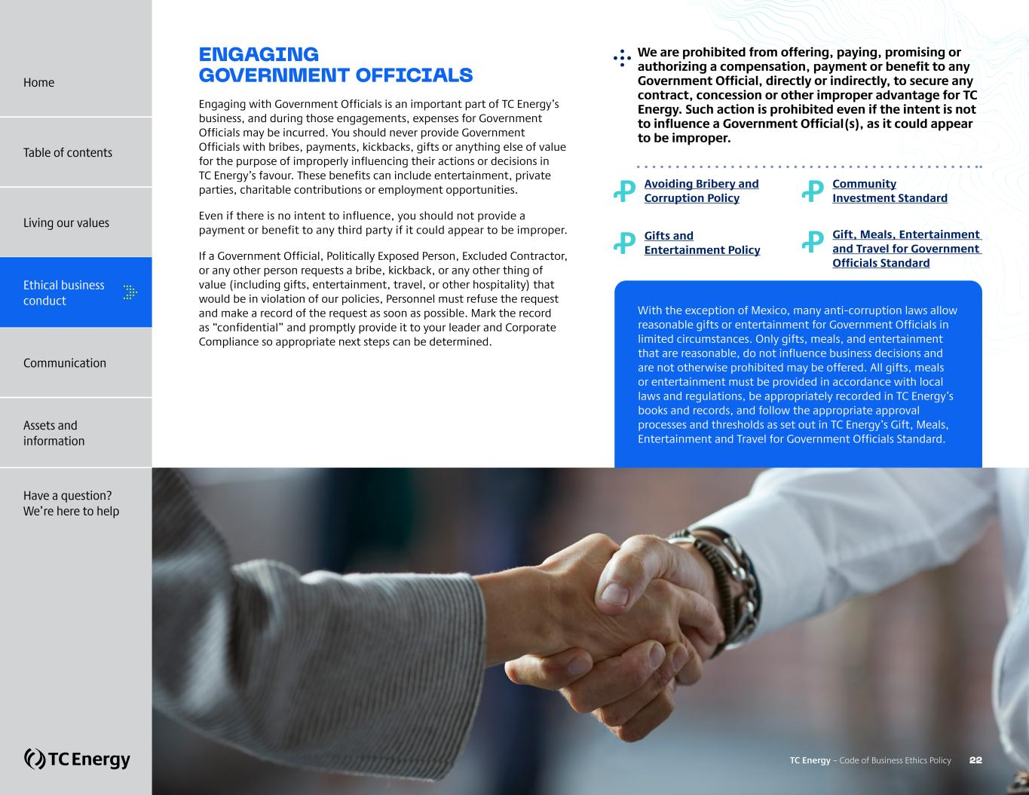
ENGAGING GOVERNMENT OFFICIALS Engaging with Government Officials is an important part of TC Energy’s business, and during those engagements, expenses for Government Officials may be incurred. You should never provide Government Officials with bribes, payments, kickbacks, gifts or anything else of value for the purpose of improperly influencing their actions or decisions in TC Energy’s favour. These benefits can include entertainment, private parties, charitable contributions or employment opportunities. Even if there is no intent to influence, you should not provide a payment or benefit to any third party if it could appear to be improper. If a Government Official, Politically Exposed Person, Excluded Contractor, or any other person requests a bribe, kickback, or any other thing of value (including gifts, entertainment, travel, or other hospitality) that would be in violation of our policies, Personnel must refuse the request and make a record of the request as soon as possible. Mark the record as “confidential” and promptly provide it to your leader and Corporate Compliance so appropriate next steps can be determined. ?We are prohibited from offering, paying, promising or authorizing a compensation, payment or benefit to any Government Official, directly or indirectly, to secure any contract, concession or other improper advantage for TC Energy. Such action is prohibited even if the intent is not to influence a Government Official(s), as it could appear to be improper. Ꝓ Avoiding Bribery and Corruption Policy Ꝓ Gifts and Entertainment Policy Ꝓ Community Investment Standard Ꝓ ?Gift, Meals, Entertainment and Travel for Government Officials Standard With the exception of Mexico, many anti-corruption laws allow reasonable gifts or entertainment for Government Officials in limited circumstances. Only gifts, meals, and entertainment that are reasonable, do not influence business decisions and are not otherwise prohibited may be offered. All gifts, meals or entertainment must be provided in accordance with local laws and regulations, be appropriately recorded in TC Energy’s books and records, and follow the appropriate approval processes and thresholds as set out in TC Energy’s Gift, Meals, Entertainment and Travel for Government Officials Standard. TC Energy – Code of Business Ethics Policy 22 Home Table of contents Living our values Ethical business conduct Communication Assets and information Have a question? We’re here to help

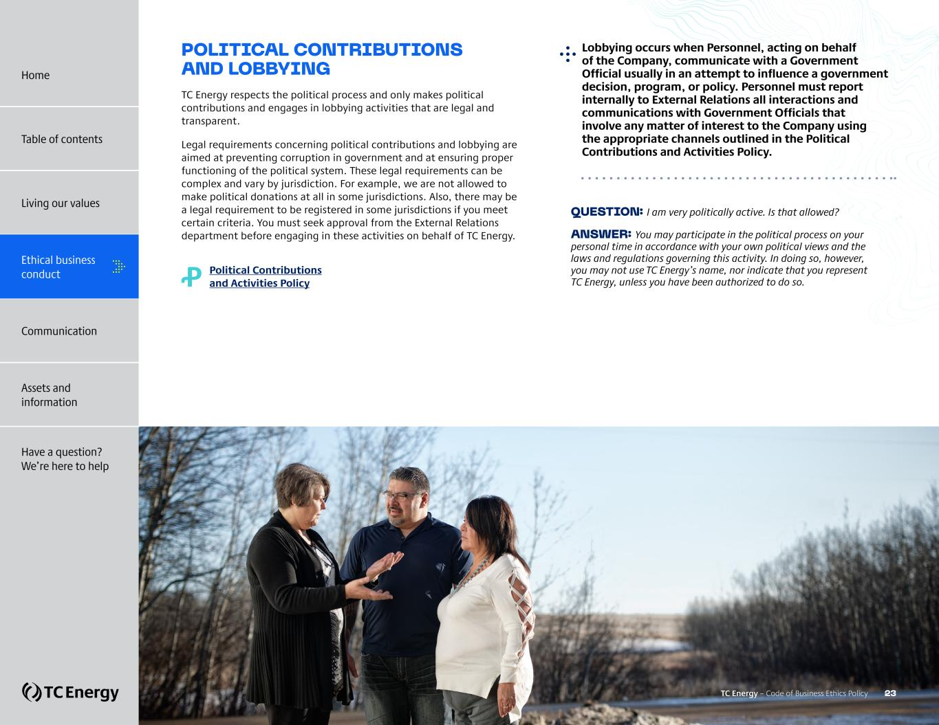
POLITICAL CONTRIBUTIONS AND LOBBYING TC Energy respects the political process and only makes political contributions and engages in lobbying activities that are legal and transparent. Legal requirements concerning political contributions and lobbying are aimed at preventing corruption in government and at ensuring proper functioning of the political system. These legal requirements can be complex and vary by jurisdiction. For example, we are not allowed to make political donations at all in some jurisdictions. Also, there may be a legal requirement to be registered in some jurisdictions if you meet certain criteria. You must seek approval from the External Relations department before engaging in these activities on behalf of TC Energy. Ꝓ Political Contributions and Activities Policy QUESTION: I am very politically active. Is that allowed? ANSWER: You may participate in the political process on your personal time in accordance with your own political views and the laws and regulations governing this activity. In doing so, however, you may not use TC Energy’s name, nor indicate that you represent TC Energy, unless you have been authorized to do so. ?Lobbying occurs when Personnel, acting on behalf of the Company, communicate with a Government Official usually in an attempt to influence a government decision, program, or policy. Personnel must report internally to External Relations all interactions and communications with Government Officials that involve any matter of interest to the Company using the appropriate channels outlined in the Political Contributions and Activities Policy. TC Energy – Code of Business Ethics Policy 23 Home Table of contents Living our values Ethical business conduct Communication Assets and information Have a question? We’re here to help

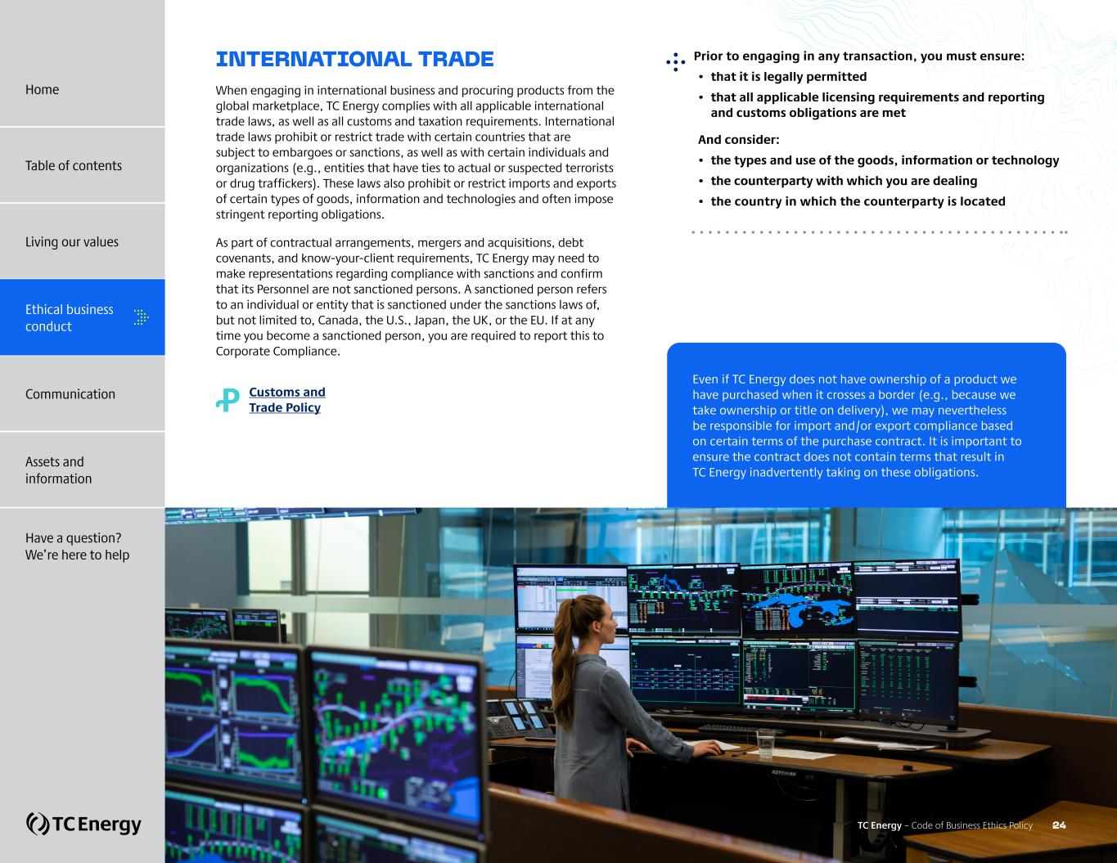
INTERNATIONAL TRADE When engaging in international business and procuring products from the global marketplace, TC Energy complies with all applicable international trade laws, as well as all customs and taxation requirements. International trade laws prohibit or restrict trade with certain countries that are subject to embargoes or sanctions, as well as with certain individuals and organizations (e.g., entities that have ties to actual or suspected terrorists or drug traffickers). These laws also prohibit or restrict imports and exports of certain types of goods, information and technologies and often impose stringent reporting obligations. As part of contractual arrangements, mergers and acquisitions, debt covenants, and know-your-client requirements, TC Energy may need to make representations regarding compliance with sanctions and confirm that its Personnel are not sanctioned persons. A sanctioned person refers to an individual or entity that is sanctioned under the sanctions laws of, but not limited to, Canada, the U.S., Japan, the UK, or the EU. If at any time you become a sanctioned person, you are required to report this to Corporate Compliance. Ꝓ Customs and Trade Policy Prior to engaging in any transaction, you must ensure: • that it is legally permitted • that all applicable licensing requirements and reporting and customs obligations are met And consider: • the types and use of the goods, information or technology • the counterparty with which you are dealing • the country in which the counterparty is located Even if TC Energy does not have ownership of a product we have purchased when it crosses a border (e.g., because we take ownership or title on delivery), we may nevertheless be responsible for import and/or export compliance based on certain terms of the purchase contract. It is important to ensure the contract does not contain terms that result in TC Energy inadvertently taking on these obligations. TC Energy – Code of Business Ethics Policy 24 Home Table of contents Living our values Ethical business conduct Communication Assets and information Have a question? We’re here to help

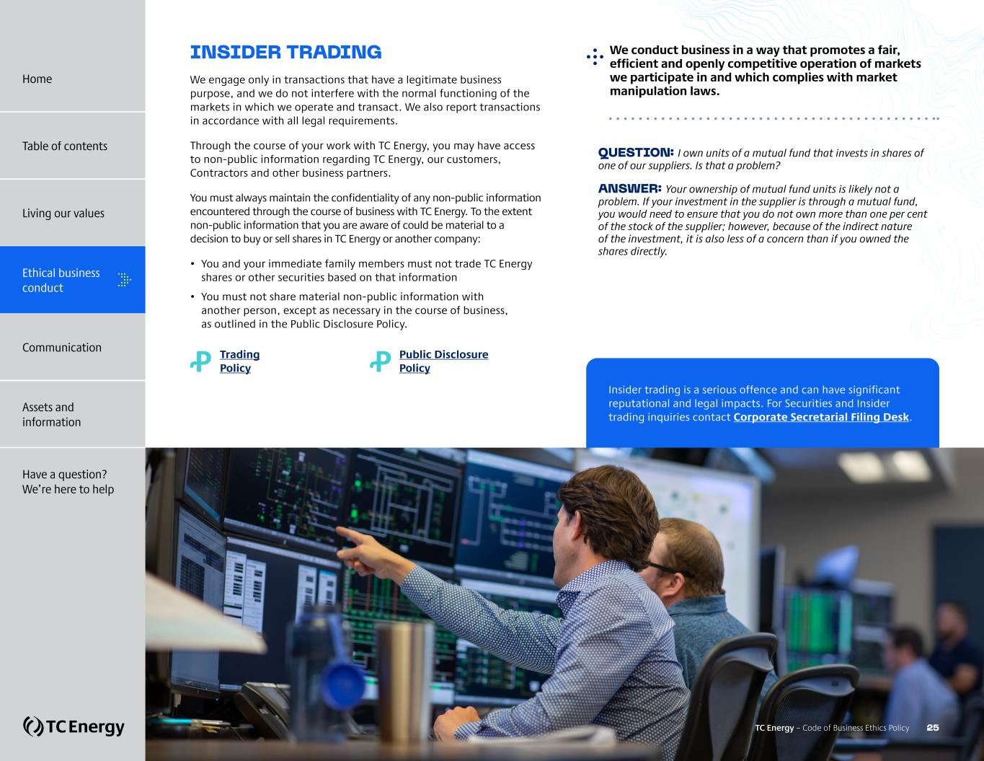
INSIDER TRADING We engage only in transactions that have a legitimate business purpose, and we do not interfere with the normal functioning of the markets in which we operate and transact. We also report transactions in accordance with all legal requirements. Through the course of your work with TC Energy, you may have access to non-public information regarding TC Energy, our customers, Contractors and other business partners. You must always maintain the confidentiality of any non-public information encountered through the course of business with TC Energy. To the extent non-public information that you are aware of could be material to a decision to buy or sell shares in TC Energy or another company: • You and your immediate family members must not trade TC Energy shares or other securities based on that information • You must not share material non-public information with another person, except as necessary in the course of business, as outlined in the Public Disclosure Policy. Ꝓ Trading Policy Ꝓ Public Disclosure Policy QUESTION: I own units of a mutual fund that invests in shares of one of our suppliers. Is that a problem? ANSWER: Your ownership of mutual fund units is likely not a problem. If your investment in the supplier is through a mutual fund, you would need to ensure that you do not own more than one per cent of the stock of the supplier; however, because of the indirect nature of the investment, it is also less of a concern than if you owned the shares directly. ?We conduct business in a way that promotes a fair, efficient and openly competitive operation of markets we participate in and which complies with market manipulation laws. Insider trading is a serious offence and can have significant reputational and legal impacts. For Securities and Insider trading inquiries contact Corporate Secretarial Filing Desk. TC Energy – Code of Business Ethics Policy 25 Home Table of contents Living our values Ethical business conduct Communication Assets and information Have a question? We’re here to help

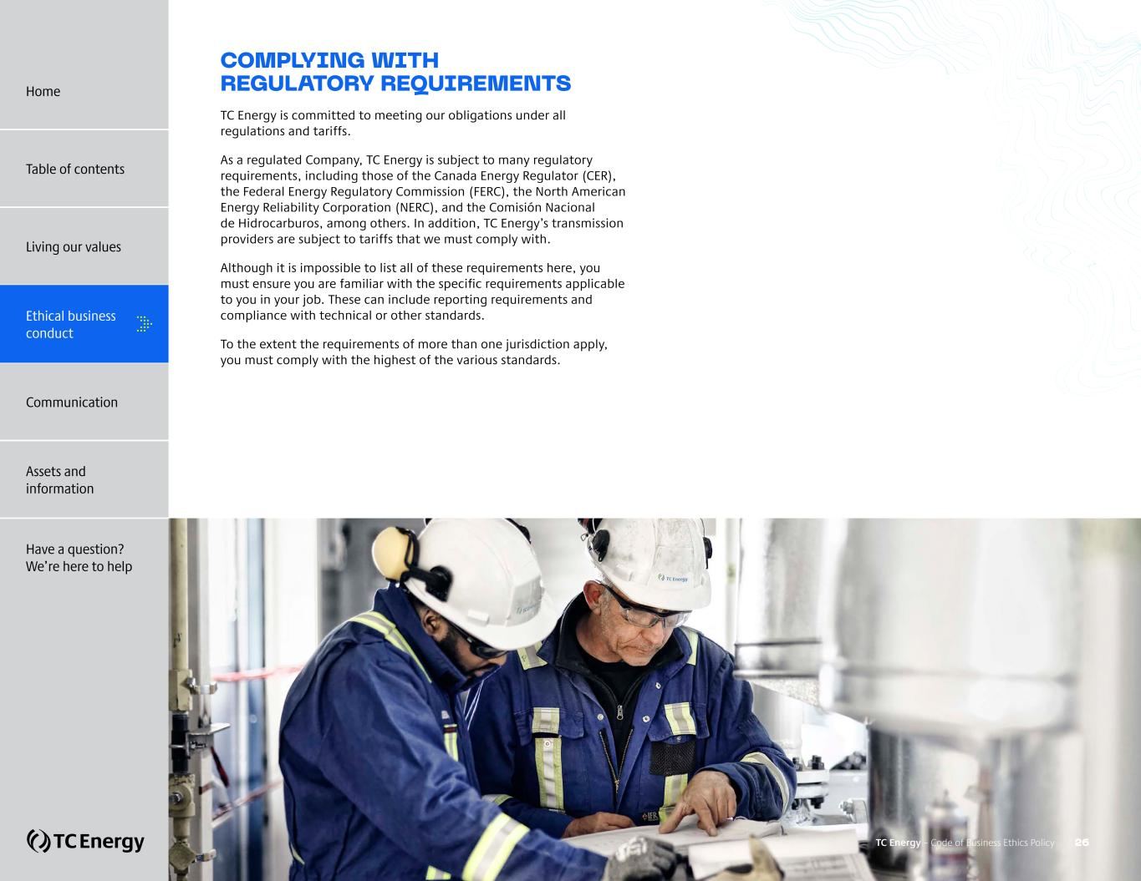
COMPLYING WITH REGULATORY REQUIREMENTS TC Energy is committed to meeting our obligations under all regulations and tariffs. As a regulated Company, TC Energy is subject to many regulatory requirements, including those of the Canada Energy Regulator (CER), the Federal Energy Regulatory Commission (FERC), the North American Energy Reliability Corporation (NERC), and the Comisión Nacional de Hidrocarburos, among others. In addition, TC Energy’s transmission providers are subject to tariffs that we must comply with. Although it is impossible to list all of these requirements here, you must ensure you are familiar with the specific requirements applicable to you in your job. These can include reporting requirements and compliance with technical or other standards. To the extent the requirements of more than one jurisdiction apply, you must comply with the highest of the various standards. TC Energy – Code of Business Ethics Policy 26 Home Table of contents Living our values Ethical business conduct Communication Assets and information Have a question? We’re here to help

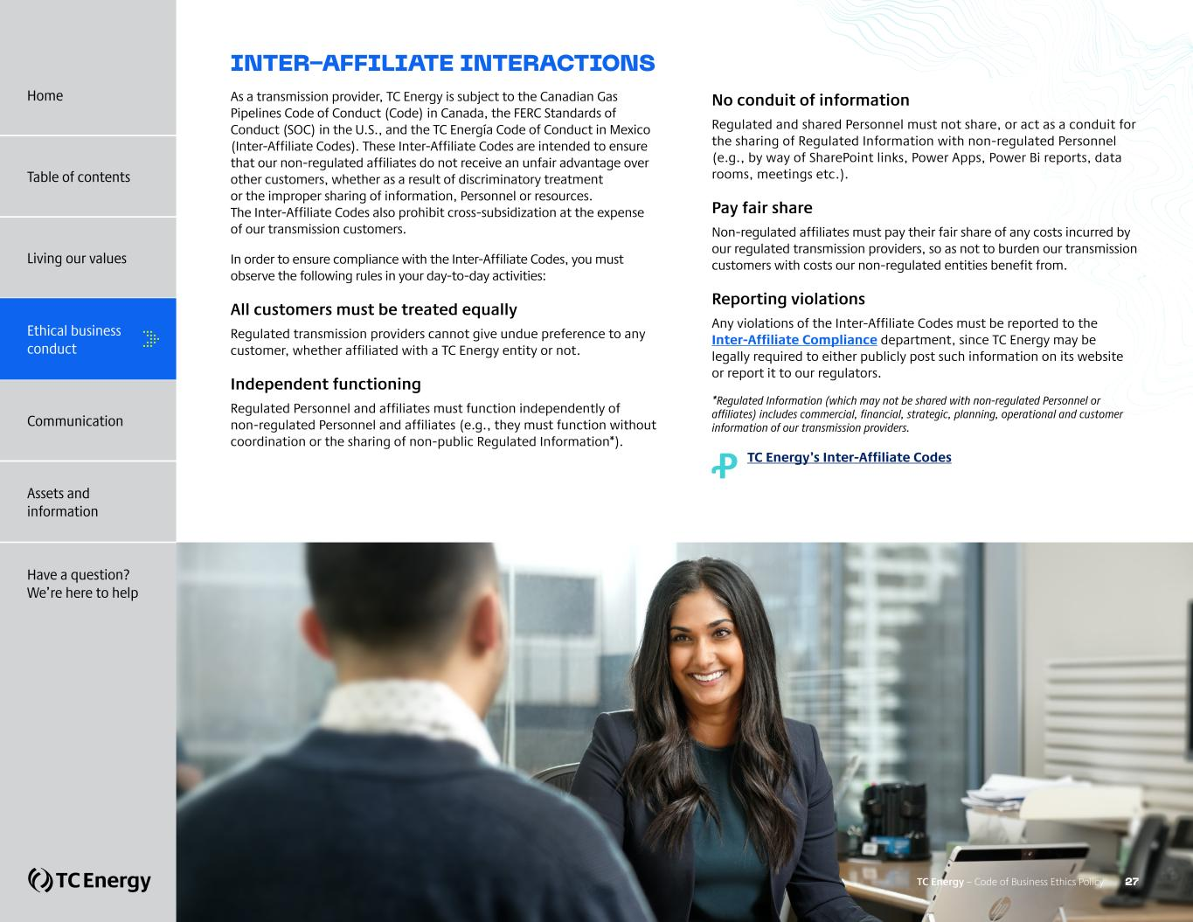
INTER-AFFILIATE INTERACTIONS As a transmission provider, TC Energy is subject to the Canadian Gas Pipelines Code of Conduct (Code) in Canada, the FERC Standards of Conduct (SOC) in the U.S., and the TC Energía Code of Conduct in Mexico (Inter-Affiliate Codes). These Inter-Affiliate Codes are intended to ensure that our non-regulated affiliates do not receive an unfair advantage over other customers, whether as a result of discriminatory treatment or the improper sharing of information, Personnel or resources. The Inter-Affiliate Codes also prohibit cross-subsidization at the expense of our transmission customers. In order to ensure compliance with the Inter-Affiliate Codes, you must observe the following rules in your day-to-day activities: All customers must be treated equally Regulated transmission providers cannot give undue preference to any customer, whether affiliated with a TC Energy entity or not. Independent functioning Regulated Personnel and affiliates must function independently of non-regulated Personnel and affiliates (e.g., they must function without coordination or the sharing of non-public Regulated Information*). No conduit of information Regulated and shared Personnel must not share, or act as a conduit for the sharing of Regulated Information with non-regulated Personnel (e.g., by way of SharePoint links, Power Apps, Power Bi reports, data rooms, meetings etc.). Pay fair share Non-regulated affiliates must pay their fair share of any costs incurred by our regulated transmission providers, so as not to burden our transmission customers with costs our non-regulated entities benefit from. Reporting violations Any violations of the Inter-Affiliate Codes must be reported to the Inter-Affiliate Compliance department, since TC Energy may be legally required to either publicly post such information on its website or report it to our regulators. *Regulated Information (which may not be shared with non-regulated Personnel or affiliates) includes commercial, financial, strategic, planning, operational and customer information of our transmission providers. Ꝓ TC Energy’s Inter-Affiliate Codes TC Energy – Code of Business Ethics Policy 27 Home Table of contents Living our values Ethical business conduct Communication Assets and information Have a question? We’re here to help

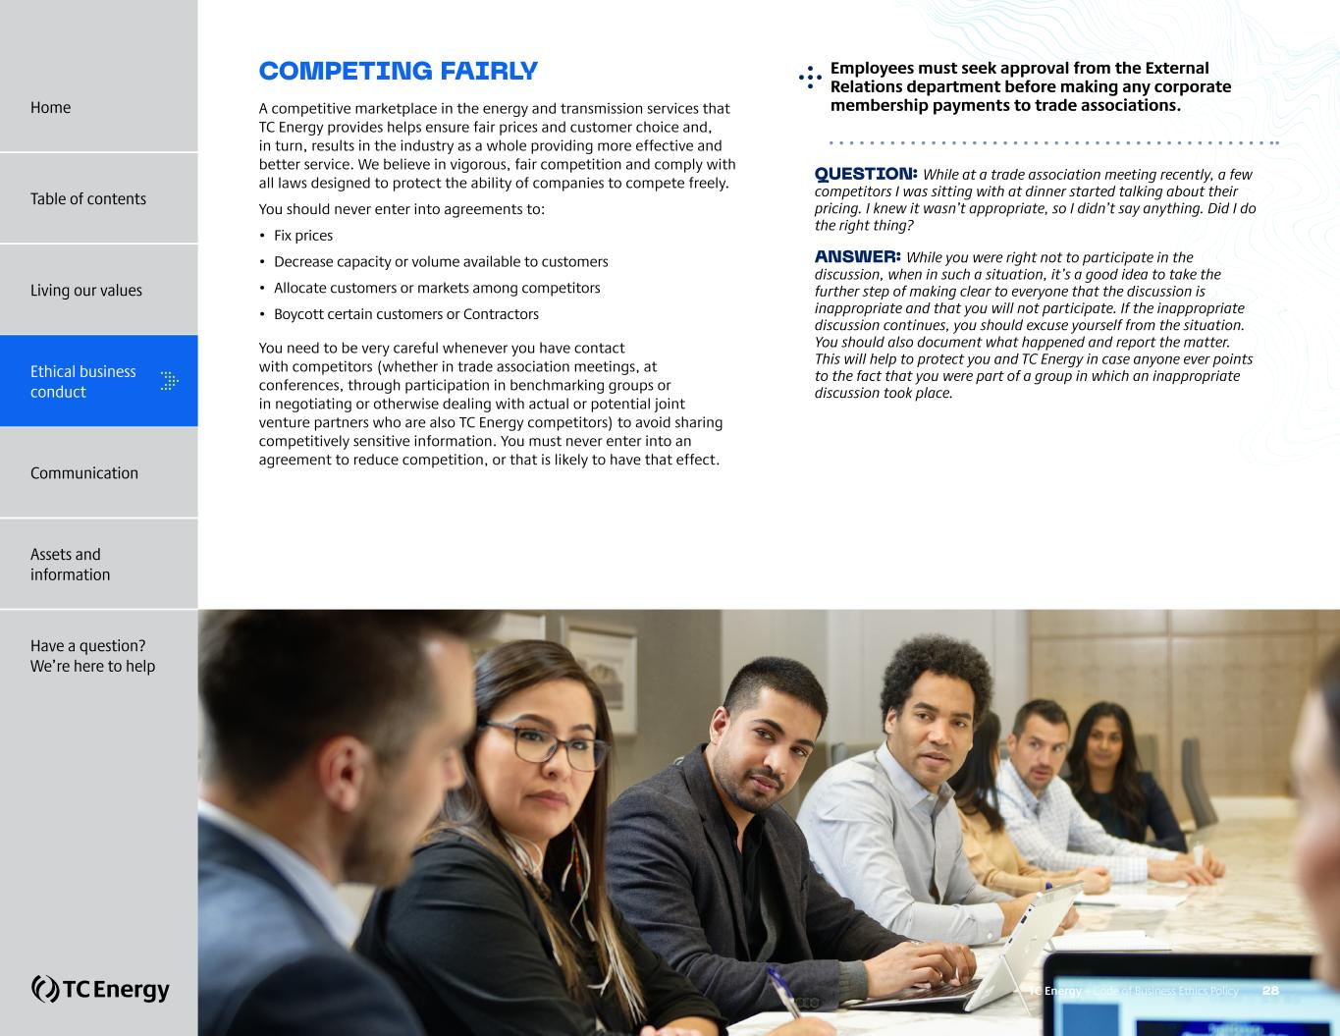
COMPETING FAIRLY A competitive marketplace in the energy and transmission services that TC Energy provides helps ensure fair prices and customer choice and, in turn, results in the industry as a whole providing more effective and better service. We believe in vigorous, fair competition and comply with all laws designed to protect the ability of companies to compete freely. You should never enter into agreements to: • Fix prices • Decrease capacity or volume available to customers • Allocate customers or markets among competitors • Boycott certain customers or Contractors You need to be very careful whenever you have contact with competitors (whether in trade association meetings, at conferences, through participation in benchmarking groups or in negotiating or otherwise dealing with actual or potential joint venture partners who are also TC Energy competitors) to avoid sharing competitively sensitive information. You must never enter into an agreement to reduce competition, or that is likely to have that effect. QUESTION: While at a trade association meeting recently, a few competitors I was sitting with at dinner started talking about their pricing. I knew it wasn’t appropriate, so I didn’t say anything. Did I do the right thing? ANSWER: While you were right not to participate in the discussion, when in such a situation, it’s a good idea to take the further step of making clear to everyone that the discussion is inappropriate and that you will not participate. If the inappropriate discussion continues, you should excuse yourself from the situation. You should also document what happened and report the matter. This will help to protect you and TC Energy in case anyone ever points to the fact that you were part of a group in which an inappropriate discussion took place. ?Employees must seek approval from the External Relations department before making any corporate membership payments to trade associations. TC Energy – Code of Business Ethics Policy 28 Home Table of contents Living our values Ethical business conduct Communication Assets and information Have a question? We’re here to help

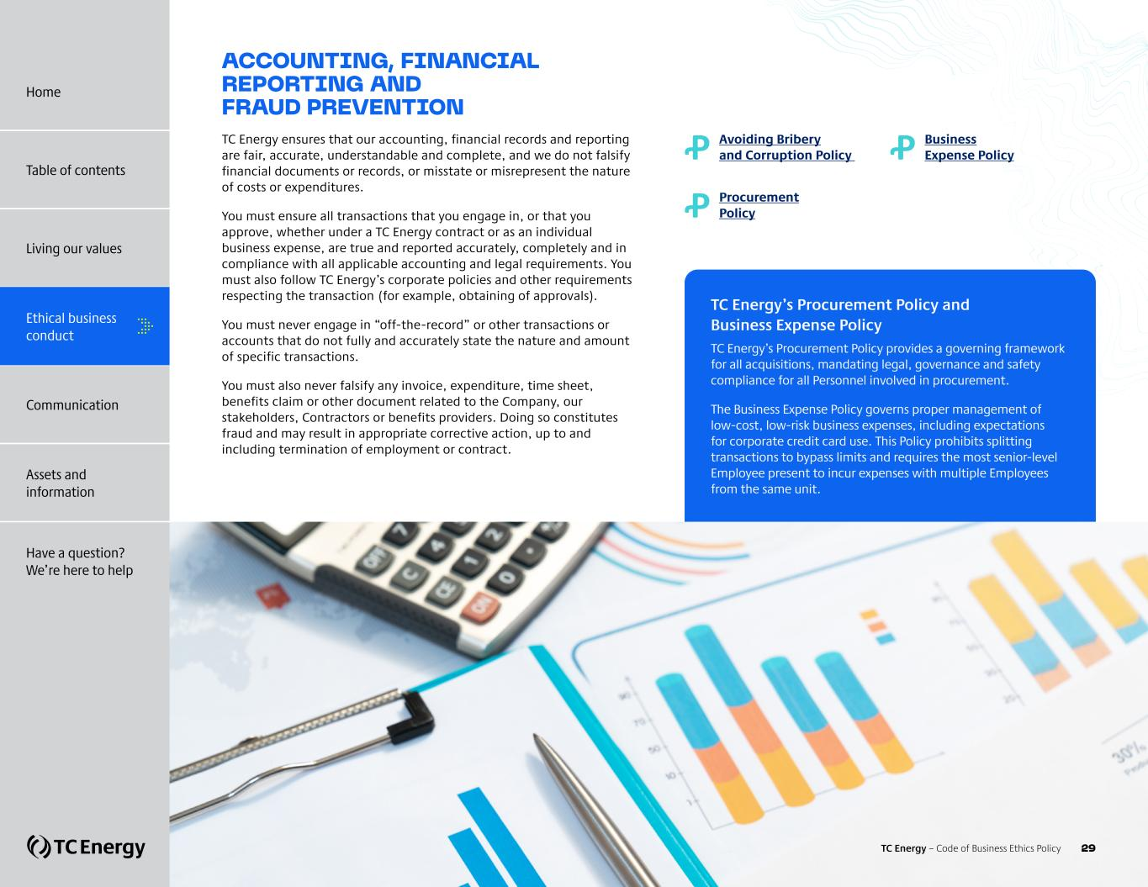
ACCOUNTING, FINANCIAL REPORTING AND FRAUD PREVENTION TC Energy ensures that our accounting, financial records and reporting are fair, accurate, understandable and complete, and we do not falsify financial documents or records, or misstate or misrepresent the nature of costs or expenditures. You must ensure all transactions that you engage in, or that you approve, whether under a TC Energy contract or as an individual business expense, are true and reported accurately, completely and in compliance with all applicable accounting and legal requirements. You must also follow TC Energy’s corporate policies and other requirements respecting the transaction (for example, obtaining of approvals). You must never engage in “off-the-record” or other transactions or accounts that do not fully and accurately state the nature and amount of specific transactions. You must also never falsify any invoice, expenditure, time sheet, benefits claim or other document related to the Company, our stakeholders, Contractors or benefits providers. Doing so constitutes fraud and may result in appropriate corrective action, up to and including termination of employment or contract. Ꝓ ?Avoiding Bribery and Corruption Policy Ꝓ Procurement Policy Ꝓ Business Expense Policy TC Energy’s Procurement Policy and Business Expense Policy TC Energy’s Procurement Policy provides a governing framework for all acquisitions, mandating legal, governance and safety compliance for all Personnel involved in procurement. The Business Expense Policy governs proper management of low-cost, low-risk business expenses, including expectations for corporate credit card use. This Policy prohibits splitting transactions to bypass limits and requires the most senior-level Employee present to incur expenses with multiple Employees from the same unit. Home Table of contents Living our values Ethical business conduct Communication Assets and information Have a question? We’re here to help TC Energy – Code of Business Ethics Policy 29

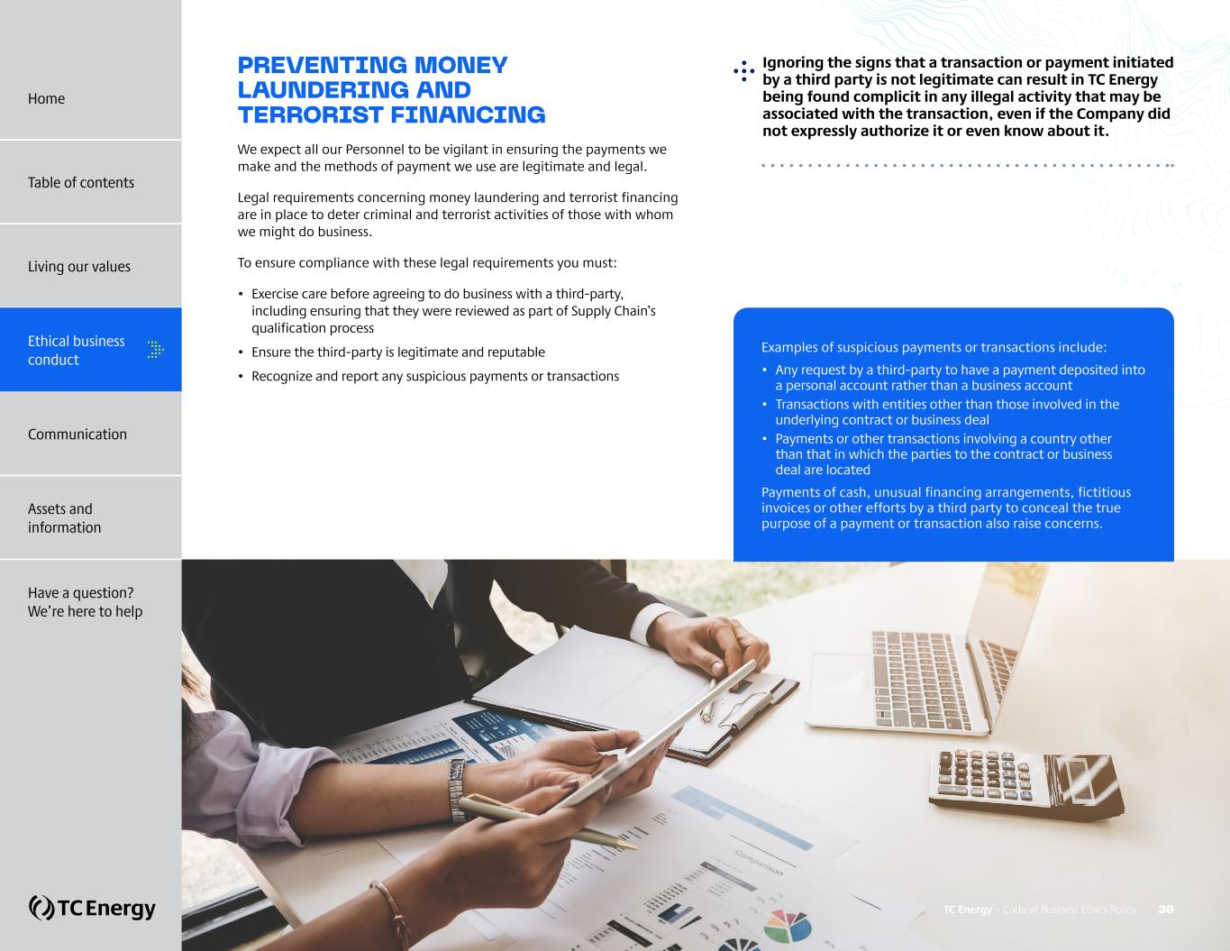
PREVENTING MONEY LAUNDERING AND TERRORIST FINANCING We expect all our Personnel to be vigilant in ensuring the payments we make and the methods of payment we use are legitimate and legal. Legal requirements concerning money laundering and terrorist financing are in place to deter criminal and terrorist activities of those with whom we might do business. To ensure compliance with these legal requirements you must: • Exercise care before agreeing to do business with a third-party, including ensuring that they were reviewed as part of Supply Chain’s qualification process • Ensure the third-party is legitimate and reputable • Recognize and report any suspicious payments or transactions ?Ignoring the signs that a transaction or payment initiated by a third party is not legitimate can result in TC Energy being found complicit in any illegal activity that may be associated with the transaction, even if the Company did not expressly authorize it or even know about it. Examples of suspicious payments or transactions include: • Any request by a third-party to have a payment deposited into a personal account rather than a business account • Transactions with entities other than those involved in the underlying contract or business deal • Payments or other transactions involving a country other than that in which the parties to the contract or business deal are located Payments of cash, unusual financing arrangements, fictitious invoices or other efforts by a third party to conceal the true purpose of a payment or transaction also raise concerns. TC Energy – Code of Business Ethics Policy 30 Home Table of contents Living our values Ethical business conduct Communication Assets and information Have a question? We’re here to help


COMMUNICATION + Being socially responsible + Being a good ambassador of TC Energy + Social media and communication with the public + Public disclosure of information + Dealing fairly with customers, Contractors and other stakeholders + Dealing fairly with competitors TC Energy – Code of Business Ethics Policy 31 Home Table of contents Living our values Ethical business conduct Assets and information Have a question? We’re here to help Communication

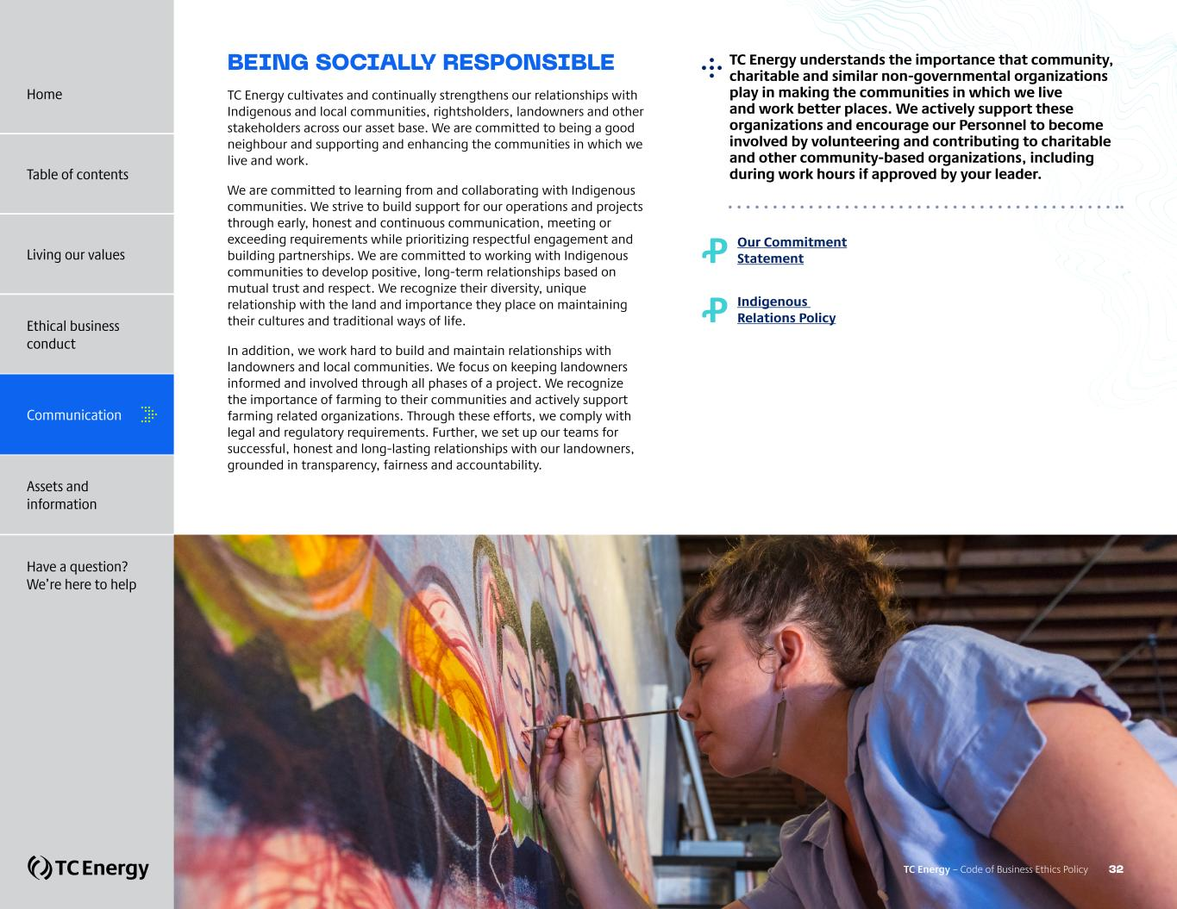
BEING SOCIALLY RESPONSIBLE TC Energy cultivates and continually strengthens our relationships with Indigenous and local communities, rightsholders, landowners and other stakeholders across our asset base. We are committed to being a good neighbour and supporting and enhancing the communities in which we live and work. We are committed to learning from and collaborating with Indigenous communities. We strive to build support for our operations and projects through early, honest and continuous communication, meeting or exceeding requirements while prioritizing respectful engagement and building partnerships. We are committed to working with Indigenous communities to develop positive, long-term relationships based on mutual trust and respect. We recognize their diversity, unique relationship with the land and importance they place on maintaining their cultures and traditional ways of life. In addition, we work hard to build and maintain relationships with landowners and local communities. We focus on keeping landowners informed and involved through all phases of a project. We recognize the importance of farming to their communities and actively support farming related organizations. Through these efforts, we comply with legal and regulatory requirements. Further, we set up our teams for successful, honest and long-lasting relationships with our landowners, grounded in transparency, fairness and accountability. Ꝓ Our Commitment Statement Ꝓ Indigenous Relations Policy ?TC Energy understands the importance that community, charitable and similar non-governmental organizations play in making the communities in which we live and work better places. We actively support these organizations and encourage our Personnel to become involved by volunteering and contributing to charitable and other community-based organizations, including during work hours if approved by your leader. TC Energy – Code of Business Ethics Policy 32 Home Table of contents Living our values Ethical business conduct Communication Assets and information Have a question? We’re here to help


BEING A GOOD AMBASSADOR OF TC ENERGY We recognize that we are ambassadors of TC Energy and conduct ourselves in a manner that is respectful and appropriate, and will not harm TC Energy’s reputation. You must always keep in mind that you are a representative of TC Energy. The things you say and do should reflect the Company’s core values. You should not speak publicly on behalf of TC Energy unless authorized to do so by the Communications team. Any posting or statement on an external website, including personal sites, social media channels or in other media, should be considered a public statement. Even on personal time, you must not participate in any illegal or inappropriate statements or activities that could be detrimental to the Company or its reputation. Personnel are encouraged to engage with social media content from official TC Energy accounts through actions such as liking and sharing. Ꝓ Public Disclosure Policy Ꝓ Communications Policy TC Energy – Code of Business Ethics Policy 33 Home Table of contents Living our values Ethical business conduct Communication Assets and information Have a question? We’re here to help

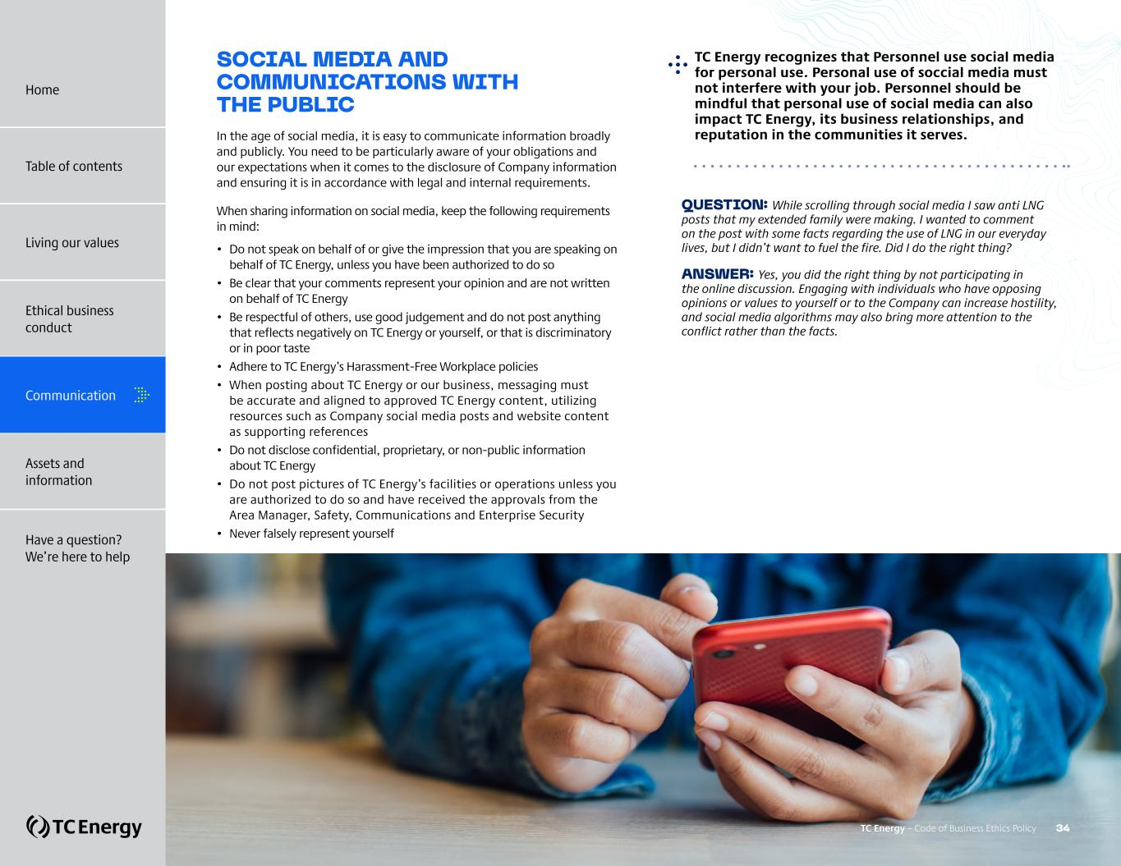
SOCIAL MEDIA AND COMMUNICATIONS WITH THE PUBLIC In the age of social media, it is easy to communicate information broadly and publicly. You need to be particularly aware of your obligations and our expectations when it comes to the disclosure of Company information and ensuring it is in accordance with legal and internal requirements. When sharing information on social media, keep the following requirements in mind: • Do not speak on behalf of or give the impression that you are speaking on behalf of TC Energy, unless you have been authorized to do so • Be clear that your comments represent your opinion and are not written on behalf of TC Energy • Be respectful of others, use good judgement and do not post anything that reflects negatively on TC Energy or yourself, or that is discriminatory or in poor taste • Adhere to TC Energy’s Harassment-Free Workplace policies • When posting about TC Energy or our business, messaging must be accurate and aligned to approved TC Energy content, utilizing resources such as Company social media posts and website content as supporting references • Do not disclose confidential, proprietary, or non-public information about TC Energy • Do not post pictures of TC Energy’s facilities or operations unless you are authorized to do so and have received the approvals from the Area Manager, Safety, Communications and Enterprise Security • Never falsely represent yourself QUESTION: While scrolling through social media I saw anti LNG posts that my extended family were making. I wanted to comment on the post with some facts regarding the use of LNG in our everyday lives, but I didn’t want to fuel the fire. Did I do the right thing? ANSWER: Yes, you did the right thing by not participating in the online discussion. Engaging with individuals who have opposing opinions or values to yourself or to the Company can increase hostility, and social media algorithms may also bring more attention to the conflict rather than the facts. ?TC Energy recognizes that Personnel use social media for personal use. Personal use of soccial media must not interfere with your job. Personnel should be mindful that personal use of social media can also impact TC Energy, its business relationships, and reputation in the communities it serves. TC Energy – Code of Business Ethics Policy 34 Home Table of contents Living our values Ethical business conduct Communication Assets and information Have a question? We’re here to help

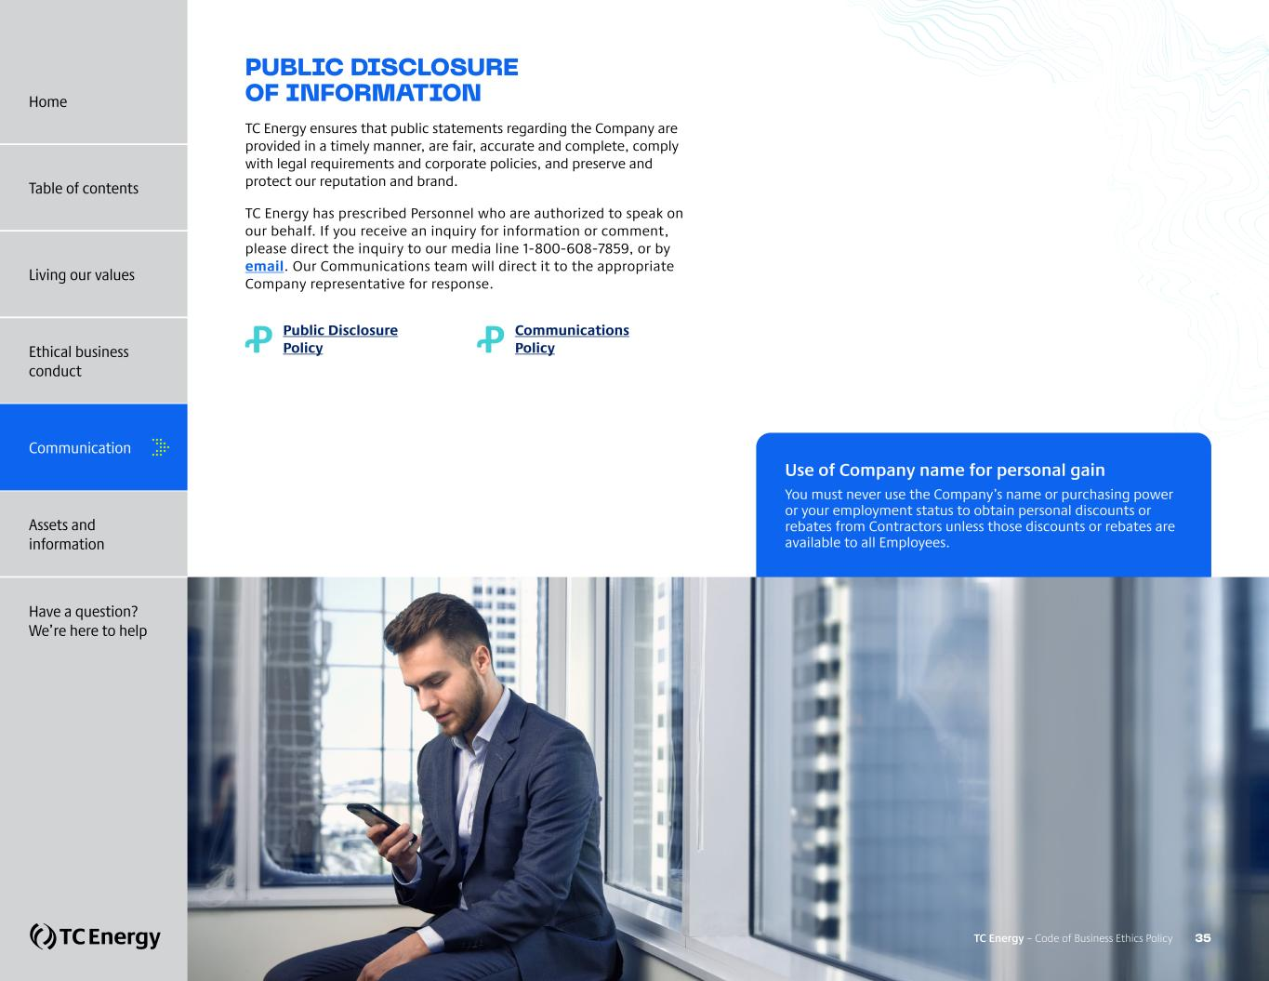
PUBLIC DISCLOSURE OF INFORMATION TC Energy ensures that public statements regarding the Company are provided in a timely manner, are fair, accurate and complete, comply with legal requirements and corporate policies, and preserve and protect our reputation and brand. TC Energy has prescribed Personnel who are authorized to speak on our behalf. If you receive an inquiry for information or comment, please direct the inquiry to our media line 1-800-608-7859, or by email. Our Communications team will direct it to the appropriate Company representative for response. Ꝓ Public Disclosure Policy Ꝓ Communications Policy Use of Company name for personal gain You must never use the Company’s name or purchasing power or your employment status to obtain personal discounts or rebates from Contractors unless those discounts or rebates are available to all Employees. TC Energy – Code of Business Ethics Policy 35 Home Table of contents Living our values Ethical business conduct Communication Assets and information Have a question? We’re here to help


DEALING FAIRLY WITH CUSTOMERS, CONTRACTORS AND OTHER STAKEHOLDERS We consider the impact of our actions on stakeholders, rightsholders, the environment and the communities in which we operate. We follow the requirements of our policies, procedures and commitment statements to make sure we act responsibly to protect us, our co-workers, our workplace and assets and the communities we work in. We act as responsible stewards of the environment and manage risk, share knowledge and best practices to ensure continual improvement. You should never make business decisions on behalf of TC Energy based on personal relationships, unfair bias or the potential for personal gain. ?We are fair and honest in our dealings with customers, Contractors and other stakeholders and we honour our obligations and commitments to them. Treating customers, Contractors and other stakeholders fairly requires that you: • Enter into business relationships based on merit • Use objective criteria to evaluate them, such as: – Price – Quality – Service It also requires that you are honest and forthright when dealing with others (never omitting important facts, manipulating another person or situation, or misrepresenting yourself or TC Energy), and that you honour TC Energy’s contractual, regulatory and other commitments. TC Energy – Code of Business Ethics Policy 36 Home Table of contents Living our values Ethical business conduct Communication Assets and information Have a question? We’re here to help

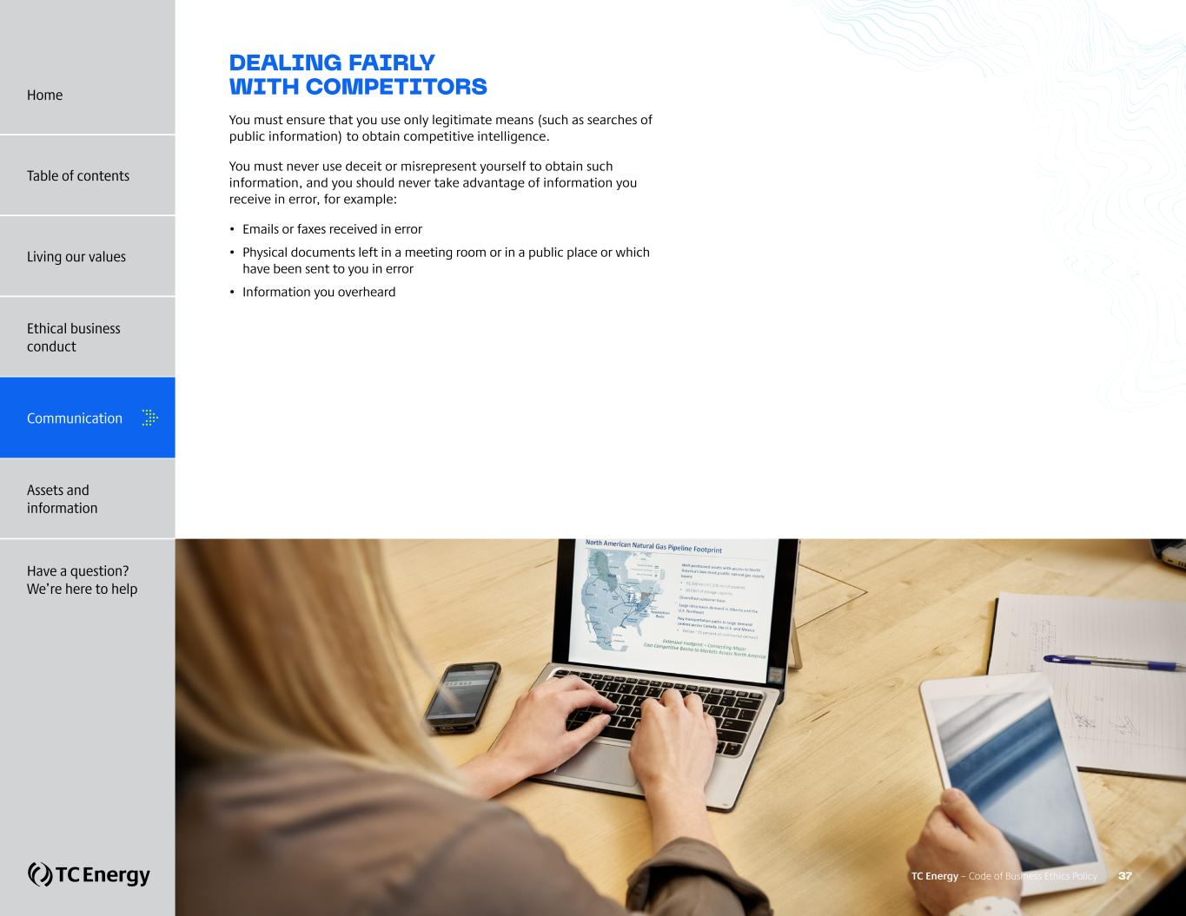
DEALING FAIRLY WITH COMPETITORS You must ensure that you use only legitimate means (such as searches of public information) to obtain competitive intelligence. You must never use deceit or misrepresent yourself to obtain such information, and you should never take advantage of information you receive in error, for example: • Emails or faxes received in error • Physical documents left in a meeting room or in a public place or which have been sent to you in error • Information you overheard TC Energy – Code of Business Ethics Policy 37 Home Table of contents Living our values Ethical business conduct Communication Assets and information Have a question? We’re here to help

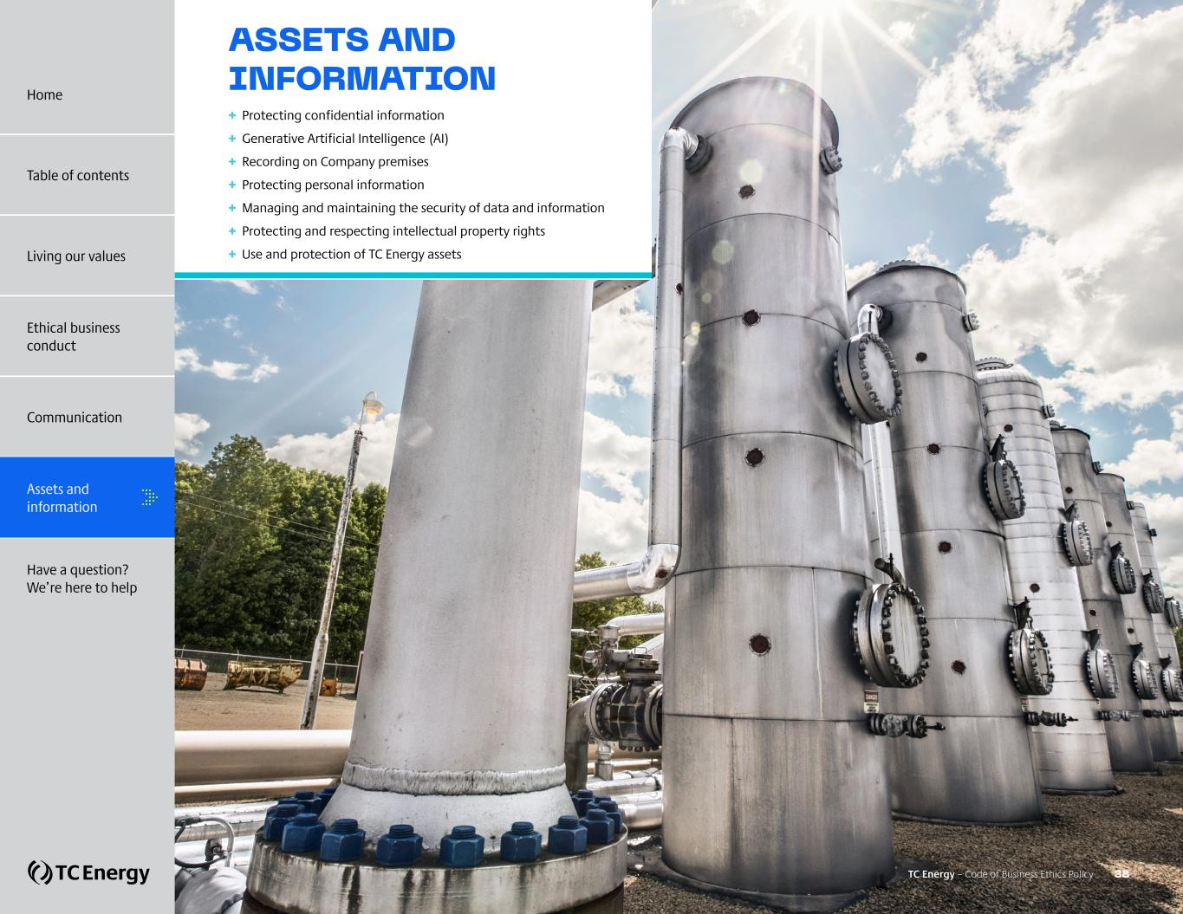
ASSETS AND INFORMATION + Protecting confidential information + Generative Artificial Intelligence (AI) + Recording on Company premises + Protecting personal information + Managing and maintaining the security of data and information + Protecting and respecting intellectual property rights + Use and protection of TC Energy assets TC Energy – Code of Business Ethics Policy 38 Home Table of contents Living our values Ethical business conduct Communication Have a question? We’re here to help Assets and information

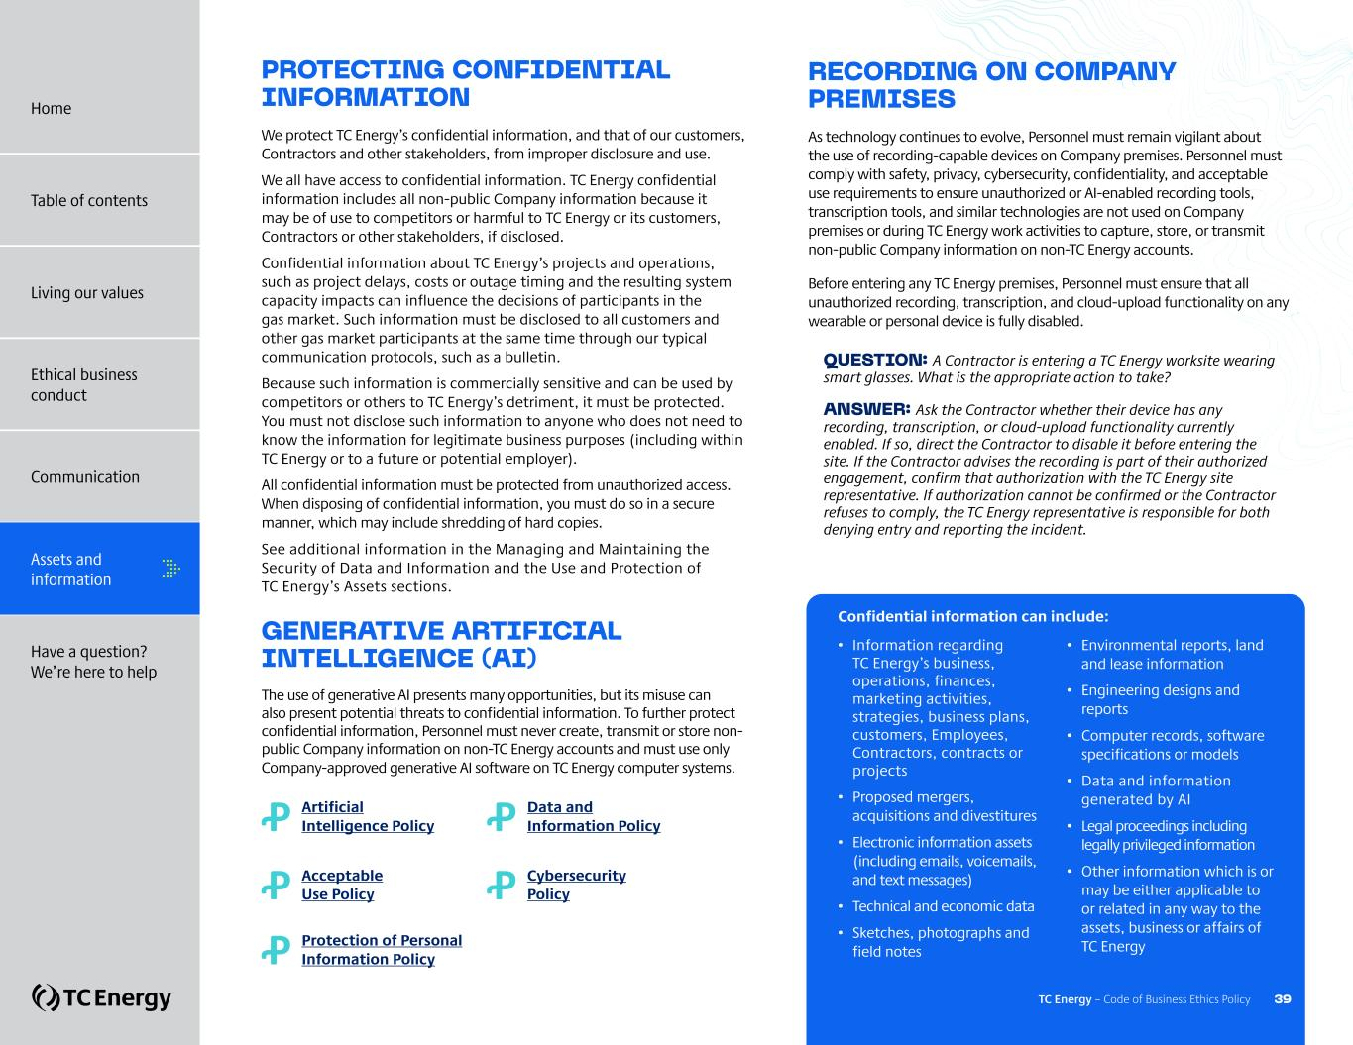
PROTECTING CONFIDENTIAL INFORMATION We protect TC Energy’s confidential information, and that of our customers, Contractors and other stakeholders, from improper disclosure and use. We all have access to confidential information. TC Energy confidential information includes all non-public Company information because it may be of use to competitors or harmful to TC Energy or its customers, Contractors or other stakeholders, if disclosed. Confidential information about TC Energy’s projects and operations, such as project delays, costs or outage timing and the resulting system capacity impacts can influence the decisions of participants in the gas market. Such information must be disclosed to all customers and other gas market participants at the same time through our typical communication protocols, such as a bulletin. Because such information is commercially sensitive and can be used by competitors or others to TC Energy’s detriment, it must be protected. You must not disclose such information to anyone who does not need to know the information for legitimate business purposes (including within TC Energy or to a future or potential employer). All confidential information must be protected from unauthorized access. When disposing of confidential information, you must do so in a secure manner, which may include shredding of hard copies. See additional information in the Managing and Maintaining the Security of Data and Information and the Use and Protection of TC Energy’s Assets sections. GENERATIVE ARTIFICIAL INTELLIGENCE (AI) The use of generative AI presents many opportunities, but its misuse can also present potential threats to confidential information. To further protect confidential information, Personnel must never create, transmit or store non- public Company information on non-TC Energy accounts and must use only Company-approved generative AI software on TC Energy computer systems. RECORDING ON COMPANY PREMISES As technology continues to evolve, Personnel must remain vigilant about the use of recording-capable devices on Company premises. Personnel must comply with safety, privacy, cybersecurity, confidentiality, and acceptable use requirements to ensure unauthorized or AI-enabled recording tools, transcription tools, and similar technologies are not used on Company premises or during TC Energy work activities to capture, store, or transmit non-public Company information on non-TC Energy accounts. Before entering any TC Energy premises, Personnel must ensure that all unauthorized recording, transcription, and cloud-upload functionality on any wearable or personal device is fully disabled. QUESTION: A Contractor is entering a TC Energy worksite wearing smart glasses. What is the appropriate action to take? ANSWER: Ask the Contractor whether their device has any recording, transcription, or cloud-upload functionality currently enabled. If so, direct the Contractor to disable it before entering the site. If the Contractor advises the recording is part of their authorized engagement, confirm that authorization with the TC Energy site representative. If authorization cannot be confirmed or the Contractor refuses to comply, the TC Energy representative is responsible for both denying entry and reporting the incident. • Information regarding TC Energy’s business, operations, finances, marketing activities, strategies, business plans, customers, Employees, Contractors, contracts or projects • Proposed mergers, acquisitions and divestitures • Electronic information assets (including emails, voicemails, and text messages) • Technical and economic data • Sketches, photographs and field notes • Environmental reports, land and lease information • Engineering designs and reports • Computer records, software specifications or models • Data and information generated by AI • Legal proceedings including legally privileged information • Other information which is or may be either applicable to or related in any way to the assets, business or affairs of TC EnergyꝒ Protection of Personal Information Policy Ꝓ Artificial Intelligence Policy Ꝓ Acceptable Use Policy Ꝓ Data and Information Policy Ꝓ Cybersecurity Policy Confidential information can include: TC Energy – Code of Business Ethics Policy 39 Home Table of contents Living our values Ethical business conduct Communication Assets and information Have a question? We’re here to help

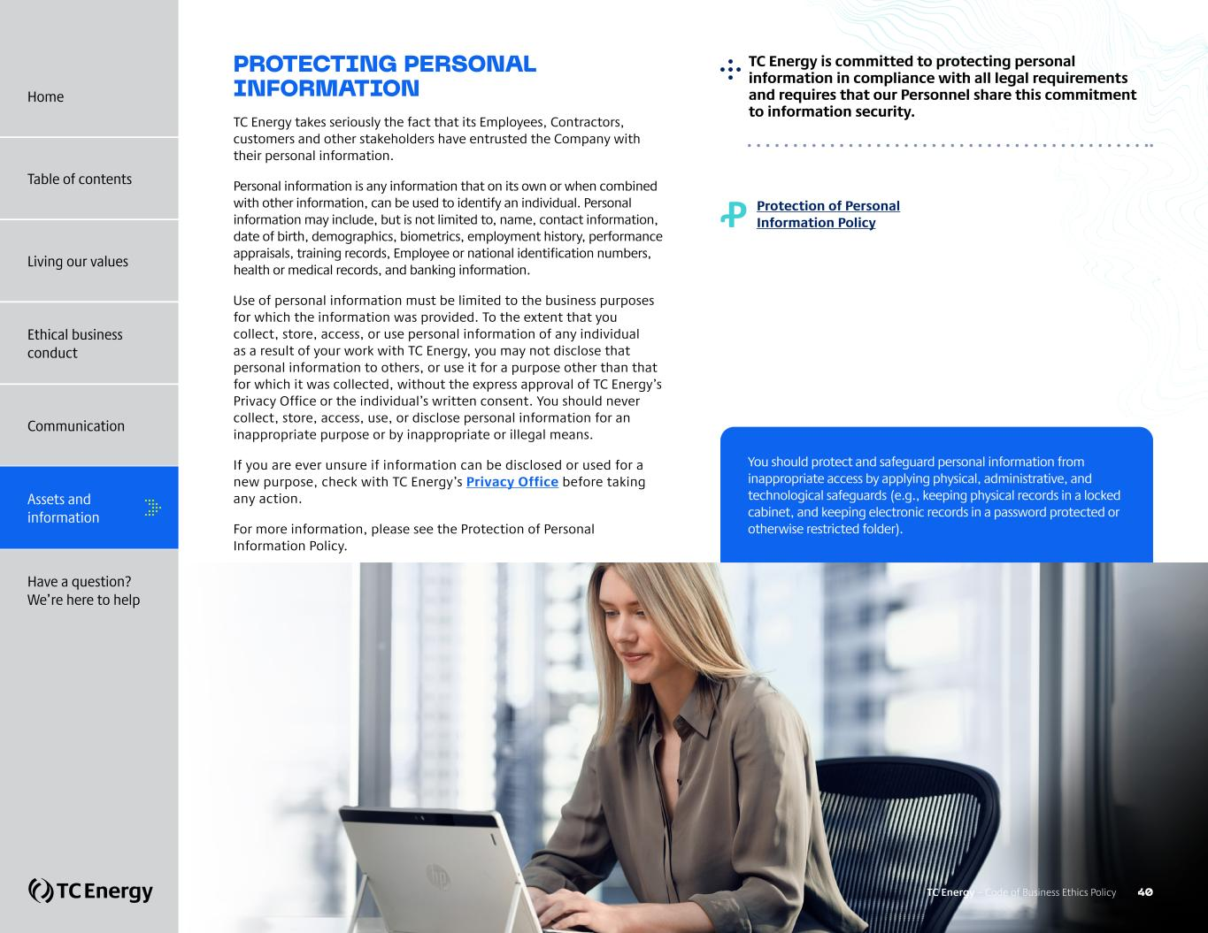
PROTECTING PERSONAL INFORMATION TC Energy takes seriously the fact that its Employees, Contractors, customers and other stakeholders have entrusted the Company with their personal information. Personal information is any information that on its own or when combined with other information, can be used to identify an individual. Personal information may include, but is not limited to, name, contact information, date of birth, demographics, biometrics, employment history, performance appraisals, training records, Employee or national identification numbers, health or medical records, and banking information. Use of personal information must be limited to the business purposes for which the information was provided. To the extent that you collect, store, access, or use personal information of any individual as a result of your work with TC Energy, you may not disclose that personal information to others, or use it for a purpose other than that for which it was collected, without the express approval of TC Energy’s Privacy Office or the individual’s written consent. You should never collect, store, access, use, or disclose personal information for an inappropriate purpose or by inappropriate or illegal means. If you are ever unsure if information can be disclosed or used for a new purpose, check with TC Energy’s Privacy Office before taking any action. For more information, please see the Protection of Personal Information Policy. Ꝓ Protection of Personal Information Policy ?TC Energy is committed to protecting personal information in compliance with all legal requirements and requires that our Personnel share this commitment to information security. You should protect and safeguard personal information from inappropriate access by applying physical, administrative, and technological safeguards (e.g., keeping physical records in a locked cabinet, and keeping electronic records in a password protected or otherwise restricted folder). TC Energy – Code of Business Ethics Policy 40 Home Table of contents Living our values Ethical business conduct Communication Assets and information Have a question? We’re here to help

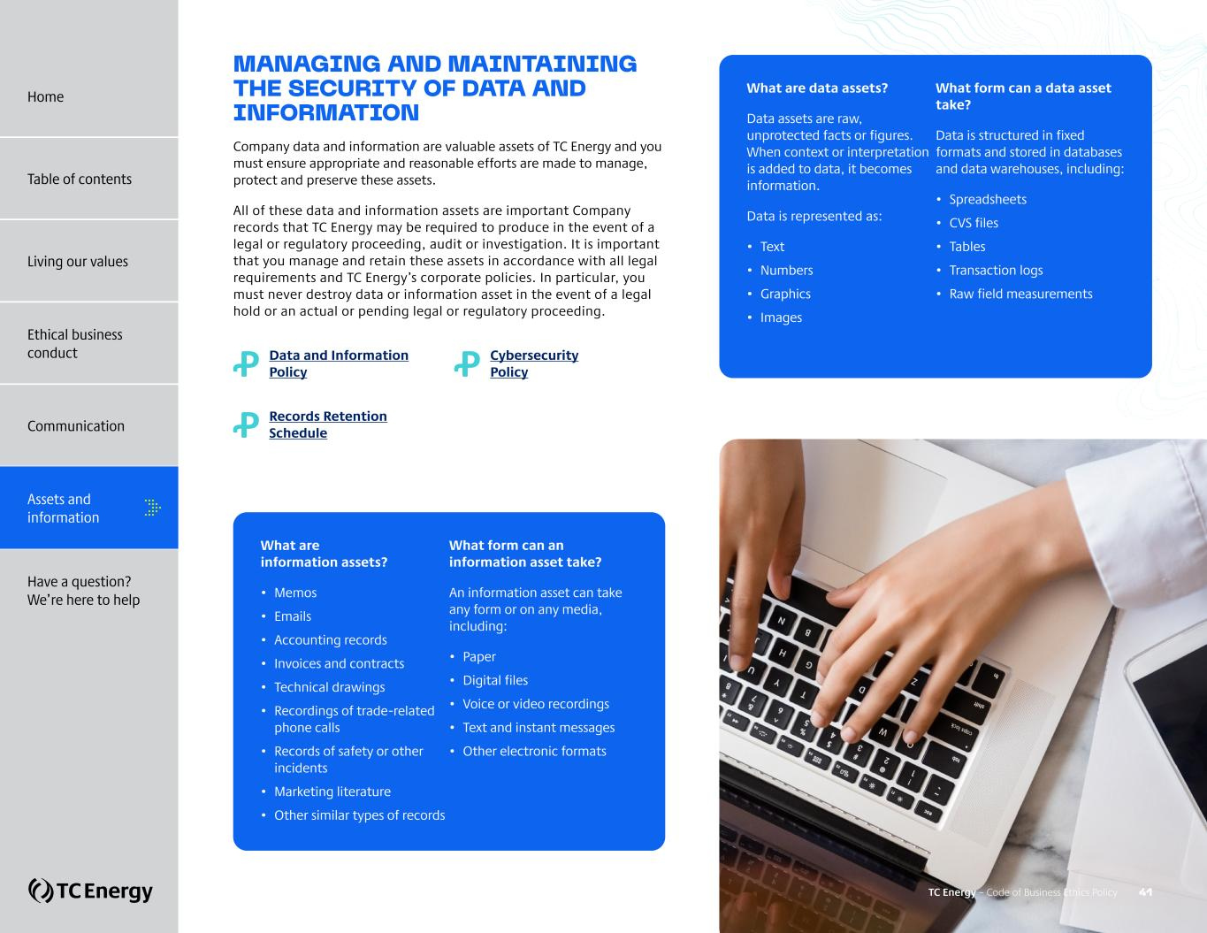
MANAGING AND MAINTAINING THE SECURITY OF DATA AND INFORMATION Company data and information are valuable assets of TC Energy and you must ensure appropriate and reasonable efforts are made to manage, protect and preserve these assets. All of these data and information assets are important Company records that TC Energy may be required to produce in the event of a legal or regulatory proceeding, audit or investigation. It is important that you manage and retain these assets in accordance with all legal requirements and TC Energy’s corporate policies. In particular, you must never destroy data or information asset in the event of a legal hold or an actual or pending legal or regulatory proceeding. Ꝓ Data and Information Policy Ꝓ Cybersecurity Policy Ꝓ Records Retention Schedule What are information assets? • Memos • Emails • Accounting records • Invoices and contracts • Technical drawings • Recordings of trade-related phone calls • Records of safety or other incidents • Marketing literature • Other similar types of records What form can an information asset take? An information asset can take any form or on any media, including: • Paper • Digital files • Voice or video recordings • Text and instant messages • Other electronic formats What are data assets? Data assets are raw, unprotected facts or figures. When context or interpretation is added to data, it becomes information. Data is represented as: • Text • Numbers • Graphics • Images What form can a data asset take? Data is structured in fixed formats and stored in databases and data warehouses, including: • Spreadsheets • CVS files • Tables • Transaction logs • Raw field measurements TC Energy – Code of Business Ethics Policy 41 Home Table of contents Living our values Ethical business conduct Communication Assets and information Have a question? We’re here to help

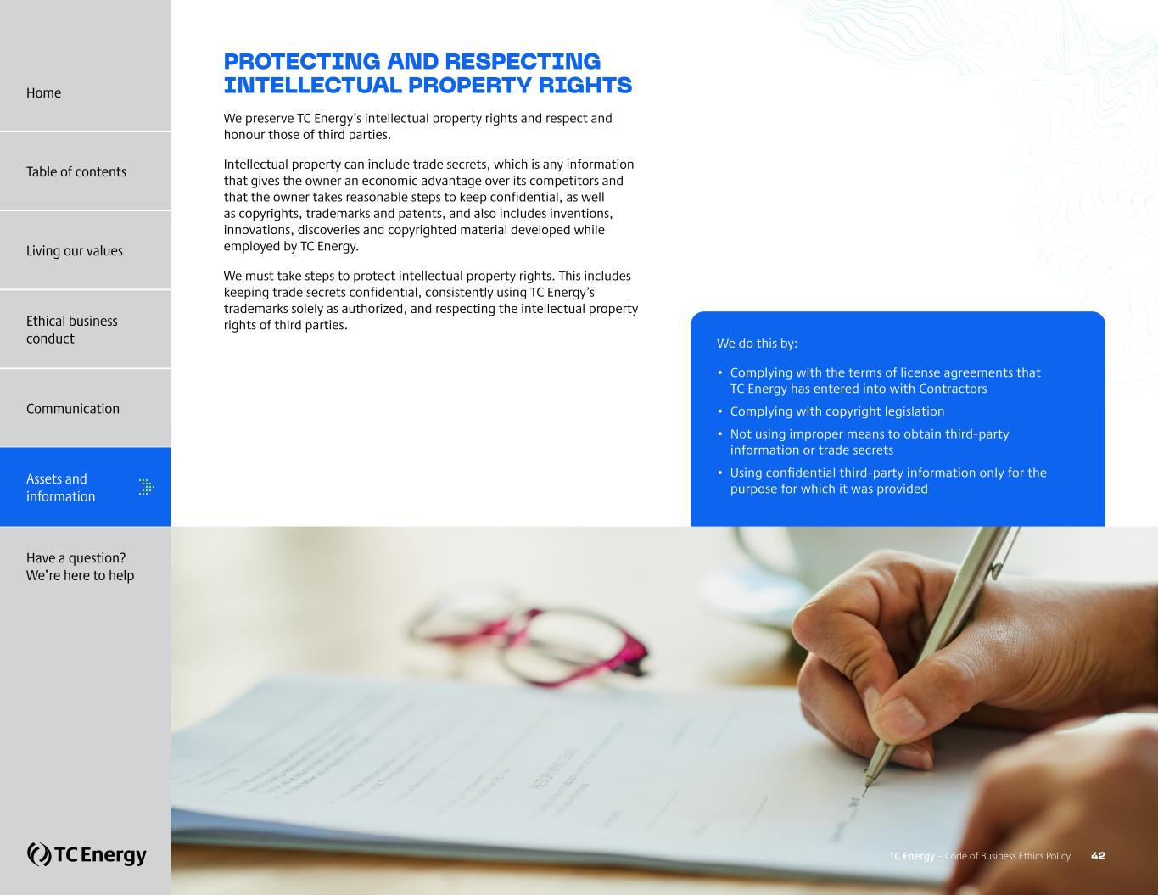
PROTECTING AND RESPECTING INTELLECTUAL PROPERTY RIGHTS We preserve TC Energy’s intellectual property rights and respect and honour those of third parties. Intellectual property can include trade secrets, which is any information that gives the owner an economic advantage over its competitors and that the owner takes reasonable steps to keep confidential, as well as copyrights, trademarks and patents, and also includes inventions, innovations, discoveries and copyrighted material developed while employed by TC Energy. We must take steps to protect intellectual property rights. This includes keeping trade secrets confidential, consistently using TC Energy’s trademarks solely as authorized, and respecting the intellectual property rights of third parties. We do this by: • Complying with the terms of license agreements that TC Energy has entered into with Contractors • Complying with copyright legislation • Not using improper means to obtain third-party information or trade secrets • Using confidential third-party information only for the purpose for which it was provided TC Energy – Code of Business Ethics Policy 42 Home Table of contents Living our values Ethical business conduct Communication Assets and information Have a question? We’re here to help

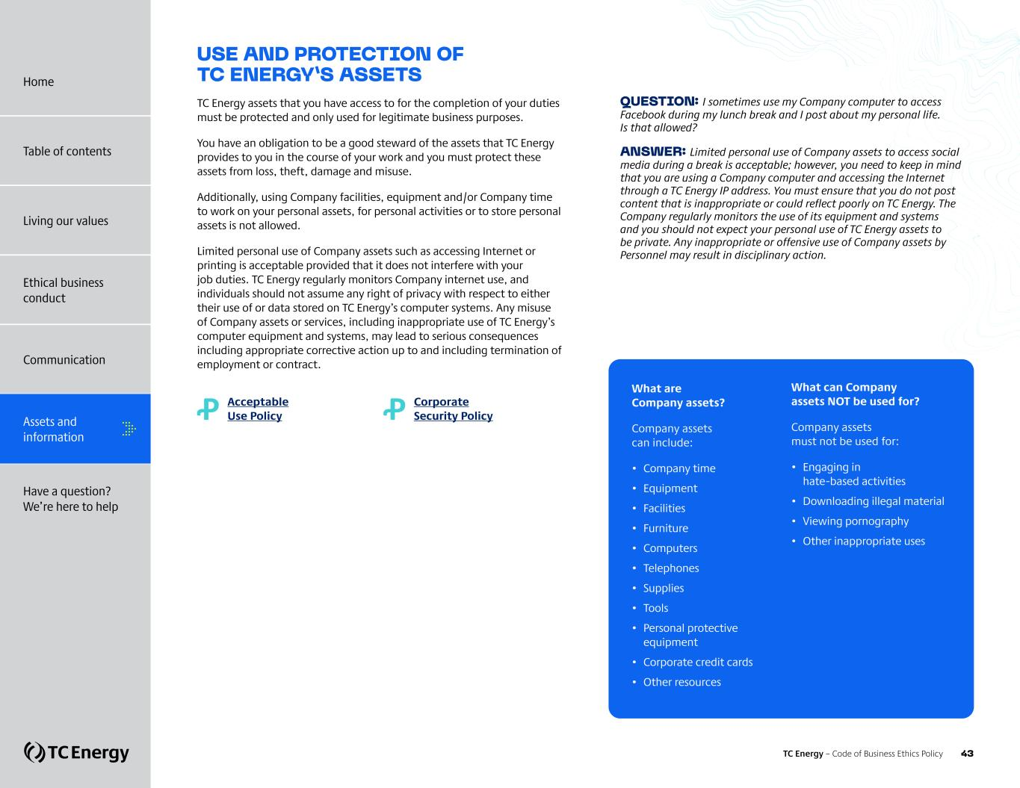
USE AND PROTECTION OF TC ENERGY’S ASSETS TC Energy assets that you have access to for the completion of your duties must be protected and only used for legitimate business purposes. You have an obligation to be a good steward of the assets that TC Energy provides to you in the course of your work and you must protect these assets from loss, theft, damage and misuse. Additionally, using Company facilities, equipment and/or Company time to work on your personal assets, for personal activities or to store personal assets is not allowed. Limited personal use of Company assets such as accessing Internet or printing is acceptable provided that it does not interfere with your job duties. TC Energy regularly monitors Company internet use, and individuals should not assume any right of privacy with respect to either their use of or data stored on TC Energy’s computer systems. Any misuse of Company assets or services, including inappropriate use of TC Energy’s computer equipment and systems, may lead to serious consequences including appropriate corrective action up to and including termination of employment or contract. Ꝓ Acceptable Use Policy Ꝓ Corporate Security Policy QUESTION: I sometimes use my Company computer to access Facebook during my lunch break and I post about my personal life. Is that allowed? ANSWER: Limited personal use of Company assets to access social media during a break is acceptable; however, you need to keep in mind that you are using a Company computer and accessing the Internet through a TC Energy IP address. You must ensure that you do not post content that is inappropriate or could reflect poorly on TC Energy. The Company regularly monitors the use of its equipment and systems and you should not expect your personal use of TC Energy assets to be private. Any inappropriate or offensive use of Company assets by Personnel may result in disciplinary action. What are Company assets? Company assets can include: • Company time • Equipment • Facilities • Furniture • Computers • Telephones • Supplies • Tools • Personal protective equipment • Corporate credit cards • Other resources What can Company assets NOT be used for? Company assets must not be used for: • Engaging in hate-based activities • Downloading illegal material • Viewing pornography • Other inappropriate uses Home Table of contents Living our values Ethical business conduct Communication Assets and information Have a question? We’re here to help TC Energy – Code of Business Ethics Policy 43

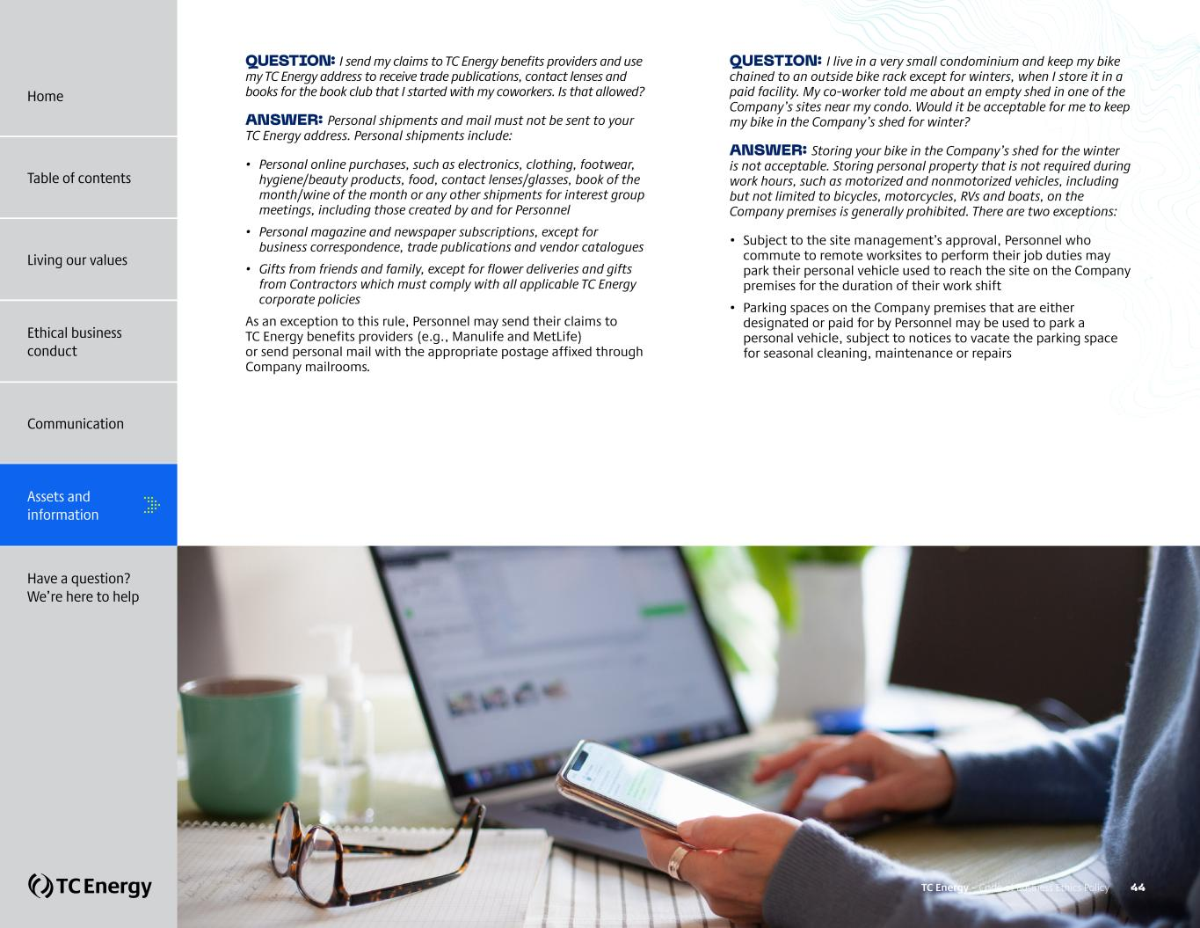
QUESTION: I send my claims to TC Energy benefits providers and use my TC Energy address to receive trade publications, contact lenses and books for the book club that I started with my coworkers. Is that allowed? ANSWER: Personal shipments and mail must not be sent to your TC Energy address. Personal shipments include: • Personal online purchases, such as electronics, clothing, footwear, hygiene/beauty products, food, contact lenses/glasses, book of the month/wine of the month or any other shipments for interest group meetings, including those created by and for Personnel • Personal magazine and newspaper subscriptions, except for business correspondence, trade publications and vendor catalogues • Gifts from friends and family, except for flower deliveries and gifts from Contractors which must comply with all applicable TC Energy corporate policies As an exception to this rule, Personnel may send their claims to TC Energy benefits providers (e.g., Manulife and MetLife) or send personal mail with the appropriate postage affixed through Company mailrooms. QUESTION: I live in a very small condominium and keep my bike chained to an outside bike rack except for winters, when I store it in a paid facility. My co-worker told me about an empty shed in one of the Company’s sites near my condo. Would it be acceptable for me to keep my bike in the Company’s shed for winter? ANSWER: Storing your bike in the Company’s shed for the winter is not acceptable. Storing personal property that is not required during work hours, such as motorized and nonmotorized vehicles, including but not limited to bicycles, motorcycles, RVs and boats, on the Company premises is generally prohibited. There are two exceptions: • Subject to the site management’s approval, Personnel who commute to remote worksites to perform their job duties may park their personal vehicle used to reach the site on the Company premises for the duration of their work shift • Parking spaces on the Company premises that are either designated or paid for by Personnel may be used to park a personal vehicle, subject to notices to vacate the parking space for seasonal cleaning, maintenance or repairs TC Energy – Code of Business Ethics Policy 44 Home Table of contents Living our values Ethical business conduct Communication Assets and information Have a question? We’re here to help


HAVE A QUESTION? WE’RE HERE TO HELP + Your responsibility and non-retaliation + Asking questions and reporting concerns TC Energy – Code of Business Ethics Policy 45 Home Table of contents Living our values Ethical business conduct Communication Assets and information Have a question? We’re here to help

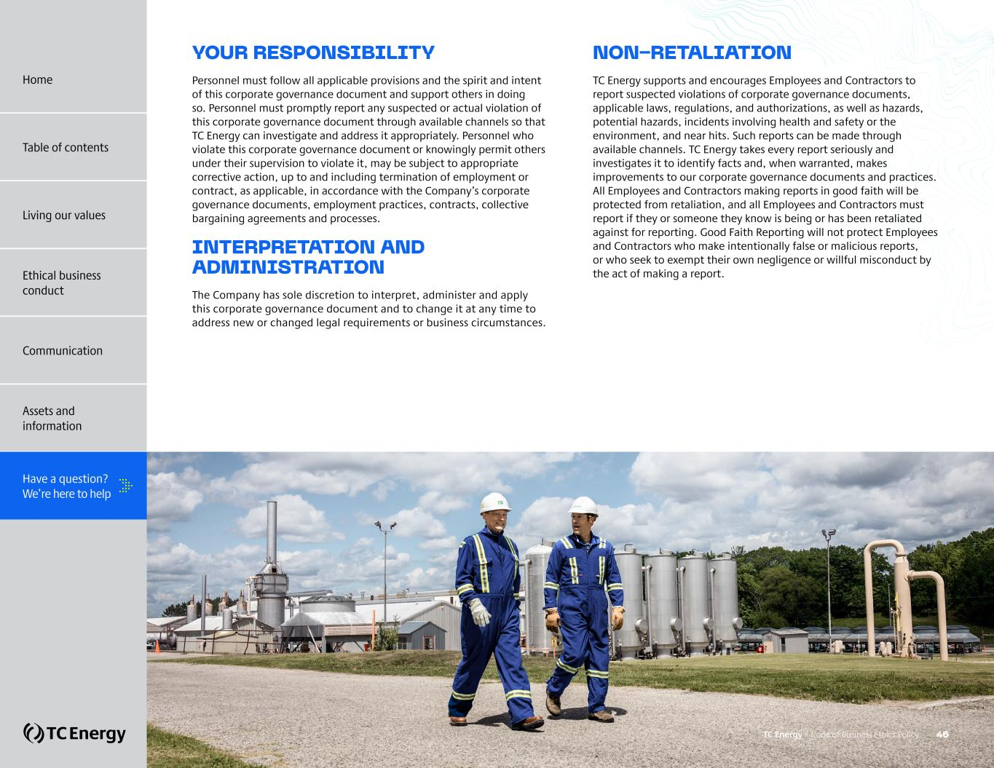
YOUR RESPONSIBILITY Personnel must follow all applicable provisions and the spirit and intent of this corporate governance document and support others in doing so. Personnel must promptly report any suspected or actual violation of this corporate governance document through available channels so that TC Energy can investigate and address it appropriately. Personnel who violate this corporate governance document or knowingly permit others under their supervision to violate it, may be subject to appropriate corrective action, up to and including termination of employment or contract, as applicable, in accordance with the Company’s corporate governance documents, employment practices, contracts, collective bargaining agreements and processes. INTERPRETATION AND ADMINISTRATION The Company has sole discretion to interpret, administer and apply this corporate governance document and to change it at any time to address new or changed legal requirements or business circumstances. NON-RETALIATION TC Energy supports and encourages Employees and Contractors to report suspected violations of corporate governance documents, applicable laws, regulations, and authorizations, as well as hazards, potential hazards, incidents involving health and safety or the environment, and near hits. Such reports can be made through available channels. TC Energy takes every report seriously and investigates it to identify facts and, when warranted, makes improvements to our corporate governance documents and practices. All Employees and Contractors making reports in good faith will be protected from retaliation, and all Employees and Contractors must report if they or someone they know is being or has been retaliated against for reporting. Good Faith Reporting will not protect Employees and Contractors who make intentionally false or malicious reports, or who seek to exempt their own negligence or willful misconduct by the act of making a report. TC Energy – Code of Business Ethics Policy 46 Home Table of contents Living our values Ethical business conduct Communication Assets and information Have a question? We’re here to help

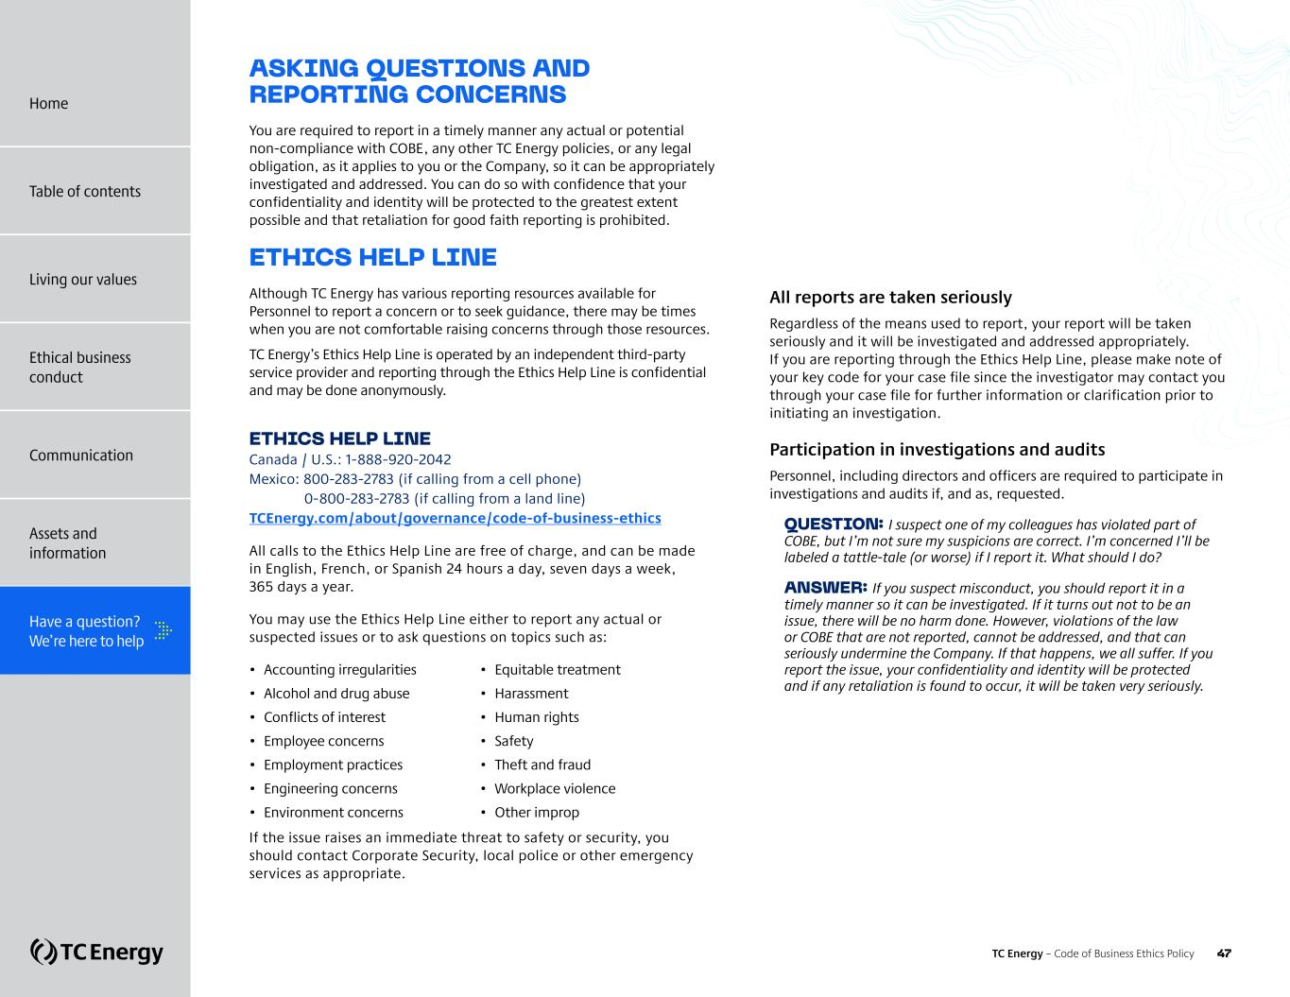
ASKING QUESTIONS AND REPORTING CONCERNS You are required to report in a timely manner any actual or potential non-compliance with COBE, any other TC Energy policies, or any legal obligation, as it applies to you or the Company, so it can be appropriately investigated and addressed. You can do so with confidence that your confidentiality and identity will be protected to the greatest extent possible and that retaliation for good faith reporting is prohibited. ETHICS HELP LINE Although TC Energy has various reporting resources available for Personnel to report a concern or to seek guidance, there may be times when you are not comfortable raising concerns through those resources. TC Energy’s Ethics Help Line is operated by an independent third-party service provider and reporting through the Ethics Help Line is confidential and may be done anonymously. ETHICS HELP LINE Canada / U.S.: 1-888-920-2042 Mexico: 800-283-2783 (if calling from a cell phone) 0-800-283-2783 (if calling from a land line) TCEnergy.com/about/governance/code-of-business-ethics All calls to the Ethics Help Line are free of charge, and can be made in English, French, or Spanish 24 hours a day, seven days a week, 365 days a year. You may use the Ethics Help Line either to report any actual or suspected issues or to ask questions on topics such as: • Accounting irregularities • Alcohol and drug abuse • Conflicts of interest • Employee concerns • Employment practices • Engineering concerns • Environment concerns • Equitable treatment • Harassment • Human rights • Safety • Theft and fraud • Workplace violence • Other improprieties If the issue raises an immediate threat to safety or security, you should contact Corporate Security, local police or other emergency services as appropriate. All reports are taken seriously Regardless of the means used to report, your report will be taken seriously and it will be investigated and addressed appropriately. If you are reporting through the Ethics Help Line, please make note of your key code for your case file since the investigator may contact you through your case file for further information or clarification prior to initiating an investigation. Participation in investigations and audits Personnel, including directors and officers are required to participate in investigations and audits if, and as, requested. QUESTION: I suspect one of my colleagues has violated part of COBE, but I’m not sure my suspicions are correct. I’m concerned I’ll be labeled a tattle-tale (or worse) if I report it. What should I do? ANSWER: If you suspect misconduct, you should report it in a timely manner so it can be investigated. If it turns out not to be an issue, there will be no harm done. However, violations of the law or COBE that are not reported, cannot be addressed, and that can seriously undermine the Company. If that happens, we all suffer. If you report the issue, your confidentiality and identity will be protected and if any retaliation is found to occur, it will be taken very seriously. Home Table of contents Living our values Ethical business conduct Communication Assets and information Have a question? We’re here to help TC Energy – Code of Business Ethics Policy 47

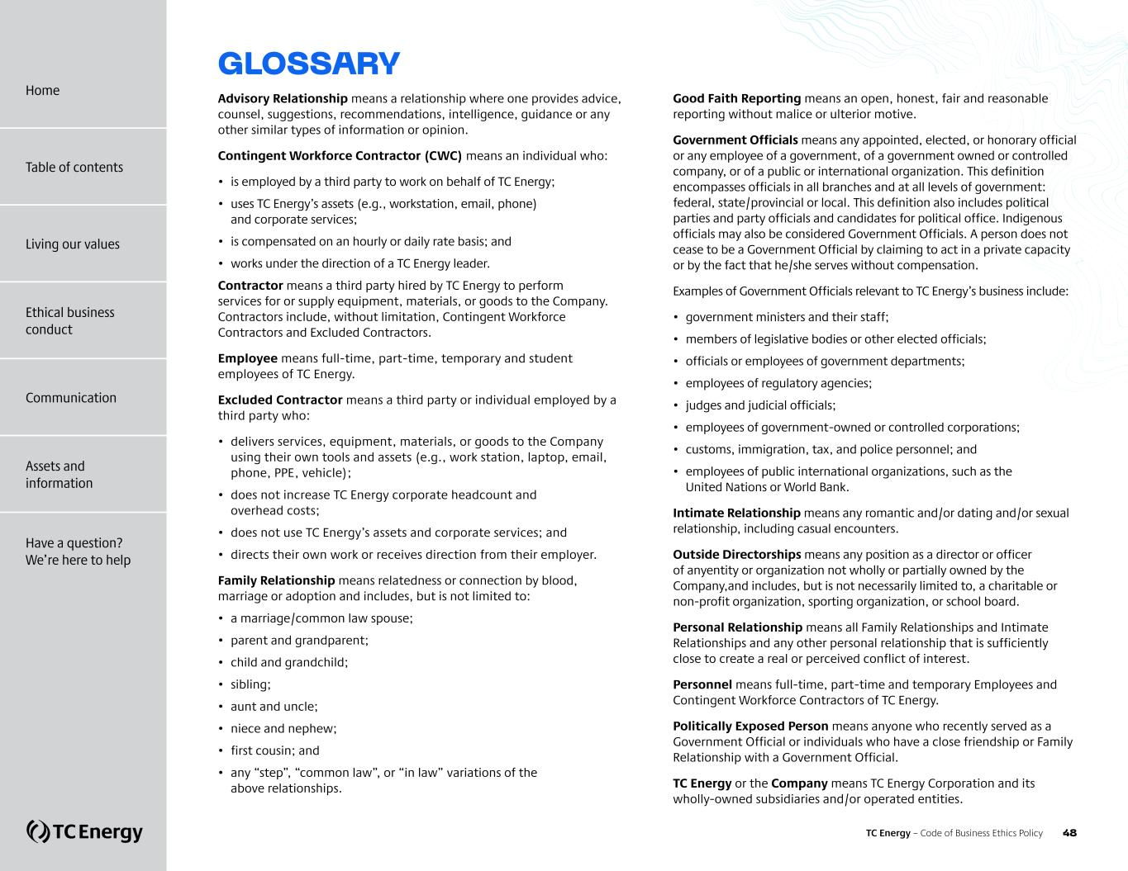
GLOSSARY Advisory Relationship means a relationship where one provides advice, counsel, suggestions, recommendations, intelligence, guidance or any other similar types of information or opinion. Contingent Workforce Contractor (CWC)? means an individual who: • is employed by a third party to work on behalf of TC Energy; • uses TC Energy’s assets (e.g., workstation, email, phone) and corporate services; • is compensated on an hourly or daily rate basis; and • works under the direction of a TC Energy leader. Contractor means a third party hired by TC Energy to perform services for or supply equipment, materials, or goods to the Company. Contractors include, without limitation, Contingent Workforce Contractors and Excluded Contractors. Employee means full-time, part-time, temporary and student employees of TC Energy. Excluded Contractor means a third party or individual employed by a third party who: • delivers services, equipment, materials, or goods to the Company using their own tools and assets (e.g., work station, laptop, email, phone, PPE, vehicle); • does not increase TC Energy corporate headcount and overhead costs; • does not use TC Energy’s assets and corporate services; and • directs their own work or receives direction from their employer. Family Relationship means relatedness or connection by blood, marriage or adoption and includes, but is not limited to: • a marriage/common law spouse; • parent and grandparent; • child and grandchild; • sibling; • aunt and uncle; • niece and nephew; • first cousin; and • any “step”, “common law”, or “in law” variations of the above relationships. Good Faith Reporting? means an open, honest, fair and reasonable reporting without malice or ulterior motive. Government Officials means any appointed, elected, or honorary official or any employee of a government, of a government owned or controlled company, or of a public or international organization. This definition encompasses officials in all branches and at all levels of government: federal, state/provincial or local. This definition also includes political parties and party officials and candidates for political office. Indigenous officials may also be considered Government Officials. A person does not cease to be a Government Official by claiming to act in a private capacity or by the fact that he/she serves without compensation. Examples of Government Officials relevant to TC Energy’s business include: • government ministers and their staff; • members of legislative bodies or other elected officials; • officials or employees of government departments; • employees of regulatory agencies; • judges and judicial officials; • employees of government-owned or controlled corporations; • customs, immigration, tax, and police personnel; and • employees of public international organizations, such as the United Nations or World Bank. Intimate Relationship means any romantic and/or dating and/or sexual relationship, including casual encounters. Outside Directorships means any position as a director or officer of anyentity or organization not wholly or partially owned by the Company,and includes, but is not necessarily limited to, a charitable or non-profit organization, sporting organization, or school board. Personal Relationship means all Family Relationships and Intimate Relationships and any other personal relationship that is sufficiently close to create a real or perceived conflict of interest. Personnel means full-time, part-time and temporary Employees and Contingent Workforce Contractors of TC Energy. Politically Exposed Person means anyone who recently served as a Government Official or individuals who have a close friendship or Family Relationship with a Government Official. TC Energy or the Company means TC Energy Corporation and its wholly-owned subsidiaries and/or operated entities. TC Energy – Code of Business Ethics Policy 48 Home Living our values Ethical business conduct Communication Assets and information Have a question? We’re here to help Table of contents


July 2026 MAKING THE RIGHT CHOICES – DOING THE RIGHT THING

