SECURITIES AND EXCHANGE COMMISSION
Washington, D.C. 20549

FORM 6-K

Report of Foreign Private Issuer

Pursuant to Rule 13a-16 or 15d-16 of
the Securities Exchange Act of 1934

For the month of May 2026

Commission File No. 1-31690

TC Energy Corporation
(Translation of Registrant's Name into English)

450 – 1 Street S.W., Calgary, Alberta, T2P 5H1, Canada
(Address of Principal Executive Offices)

Indicate by check mark whether the registrant files or will file annual reports under cover of Form 20-F or Form 40-F:

Form 20-F ☐ Form 40-F ☑

Exhibits 99.1 and 99.2 to this report, furnished on Form 6-K, are furnished, not filed, and will not be incorporated by reference into any registration statement filed by the registrant under the Securities Act of 1933, as amended.

EXHIBIT INDEX

99.1 |  |  | A copy of the registrant’s news release dated May 7, 2026.
99.2 |  |  | A copy of the registrant's Report of Voting Results dated May 7, 2026.

SIGNATURES

Pursuant to the requirements of the Securities Exchange Act of 1934, the registrant has duly caused this report to be signed on its behalf by the undersigned, thereunto duly authorized.

Date: May 7, 2026

 |  |  | TC ENERGY CORPORATION
 |  |  | By: |  |  | /s/ Jane M. Brindle
 |  |  |  |  |  | Jane M. Brindle
 |  |  |  |  |  | Vice-President, Law and Corporate Secretary

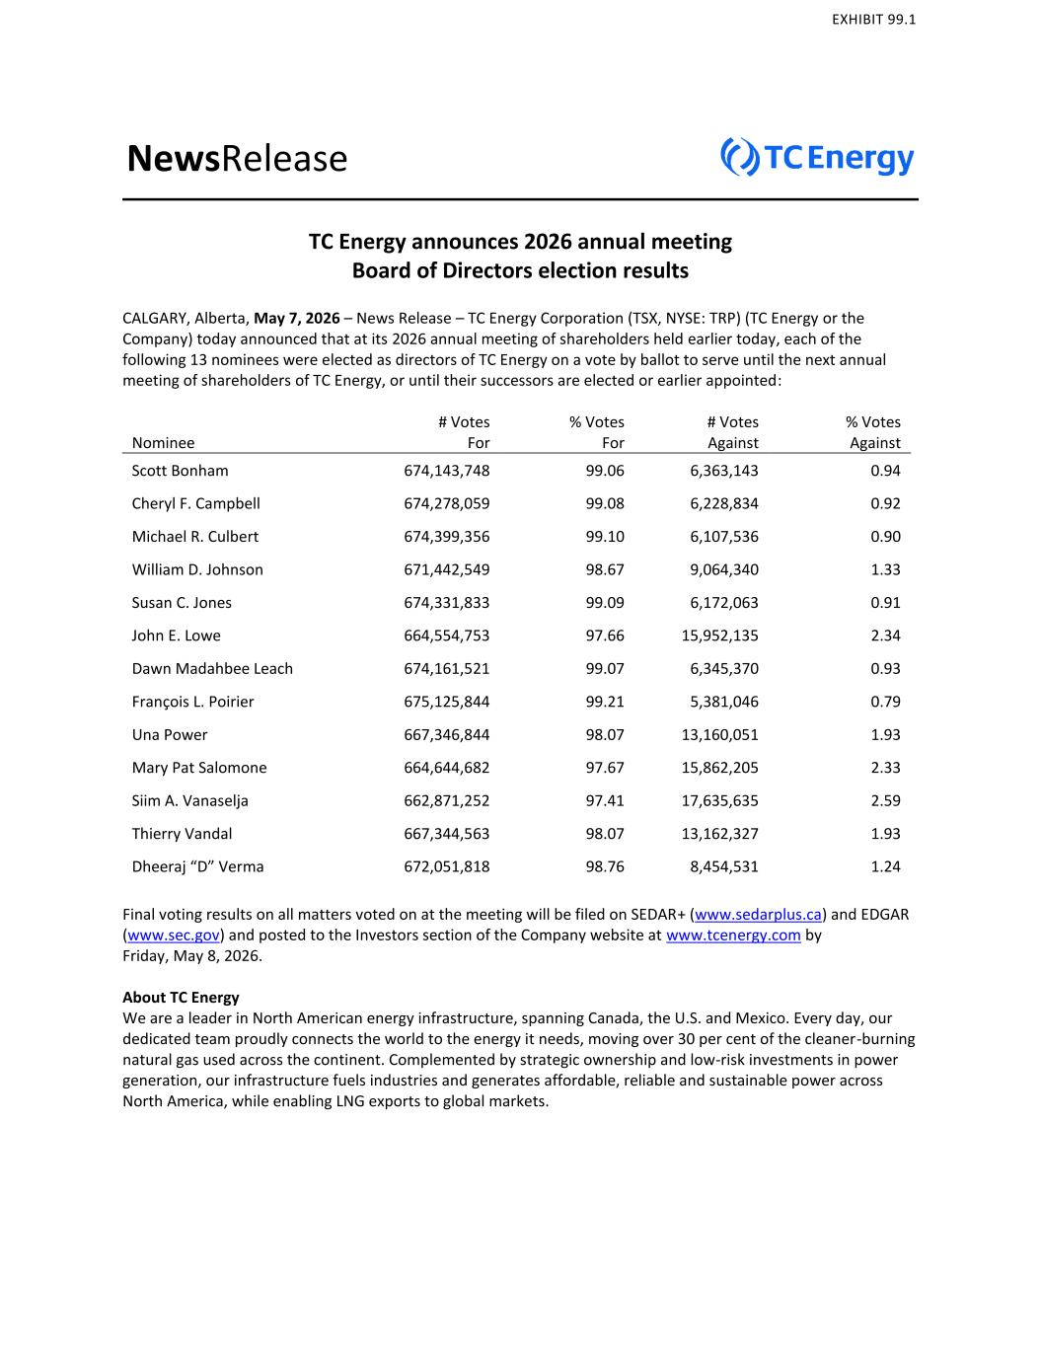

NewsRelease TC Energy announces 2026 annual meeting Board of Directors election results CALGARY, Alberta, May 7, 2026 – News Release – TC Energy Corporation (TSX, NYSE: TRP) (TC Energy or the Company) today announced that at its 2026 annual meeting of shareholders held earlier today, each of the following 13 nominees were elected as directors of TC Energy on a vote by ballot to serve until the next annual meeting of shareholders of TC Energy, or until their successors are elected or earlier appointed: Nominee # Votes For % Votes For # Votes Against % Votes Against Scott Bonham 674,143,748 99.06 6,363,143 0.94 Cheryl F. Campbell 674,278,059 99.08 6,228,834 0.92 Michael R. Culbert 674,399,356 99.10 6,107,536 0.90 William D. Johnson 671,442,549 98.67 9,064,340 1.33 Susan C. Jones 674,331,833 99.09 6,172,063 0.91 John E. Lowe 664,554,753 97.66 15,952,135 2.34 Dawn Madahbee Leach 674,161,521 99.07 6,345,370 0.93 François L. Poirier 675,125,844 99.21 5,381,046 0.79 Una Power 667,346,844 98.07 13,160,051 1.93 Mary Pat Salomone 664,644,682 97.67 15,862,205 2.33 Siim A. Vanaselja 662,871,252 97.41 17,635,635 2.59 Thierry Vandal 667,344,563 98.07 13,162,327 1.93 Dheeraj “D” Verma 672,051,818 98.76 8,454,531 1.24 Final voting results on all matters voted on at the meeting will be filed on SEDAR+ (www.sedarplus.ca) and EDGAR (www.sec.gov) and posted to the Investors section of the Company website at www.tcenergy.com by Friday, May 8, 2026. About TC Energy We are a leader in North American energy infrastructure, spanning Canada, the U.S. and Mexico. Every day, our dedicated team proudly connects the world to the energy it needs, moving over 30 per cent of the cleaner-burning natural gas used across the continent. Complemented by strategic ownership and low-risk investments in power generation, our infrastructure fuels industries and generates affordable, reliable and sustainable power across North America, while enabling LNG exports to global markets. EXHIBIT 99.1

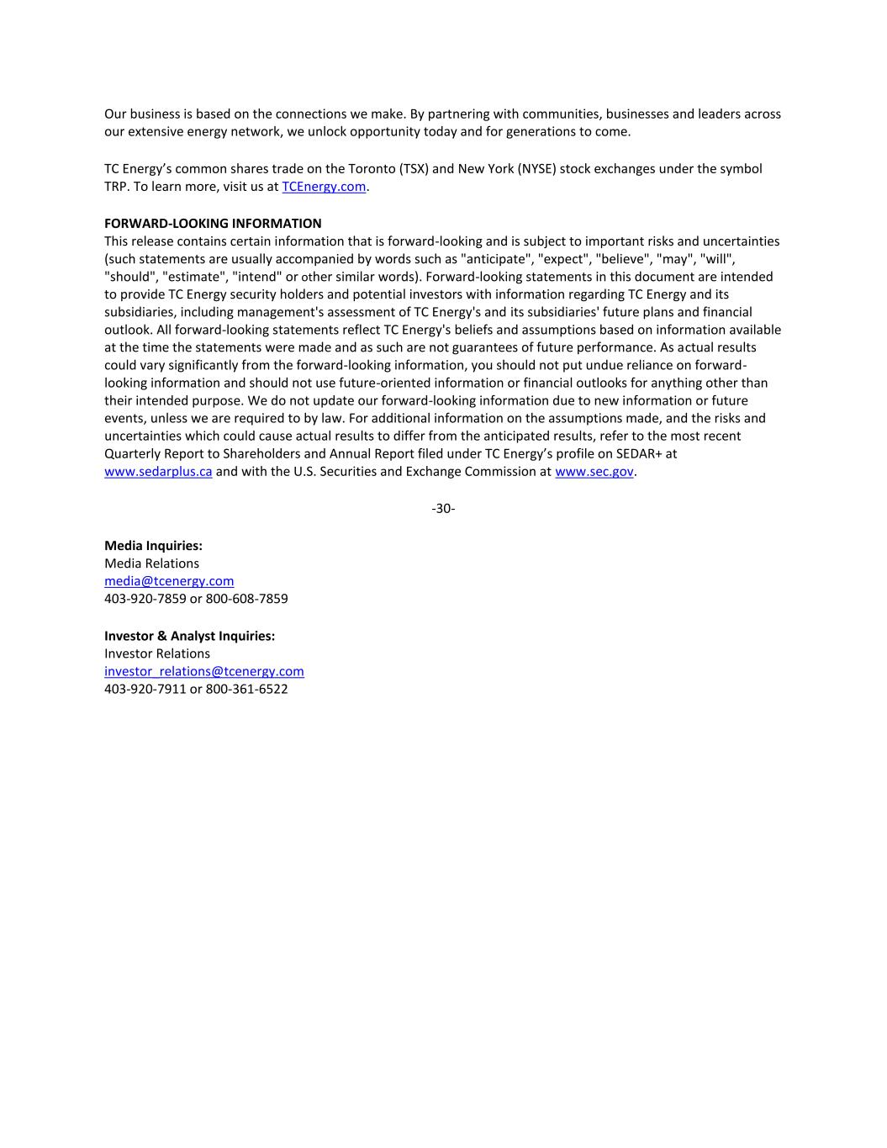
Our business is based on the connections we make. By partnering with communities, businesses and leaders across our extensive energy network, we unlock opportunity today and for generations to come. TC Energy’s common shares trade on the Toronto (TSX) and New York (NYSE) stock exchanges under the symbol TRP. To learn more, visit us at TCEnergy.com. FORWARD-LOOKING INFORMATION This release contains certain information that is forward-looking and is subject to important risks and uncertainties (such statements are usually accompanied by words such as "anticipate", "expect", "believe", "may", "will", "should", "estimate", "intend" or other similar words). Forward-looking statements in this document are intended to provide TC Energy security holders and potential investors with information regarding TC Energy and its subsidiaries, including management's assessment of TC Energy's and its subsidiaries' future plans and financial outlook. All forward-looking statements reflect TC Energy's beliefs and assumptions based on information available at the time the statements were made and as such are not guarantees of future performance. As actual results could vary significantly from the forward-looking information, you should not put undue reliance on forward- looking information and should not use future-oriented information or financial outlooks for anything other than their intended purpose. We do not update our forward-looking information due to new information or future events, unless we are required to by law. For additional information on the assumptions made, and the risks and uncertainties which could cause actual results to differ from the anticipated results, refer to the most recent Quarterly Report to Shareholders and Annual Report filed under TC Energy’s profile on SEDAR+ at www.sedarplus.ca and with the U.S. Securities and Exchange Commission at www.sec.gov. -30- Media Inquiries: Media Relations media@tcenergy.com 403-920-7859 or 800-608-7859 Investor & Analyst Inquiries: Investor Relations investor_relations@tcenergy.com 403-920-7911 or 800-361-6522

EXHIBIT 99.2
Annual Meeting of Shareholders of
TC Energy Corporation (“TC Energy”)

May 7, 2026

REPORT OF VOTING RESULTS
National Instrument 51-102 – Continuous Disclosure Obligations, Section 11.3

1.Election of Directors

By resolution passed via ballot, the following 13 nominees were appointed as Directors of TC Energy to hold office until the next annual meeting of shareholders of TC Energy, or until their successors are earlier elected or appointed. The results of the ballot were as follows:
Nominee |  |  | # Votes For |  |  | % Votes For |  |  | # Votes Against |  |  | # Votes Against
Scott Bonham |  |  | 674,143,748 |  |  | 99.06 |  |  | 6,363,143 |  |  | 0.94
Cheryl F. Campbell |  |  | 674,278,059 |  |  | 99.08 |  |  | 6,228,834 |  |  | 0.92
Michael R. Culbert |  |  | 674,399,356 |  |  | 99.10 |  |  | 6,107,536 |  |  | 0.90
William D. Johnson |  |  | 671,442,549 |  |  | 98.67 |  |  | 9,064,340 |  |  | 1.33
Susan C. Jones |  |  | 674,331,833 |  |  | 99.09 |  |  | 6,172,063 |  |  | 0.91
John E. Lowe |  |  | 664,554,753 |  |  | 97.66 |  |  | 15,952,135 |  |  | 2.34
Dawn Madahbee Leach |  |  | 674,161,521 |  |  | 99.07 |  |  | 6,345,370 |  |  | 0.93
François L. Poirier |  |  | 675,125,844 |  |  | 99.21 |  |  | 5,381,046 |  |  | 0.79
Una Power |  |  | 667,346,844 |  |  | 98.07 |  |  | 13,160,051 |  |  | 1.93
Mary Pat Salomone |  |  | 664,644,682 |  |  | 97.67 |  |  | 15,862,205 |  |  | 2.33
Siim A. Vanaselja |  |  | 662,871,252 |  |  | 97.41 |  |  | 17,635,635 |  |  | 2.59
Thierry Vandal |  |  | 667,344,563 |  |  | 98.07 |  |  | 13,162,327 |  |  | 1.93
Dheeraj “D” Verma |  |  | 672,051,818 |  |  | 98.76 |  |  | 8,454,531 |  |  | 1.24

2.Appointment of Auditor

By a resolution passed via ballot, KPMG LLP, Chartered Professional Accountants, were appointed as auditor of TC Energy until the close of the next annual meeting of shareholders of TC Energy, and the directors were authorized to fix their remuneration. The results of the ballot were as follows:

# Votes For |  |  | % Votes For |  |  | # Votes Withheld |  |  | % Votes Withheld
656,126,944 |  |  | 93.83 |  |  | 43,129,095 |  |  | 6.17

3.Advisory Vote on Executive Compensation

By resolution passed via ballot, on an advisory basis, TC Energy’s approach to Executive Compensation was approved. The results of the ballot were as follows:

# Votes For |  |  | % Votes For |  |  | # Votes Against |  |  | % Votes Against
669,435,060 |  |  | 98.37 |  |  | 11,071,822 |  |  | 1.63

