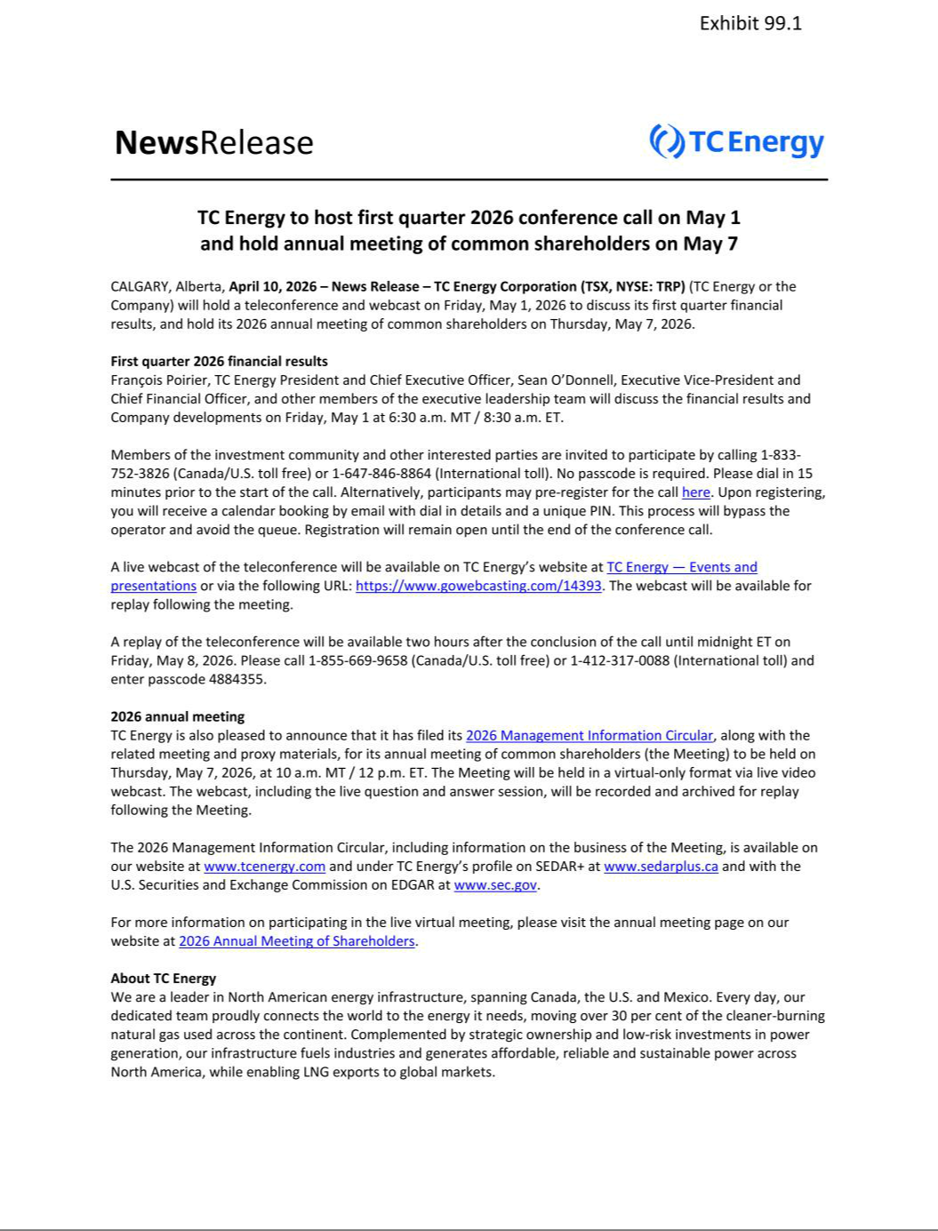

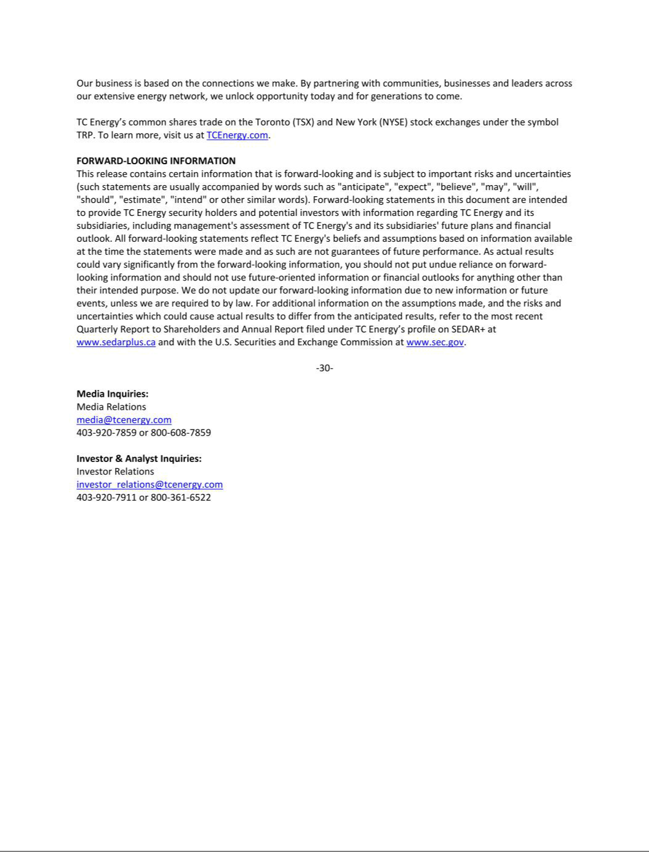

SECURITIES AND EXCHANGE COMMISSION

Washington, D.C. 20549

FORM 6-K

Report of Foreign Private Issuer

Pursuant to Rule 13a-16 or 15d-16 of

the Securities Exchange Act of 1934

For the month of April 2026

Commission File No. 1-31690

TC Energy Corporation

(Translation of Registrant's Name into English)

450 – 1 Street S.W., Calgary, Alberta, T2P 5H1, Canada

(Address of Principal Executive Offices)

Indicate by check mark whether the registrant files or will file annual reports under cover of Form 20-F or Form 40-F:

Form 20-F ☐ Form 40-F ☑

Exhibit 99.1 to this report, furnished on Form 6-K, is furnished, not filed, and will not be incorporated by reference into any registration statement filed by the registrant under the Securities Act of 1933, as amended.

EXHIBIT INDEX

99.1 A copy of the registrant’s news release dated April 10, 2026.

SIGNATURES

Pursuant to the requirements of the Securities Exchange Act of 1934, the registrant has duly caused this report to be signed on its behalf by the undersigned, thereunto duly authorized.

Date: April 10, 2026

TC ENERGY CORPORATION

^{By:} /s/ Jane M. Brindle

Jane M. Brindle

Vice-President, Law and Corporate Secretary

